European Maritime Transport Environmental Report - 2024

Version: version #
Date:

Author:
From:

Contributors:
From:

Document History (optional)

Version | Date | Author(s) | Remarks
0.1 | 01-02-2024 |  | Draft for Consultation

Contents
European Maritime Transport Environmental Report - 2024 1
Contents 2
Foreword/Preface 4
Acknowledgements 5
Executive Summary and Key Messages 6
1 Introduction 7
1.1 Aim and objective 7
1.2 From EMTER-2021 to EMTER-2024 7
1.3 State of the maritime transport sector traffic and trade 8
2 Trends, status and prospects 13
2.1 Emissions to the atmosphere 13
2.1.1 Greenhouse gases 13
2.1.2 Air Quality 25
2.2 Water Pollution 40
2.2.1 Oil spills 40
2.2.2 Discharge waters and contaminants 45
2.2.3 Ballast waters and non-indigenous species (NIS) 49
2.2.4 Underwater radiated noise 51
2.3 Marine litter and waste generation 55
2.3.1 Marine litter, passively fished waste and container loss. 55
2.3.2 Waste reception at ports 60
2.3.3 Ship recycling 61
2.4 Hazards and physical disturbance of seabed 63
2.4.1 Collisions with animals 63
2.4.2 Physical disturbance of the seabed 67
2.4.3 Seabed disturbance: A special focus on ports 70
3 Achieving decarbonisation targets 74
3.1 An EU basket of measures 74
3.1.1 EU Emission Trading System 74
3.1.2 Fuel EU Maritime 75
3.1.3 Alternative Fuel Infrastructure Regulation 75
3.1.4 Renewable Energy Directive 75
3.1.5 Energy Taxation Directive 76
3.2 Climate neutral energy solutions 76
3.2.1 Biofuels 76
3.2.2 Methanol 76
3.2.3 Hydrogen 77
3.2.4 Synthetic fuels 78
3.2.5 Ammonia 79
3.2.6 Wind assistance 80
3.2.7 Batteries 81
3.2.8 Fuel cells 82
3.2.9 Nuclear propulsion 82
3.2.10 Carbon capture and storage 83
3.2.11 Onshore Power Supply 84
3.3 Energy transition foresight 85
3.3.1 CO₂ emissions outlook 85
3.3.2 Roadmap to energy transition in 2030 and 2050 86
3.3.3 Green corridors 91
3.3.4 Human element and seafarer training outlook 92
4 Knowledge gaps 93
4.1 Gaps 93
4.2 The role of research and innovation 94
4.3 A new integrated monitoring infrastructure 95
List of abbreviations 97
References 101
Annex 1 Regulatory and monitoring frameworks 118

Foreword/Preface

Text to be added here

Acknowledgements
Text to be added here

Executive Summary and Key Messages
Text to be added here

Introduction

Aim and objective
The European Maritime Transport Environment Report (EMTER) assesses the environmental footprint of the maritime transport sector and supports attainment of the pollution prevention and decarbonisation objectives of the sector as indicated by the European Green Deal (EGD) and the "Fit for 55" package, and reflected in key initiatives such as the Sustainable and Smart Mobility Strategy (SSMS) and the Zero Pollution Action Plan (ZPAP) (EC, 2021f). The objective of this second EMTER report is to update the indicators developed for the first report (EMTER 2021), analyse new datasets and fill existing gaps (for example, fishing vessels and new energy carriers), in view of providing a data and knowledge-based assessment of the maritime transport sector’s transition to sustainability. As with the first version of the report, EMTER 2024 is targeted to a wide range of stakeholders, including European Union (EU) policy decision makers, EU member states’ maritime and environmental national administrations, industry and science organisations, business and environmental NGOs, and the civil society.

From EMTER-2021 to EMTER-2024
The first edition of the EMTER was published in 2021 and provided the first factual analysis of environmental footprint of the maritime transport sector. It presented information on the relevant environmental standards and described actions to reduce the sector’s impact on our environment, highlighting the challenges and opportunities to foster the necessary implementation and cooperation at European level.
Within this context, EMSA and the EEA have been working to update the first edition of the report, to fill in these gaps and to provide a set of new elements. These include biodiversity-related indicators, the analysis of observational air emission measurements from remotely piloted aircraft systems, insight on water discharges, underwater radiated noise forecast scenarios, marine litter, fishing vessels, EU 2030 targets for decarbonisation, alternative carbon-free energy sources, as well as an up-to-date CO₂ emission outlook and energy transition foresight. The report also provides new elements on how the maritime transport sector contributes to cleaning the seas from marine litter, with new data on waste collected during fishing activities (passively fished waste).
Nevertheless, it is important to note that some of the gaps identified in EMTER 2021 have not been completely addressed in this edition, for example regarding air quality in ports, where data enabling the analysis of the shipping contribution is still missing.
The report is structured in three main chapters plus an Annex, providing information on the relevance of the maritime transport sector, the policies, the data trends, status and outlooks, and information for the energy transition required to reach the sector’s decarbonisation targets. Chapter 1 provides an overview of the status of the maritime transport sector from an economic and social perspective. Chapter 2 offers an update of the key elements of EMTER 2021, evaluating the trends and progress made to reach the maritime environmental targets, and where possible, provides new elements to fill-in the knowledge gaps identified in the first edition. In Chapter 3, spurred by the ambition of the EU Green Deal and the proposals related to the maritime transport sector, the report examines the opportunities and challenges of the sector regarding the implementation of the new legislative framework on decarbonisation. The report concludes with a summary of the main remaining gaps and highlights those priority areas that need to be developed to further reduce the environmental footprint of the maritime transport sector and support the EU decarbonisation roadmap. Annex 1 covers all of the international and EU environmental regulatory and monitoring frameworks which are relevant to for the maritime transport sector, and thus also provides the context on the monitoring and reporting provided for the data, indicators and trends presented in Chapter 2.

State of the maritime transport sector traffic and trade
Throughout the report, the term maritime transport is used to describe all shipping and related port activities of a commercial or private nature linked to the transport domain. It therefore includes cargo, carriers, containers, tankers, vehicle/passenger (Ro-Ro and Ro-Pax), and cruise ships alike. Unlike with EMTER 2021, in this version of the report fishing vessels are indeed included in this definition, while offshore and other marine and maritime industrial platforms have not been considered within the scope.
Maritime transport plays a crucial role in sustaining trade, economic growth, connectivity, and accessibility, while also contributing to energy security and job creation. Large volumes of cargo are delivered thanks to maritime transport, resulting in reduced energy consumption and transportation costs, and increased efficiency (economies of scale) compared to other modes of transport (UNCTAD, 2020).
However, increased transport demand for the maritime sector comes with additional environmental impacts on the atmosphere and marine ecosystems. The majority of goods transported in and out of the EU are shipped using maritime transport. In 2021, 74% of EU total merchandise imports and exports were traded by sea. The maritime transport sector generated a Gross Value Added (GVA) of €29.5 billion in 2020, a decline of 14% compared to the 2019 peak. Gross profit, at €14.7 billion, decreased by 15% on the previous year. 54% of the sector’s GVA (€15.9 billion) was generated by freight transport activities, followed by renting and leasing services with €11 billion (37%) and then passenger transport with €2.6 billion (9%). The profit margin was estimated at 10%, slightly below the 11% recorded in 2019. The turnover reported for 2020 was €147.4 billion, a 10%-decrease on the previous year (EC & JRC, 2023).
In 2020, around 371,000 persons were directly employed in the sector. Nearly half of them were employed in activities related to renting and leasing of water transport equipment. The other half were employed in passenger transport activities (26%) and freight transport operations (24%). Employment has been increasing steadily since 2014, reaching the record level of 403,000 persons in 2019, before suffering an 8% decrease due to the travel restrictions imposed by the pandemic (EC & JRC, 2023).
The EU-27 external trade is dominated in both weight and value by maritime transport compared to other modes with only a slight decline during the COVID outbreak in 2020, as seen in Figure 1.1. More precisely, the pandemic highlighted the importance and relevance of maritime transport for the EU as a crucial transport mode to support the functioning of the economy. Demand for maritime transport is continuously growing with the amount of goods handled by EU ports in 2021 being 346,260 thousand tons for external trade as per Figure 1.3 (EUROSTAT, ).
With 17.6% of the total world fleet in Gross Tonnage (GT), the EU faces a critical decade where it must lead the transition towards a more economically, socially, and environmentally sustainable maritime transport sector (EEA, 2021). The realisation of integrated policies and strategies, such as the "Fit for 55" package (EC, 2021c), the Sustainable and Smart Mobility Strategy (SSMS) (EC, 2020c), the EU Biodiversity Strategy (EC, 2020b), the Zero Pollution Action Plan (EC, 2021f), as well as the implementation of EU regulations and directives such as the Emission Trading Scheme (ETS) extension to the maritime sector (EU, 2023c), the Fuel EU Regulation (EU, 2023b), the Marine Strategy Framework Directive (EU, 2008a), the Water Framework Directive (EU, 2000), the Habitats and Birds Directives (EC, 2010, 2013), the Marine Spatial Planning Directive (EU, 2014a), and the Ship-Source Pollution Directive (EU, 2009b), are crucial to reduce the environmental impacts and achieve a more sustainable maritime transport sector.
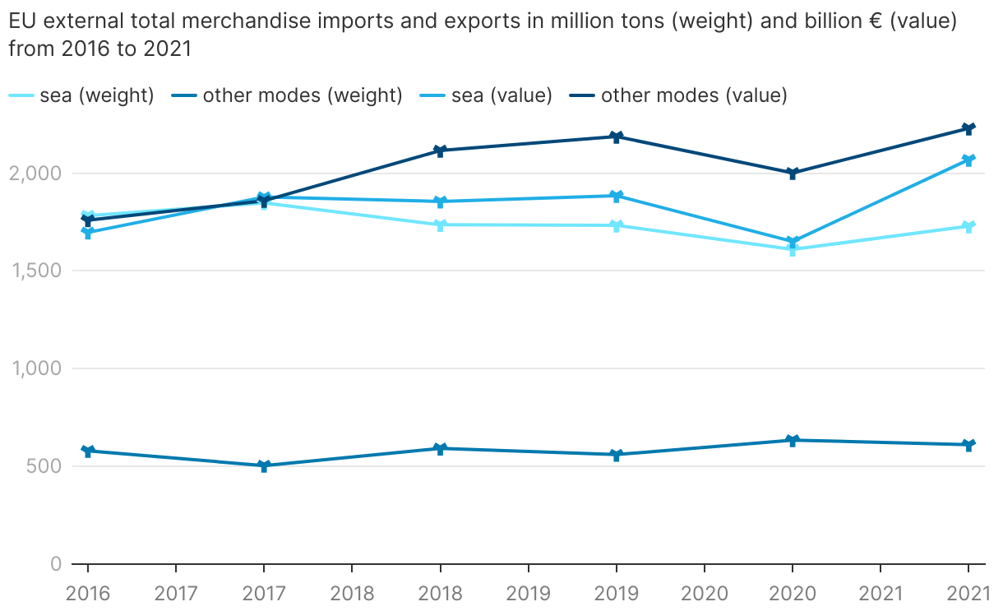
Figure 1.1 EU external trade per mode (in weight and value).
Source: EC (Statistical Pocketbooks 2017 to 2022, Section 2.1).
The volume of sea-borne imports and exports in Europe in 2020 diminished by 7.3% and 7.8% respectively compared to the previous year. However, in 2021 there was a sound rebound (+8.3% and +7.9%,respectively compared to the previous year) due to the gradual reopening of economies (UNCTAD, 2022). Due to the pandemic, other economic activities of the sector suffered more than freight transport. In 2019, approximately 400 million passengers embarked and disembarked in EU ports each year. In 2020, due to the COVID-19 pandemic, this figure declined to about 230 million (EC, 2023a). The number of seaborne passengers only partially recovered in 2022. Despite a 30% increase on the previous year, it remains below the 2019 levels (Figure 1.2).
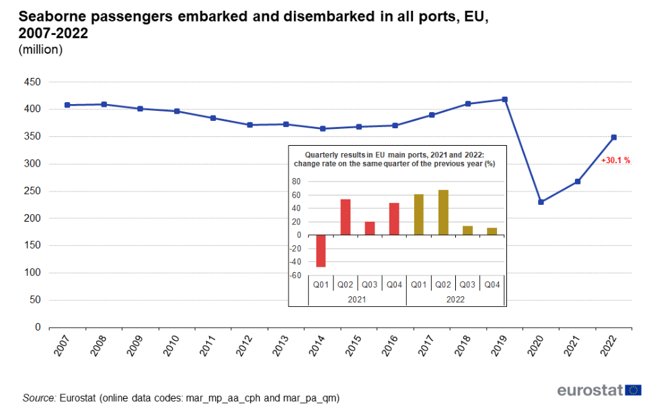
Figure 1.2 - Seaborne passengers in all EU ports, 2007-2022 (embarked + disembarked).
Source: Eurostat, 2023.
Ports are an integral part of the marine ecosystem and are at the heart of the sustainable development of the maritime transport sector. EU ports are heterogenous in size and may either receive port calls from a variety of ship types calling-in or from specific types of vessels (EEA & EMSA, 2021).
Ports are crucial to the European economy and are essential infrastructures of pivotal commercial and strategic importance. Ports are gateways for EU trade and instrumental in supporting the free movement of goods and persons in Europe. They also enable economic and trade development through traditional activities such as cargo handling, logistics and servicing, while at the same time supporting a complex cross section of industries and facilitating the clustering of energy and industrial companies in their proximity.
In 2020, the GVA generated by the sector amounted to €26.9 billion, representing a 3.6% decrease from the peak registered in 2019 (€27.9 billion). Gross profits registered a year-on-year drop of €1 billion, although they remained relatively steady across the past decade, at approximately €10.8 billion on average. Reported turnover, at €67.7 billion in 2020, was only marginally lower than in 2019 (€68.5 billion) (EC, 2023a).
A total of 385,627 persons were employed in port activities in 2020, up from 382,625 in 2019. 56% of them were employed in the port and water projects sub-sector in 2020. The remaining 44% of the workforce was employed in cargo and warehousing activities. In 2020, the two sub-sectors generated an equal share of the sector’s turnover, i.e., approximately €33.8 billion each (EC & JRC, 2023).
North Sea EU ports remain at the top of the list in terms of total containers handled, with figures twice of those of Mediterranean Sea ports, as shown in Figure 1.3.
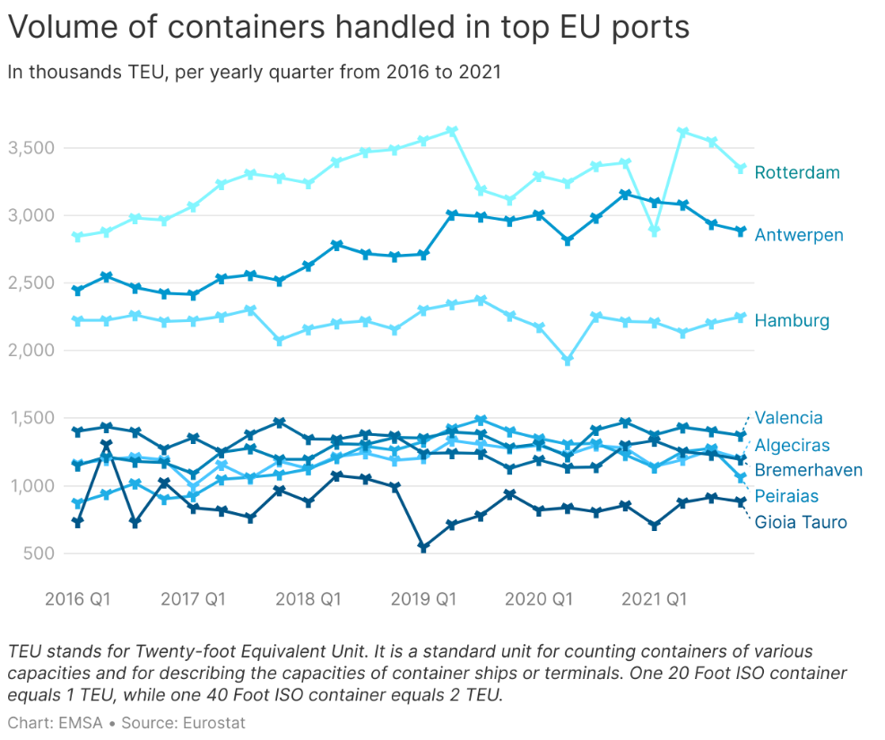
Figure 1.3 Volume of containers handled in EU top 8 ports.
Source: Eurostat.
However, it is also important to highlight the role of transhipments ports in neighbouring countries. These are ports where containers are unloaded from a ship in port for the purpose of being loaded on another ship. Although this report focuses on maritime transport in the EU, there are substantial interlinkages with neighbouring non-EU ports which should ideally be taken into account when assessing the environmental impacts of ports.
EU ports handle a significant proportion of the total port calls made globally on a yearly basis. In 2022, more than 12 million port calls took place globally, with almost 3 million or approximately 23% of them, located in EU and European Economic Area ports.

Figure 1.4 Port call distribution in EU per ship type in 2022.
Source: EMSA, 2023.
The impact of fishing vessels to the marine environment is examined for the first time in this report. Overall, the total number of fishing vessels in the EU is in decline since 2016 from about 77,500 to 72,500 in 2022 (-6.5%). However, both in terms of size and power needs, the fishing fleet is smaller than the merchant fleet, hence the overall related emissions and environmental impacts can be assumed to be lower, irrespective of where the fleet operates. Figure 1.5 shows that the majority of the fishing fleet belonging to EU Member States is registered in five EU countries, namely Greece, Italy, Spain, Portugal, and Croatia, which collectively account for 68% of the total EU fishing fleet. The same countries account for 51.2% of the gross tonnage and 53.1% of the engine power. Interestingly, while the Greek fleet is numerous (19.5% - the largest in terms of numbers) but relatively small in gross tonnage (5.2%) and engine power (7.8%), the French fleet is smaller in numbers (8.4%), but largest in engine power (18.3%).
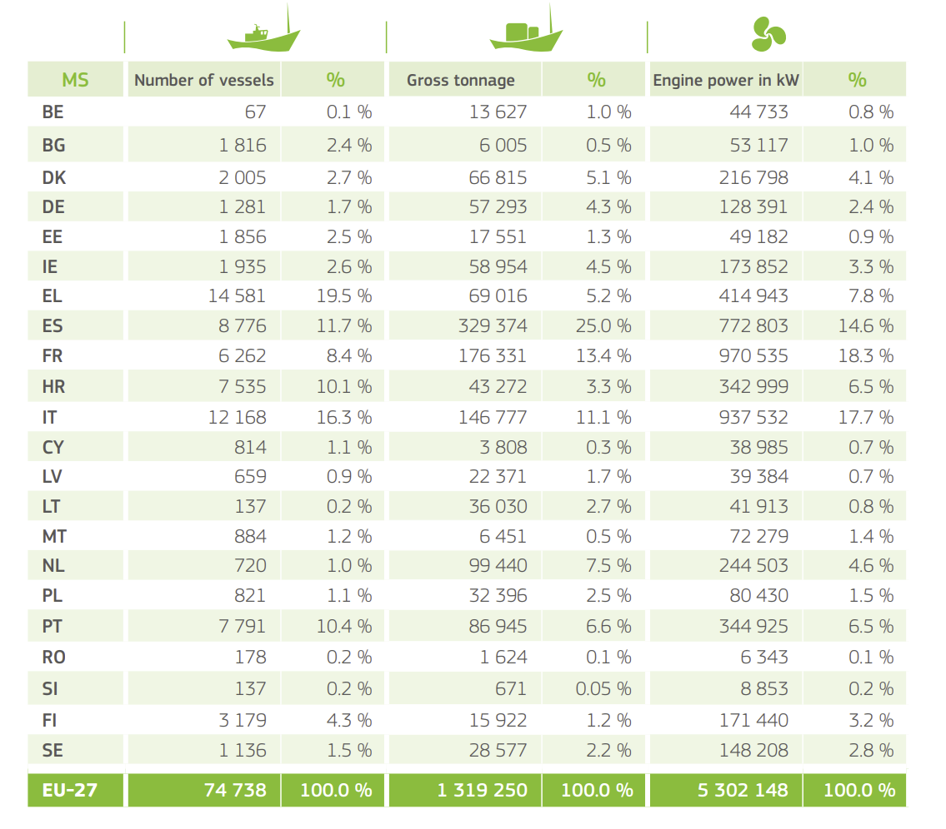
Figure 1.5 Total EU size, gross tonnage and engine power of fishing vessel fleet per EU Member State (July 2021).
Source: EU Fleet Register, DG MARE.

Trends, status and prospects
In this chapter, the state of play in relation to the various environmental impacts of shipping is provided, together with an analysis of the trends, status and certain future prospects. This builds upon the indicators developed in the first edition of EMTER, released in 2021, which are herein expanded and updated.

Emissions to the atmosphere

Greenhouse gases
Data reported under the EU Monitoring Reporting Verification (MRV) of maritime transport emission system shows that for all in scope voyages and activities for the reporting year 2022, at the moment of data extraction, the sector has emitted 135.9 million tonnes of CO₂ into the atmosphere. This value corresponds to an increase of 7.14% in comparison with 2021 reported data (126.2 million tonnes). These emissions originated from a fleet of 11,997 ships (EMSA, 2018). MRV monitoring covers around 55% of the ships calling to EEA ports, which represents 90% of all CO₂ emissions of the fleet in tons of CO₂ equivalent (EC, 2023c).
By analysing MRV data from 2021 (see Figure 2.1), it is possible to note that of the total emissions of CO₂, voyages towards ports in the European Economic Area (EEA) contributes 34%, while voyages departing from EEA ports represent 32%. voyages between EEA ports represent 26%, while around 6% of the emissions comes from ships at berth (EC, 2023c).
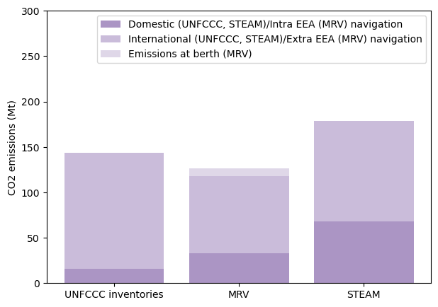
Figure 2.1 CO₂ emissions from the maritime sector (Mt) in 2021 according to data reported under: UNFCCC GHG inventories (left column), MRV regulation (central column), STEAM (right column).
Source: UNFCCC, MRV, STEAM.

 |  | MRV | GHG INVENTORIES | STEAM
Scope | Vessel | > 5000 GT cargo/passenger ships  Exceptions applies (military, fishing vessels, …) | Any waterborne vessel  includes navigation on lakes and inland waterways  fishing and military vessels are reported as separate categories | All vessels entering the scope of the AIS system regardless of location.
Scope | Geographical | European Economic Area  EU27 + Iceland, Liechtenstein, and Norway | EU27  Difference between EU inventory and UNFCCC inventory due to differences in territory accounted for Denmark and France | Global
Scope | Emissions | TtW | TtW | TtW
Categorisation |  | Intra EEA/extra EEA/at berth | Domestic/international  based on port of departure/arrival (for each segment of a trip)  EU-27 results are obtained summing MS contributions | Total/Domestic/ International. International - ship movements which occur between two different countries; Domestic - between ports belonging to the same country.
Main approach |  | Fuel consumed on board | Fuel sold | Vessel activity through AIS data
Main output |  | CO₂ emissions | GHG (CO₂, CH₄, N₂O) emissions | GHG, AP, contaminants
Reporting cycle/timeliness |  | Yearly, T-1 | Yearly, T-2 | Yearly, T-1
Table 2.1 - Data used in the report and the differences between UNFCCC inventories, STEAM model and EU MRV.
Source: EMSA, EEA.
Figure 2.1 illustrates CO₂ emissions from the shipping sector according to three distinct datasets with different scopes of application and methodologies, the United Nations Framework Convention on Climate Change (UNFCCC) GHG inventories, the European Union MRV system, and the Ship Traffic Emissions Assessment Model (FMI, 2023). It is important to highlight that the presented sets of data are not directly comparable, nor it is the scope of the figure to compare them. This is due to fundamental differences in underlying methodologies to calculate emissions, as also summarised in Table 2.1. The three datasets give complementary visions of the sector’s emissions. For example, through STEAM is possible to observe the geographical distribution of emissions at regional level, through the utilisation of Automatic Identification System (AIS) data, while the UNFCCC inventories provide an historical series of data. Despite these differences, it is possible to observe that for the year 2021 the overall CO₂ emissions reported under the UNFCCC inventories and the MRV regulation are 143.3 million tonnes and 126.2 million tonnes, respectively. Despite the above, the datasets are in good agreement providing confidence in the data reported. The domestic navigation definition for the UNFCCC inventories accounts for emissions occurring from voyages starting and ending in ports located in the same Member States. According to the inventories, in 2021 domestic emissions amounted to 15.7 million tonnes, approximately 11% of the total. In STEAM, domestic navigation (with a definition similar to the one of inventories) in 2021 was equal to 67.9 million tonnes and accounted for 38% of the total. Finally, in the MRV, the intra EEA plus the at berth emissions accounted for 32% of the total share.
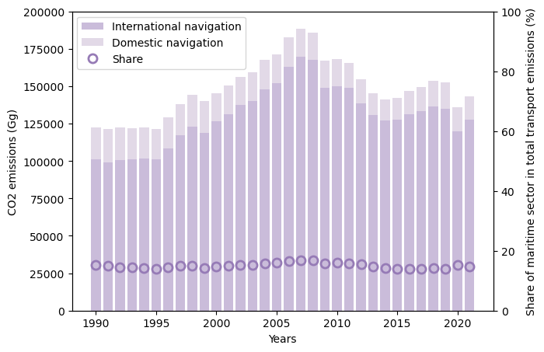
Figure 2.2 CO₂ emissions from the maritime sector (Gg) and their share in total transport emissions (%) between 1990 and 2021 in EU-27.
Source: UNFCCC (EEA, 2022c).
The share of the maritime transport sector to overall transport emissions as reported within the same UNFCCC GHG inventories has remained roughly constant in time, reaching approximately 15% in 2021 compared to total transport emission (see Figure 2.2). At the same time (not shown in the graph), between 1995 and 2021, the EU domestic freight maritime transport activity (measured in billion tkm) has increased by 39% (despite the impact of COVID-19 pandemic) while the passenger one (in billion pkm) has decreased by 39% (EC, 2023b). The GHG Inventories data on the impact of COVID on ship activity shows that from 2019 to 2020 the overall emissions from the sector decreased by 11%, despite the share remaining the same, in line with the reduction of activity caused by the COVID-19 pandemic. Indeed, in the same period, for the maritime sector, freight activity decreased by 6% while passenger activity by 51% (EC, 2023b).
Ship calls at EU ports declined by 3.5% in 2020 compared to 2019 and increased 3.7% comparing 2019 with 2021, while total Gross Tonnage (GT) decreased by 11.1% and 9.1%, respectively. It is also important to note that from 2019 to June 2022 there was an increase of 4.2% on port calls, that in GT terms represents a reduction of 16.2% compared with the 2019 values, which is a result of the current crisis in Ukraine (EMSA, 2022).
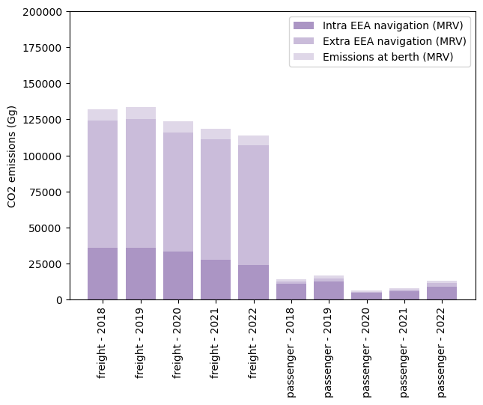
Figure 2.3 Distribution of CO₂ emissions from freight and passenger vessels (Gg) between 2018 and 2022 in the EEA (2021 onwards without UK).
Source: EMSA, THETIS-MRV.
Overall freight emissions in 2022 were equal to 105.5 million tonnes, approximately four times higher compared to passenger emissions (see Figure 2.3). Focussing on intra-European Economic Area voyages, in absolute terms, the difference of emissions from the two modes have decreased. The total emissions from freight transport have decreased by 20% in the 2018-2022 period, while passenger transport emissions seem to have fluctuated due to the impact of the COVID-19 pandemic. Emissions at berth for freight remained rather stable over the period considered and equal to approximately 6% of the total. For passenger transport this value oscillated between 8% and 15%, depending on the year considered.
From 2018 until 2022 five ship types represent the majority of ships reporting under the MRV, submitting 81% of the total MRV emission reports (see Figure 2.4). Containerships, oil tankers, bulk carriers, chemical tankers, and general cargo ships accounted for 64% of the total CO₂ emissions for 2022. Identifying the main contributors serves as starting point to prioritise decarbonisation strategies and identify the sectors requiring urgent investments to accelerate the transition towards cleaner fuels and power solutions alternatives.
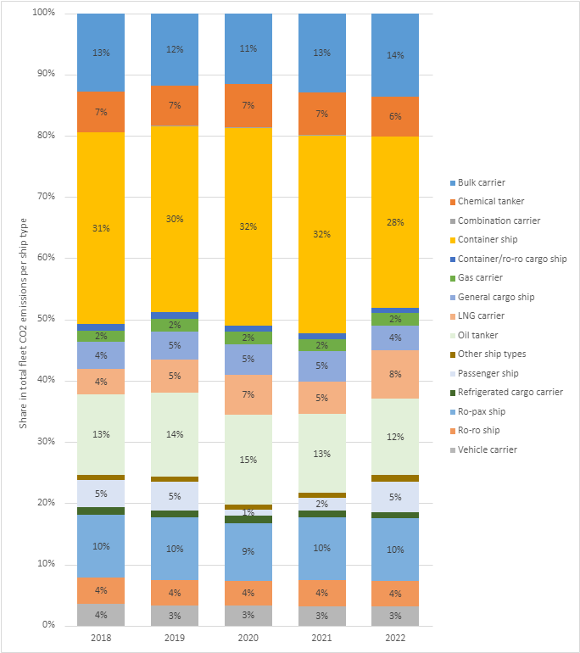
Figure 2.4 Shares in total fleet CO₂ emissions by ship type; 2018 – 2022.
Source: EMSA, THETIS-MRV (2021 and 2022 UK is not included).
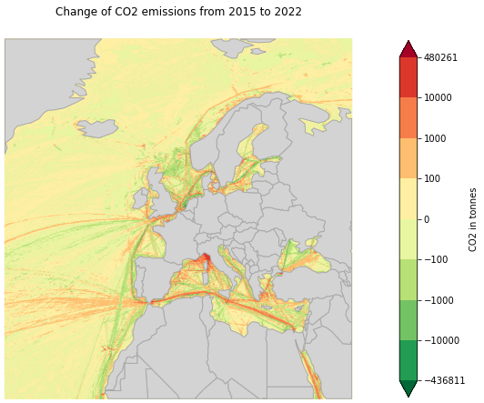
Map 2.1 Difference in CO₂ emissions in European shipping areas between 2015 and 2022.
Source: STEAM, FMI.
The STEAM modelled data allows to visualise the uneven distribution of CO₂ emissions in the different regions of Europe (see Map 2.1). It is important to consider that variables such as the traffic volume (in absolute number of vessel position messages) will influence the total emissions. In the period considered, STEAM data shows that the Mediterranean had the higher average yearly CO₂ emissions, equal to 65.2 million tonnes/year, followed by the Atlantic with 33.3 million tonnes/year and the North Sea with 27.3 million tonnes/year.
In the 2015-2022 timeframe, CO₂ emissions have increased by respectively 127% in the Atlantic, 35% in the Mediterranean, 30% in the North Sea, 7% in the Baltic and 5% in the Black Sea. In the same timeframe, the cumulative distance travelled by ships on a per region basis increased by 208%, 20%, 23%, 13%, and 7%, respectively. In the Arctic region, CO₂ emissions have grown around six times, together with an increase in the distance travelled in the area, around five times.

CO₂ emissions and ship types
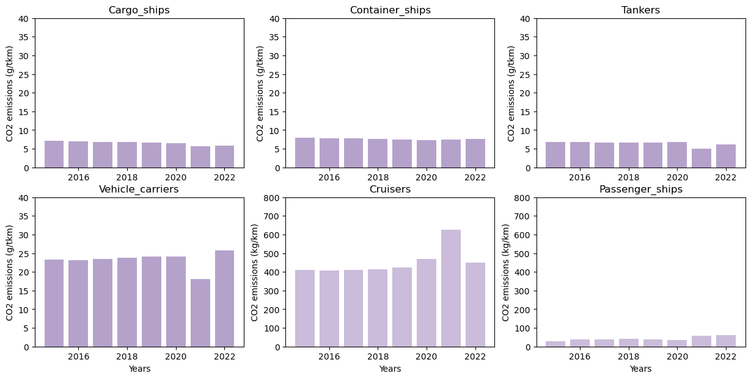
Figure 2.5 CO₂ specific emissions from selected freight and passenger ship types in (g/tkm) or (kg/km) respectively, between 2015 and 2022 in the EU.
Source: STEAM, FMI.
Specific emissions have been declining for all the ship types during the period considered as it can be noted in Figure 2.5. Note that the following figures refers to averages per ship type. In particular, CO₂ emissions decreased by 18%, 5%, and 9% for cargo, containers, and tankers respectively, while they increased by 10% for vehicle carrier vessels. For reference, in the same region and timeframe, the payload carried increased respectively by 39%, 22%, 44% and 8%. This, in the first three cases, was enough to overcompensate the absolute emission increase of respectively 13%, 16%, 31% and 19%.
Over the time period considered, cargo ships and tankers had the lowest yearly emission per transport work with 6,537 mg/tkm and 6,472 mg/tkm. By comparison, container ships emitted on average 7,628 mg/tkm, while vehicle carriers’ emissions were up to 23,213 mg/tkm.
Specific emissions of cruisers in Europe have been decreasing by 9% during the period considered, with an increase in the distance travelled of 21%. Conversely, passenger ships emissions have strongly increased by 111%, with a relatively modest increase of 3% in the distance travelled. At the same time, absolute CO₂ emissions increased by 32% for cruise ships and by 117% for passenger ships.
For the same considered time period, cruiser ships emitted 452 kg/km. This is approximately 11 times higher than conventional passenger ships’ emissions in the same region and period, i.e. 42.6 kg/km. It is, however, important to note that these figures do not take into account the amount of passengers transported.
Trends in fuel consumption
Based on reported data under the MRV regulation, is observable that there has been a shift in the shares of fuel used from 2020 from heavy fuel oil (HFO) to light fuel oil (LFO), as shown in Figure 2.6. The implementation of the Global Sulphur Cap in 2020 and the prohibition on the carriage of such fuel without abatement technologies onboard are two of the main factors which can help explain this trend (IMO, 2020b). In 2021, the fleet falling under the MRV regulation consumed approximately 40.008 million tonnes of fuel, showing a 0.8% decrease compared to 2020 (41,416 million tonnes).

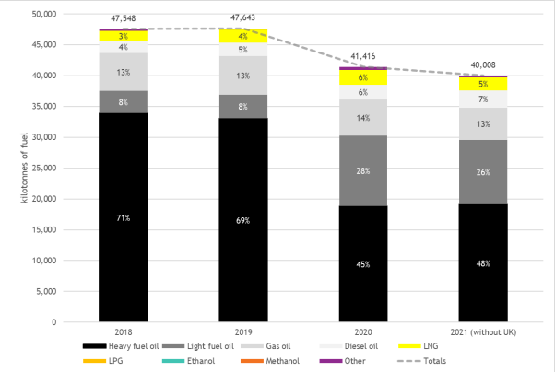
Figure 2.6 - 2018 to 2021 total fuel consumption of EU MRV fleet and shares per fuel type.
Source: EMSA, THETIS-MRV.
CO₂ and fishing vessels
Finally, STEAM data shows the average emissions per ship of fishing vessels decreased by 1% from 2015. On average in 2020, a fishing vessel was emitting approximately 473.2 tonnes of CO₂ per year. The fishing fleet has slightly decreased over the same period, i.e. 7%, and absolute CO₂ emissions decreased by 8%.
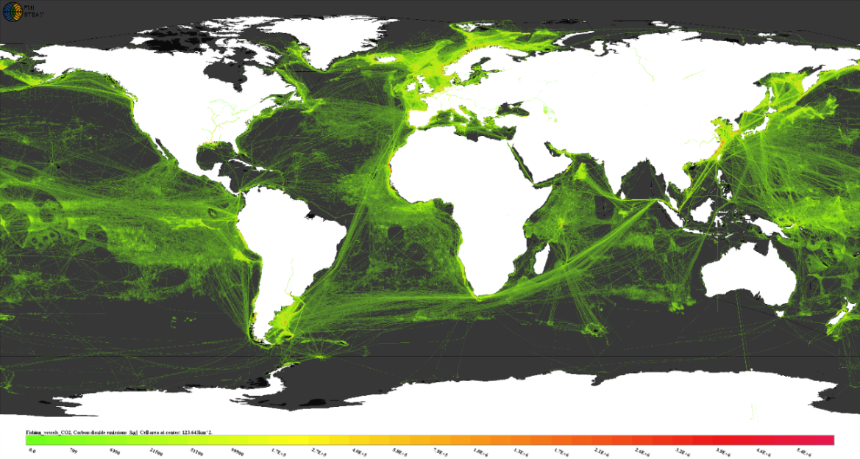
Map 2.2 - 2022 global CO₂ emissions for fishing vessels (only).
Source: STEAM, FMI.
The emissions of CO₂ for fishing vessels calculated by the STEAM model for 2022 in the EU are equivalent to 4,090 million tonnes, compared to a value of 13,000 million tonnes at global level representing a share of 31.5% (see Map 2.2). The 2022 equivalent STEAM estimates for the CO₂ emissions of the maritime sector (i.e. all vessel types, activities, and voyages) are 9.19 billion tonnes globally and 2 billion tonnes in the EU. Thus, fishing vessels represent 2% of CO₂ emissions in the EU and 1.4% at global level. It is nevertheless important to note that these estimates are based on the AIS occurrences, and recent studies have shown that about three-quarters (72–76%) of globally mapped industrial fishing vessels did not appear in public monitoring systems (in the period 2017-2021), compared with one-quarter (21–30%) for other vessel activities (Paolo et al., 2024). Therefore, using solely AIS to estimate CO₂ emissions from fishing vessels has some limitations.
The European Parliament’s Communication paper on the “Energy Transition in EU fisheries and aquaculture” (EP, 2023) highlights the current energy intensity and reliance on fossil fuels and discusses the need to strengthen fuel efficiency switching to alternative and low-carbon energy sources. It reports that “At present, most fishing vessels rely on marine diesel for their operations, although smaller vessels may use petrol. In total, the EU fleet consumed over 1.9 billion litres of marine diesel in 2020 […] This fuel consumption led to direct emissions of approximately 5.2 million tonnes of CO₂”. Data from the EU Blue Economy Observatory, shows the evolution of CO₂ emissions for the different segments of fishing vessels (by length), as well as the evolution of CO₂ emissions per kg of fish caught (which can be relevant to control for the efficiency of the fishing vessels and overall sector).
Figure 2.7 shows the evolution of CO₂ emissions from fishing vessels as a function of the vessel length, both in absolute terms and per unit mass of fish caught between 2008 and 2021. The analysis shows that in absolute terms, smaller vessels (<12 m) emit less CO₂ emissions per year in the considered time series and that larger fishing vessels (>40 m) are the second less emitting vessel type. It is important to consider that in 2021, the last reporting year where data is available, and according to the EU Fleet Register, the majority of the fishing fleet registered in the EU was smaller than 12 meters accounting for around 86% (11% of the fleet ranged from 12-24 meters, and the remaining 3% were vessels larger than 24 meters) (EC, 2021e). This allows to note that the vast majority of the EU fishing fleet is composed of vessels smaller than 12 meters and that, in absolute terms, this is the least emitting vessel type. However, if the analysis considers the emissions per kilo of fish captured, vessels < 12 meters, emit on average more than both the larger vessels (> 40 m) and vessels ranged from 24-40 m. The larger the fishing vessel the less it emits per kilo of fish landed. Another aspect which emerges from the total emissions of CO₂ is that vessels ranging from 12-24 meters and 24-40 meters emit more than the ones larger than 40 meters. The range of vessels included in these categories, the predominantly fishing techniques used and the efficiency of the fleet, as well as the number of vessels in each category could all account for these higher emissions. In terms of absolute emissions and noting that the European fishing fleet has reduced in total number of vessels, the emissions are lower than in 2008, however this decrease is not significant.
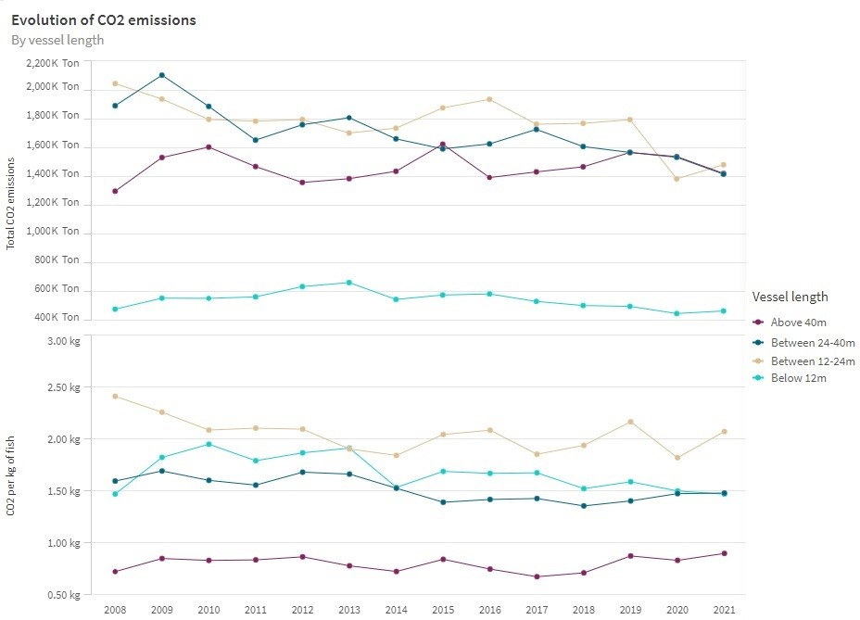
Figure 2.7 Evolution of CO2 emissions per fishing vessel length, and CO2 emissions per kg of fish caught, 2008-2021.
Source: EU Blue Economy Observatory.

Methane
In the context of the inclusion of maritime transport in the EU ETS, an expansion of the EU MRV scope took place, by which relevant methane emissions data will be reported and published for the first time in 2025 for the reporting year 2024.

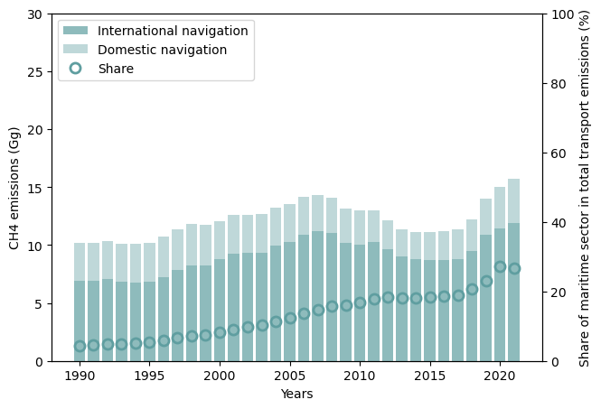
Figure 2.8 CH₄ emissions from the maritime sector (Gg) and their share in total transport emissions (%) between 1990 and 2021 in the EU-27.
Source: UNFCCC.
Using the UNFCCC inventories data as presented in Figure 2.8 it is possible to note that the contribution of the maritime transport sector to overall transport methane emissions of CH₄ has increased over time, reaching approximately 27% in 2021. In this year, methane emissions from the maritime transport sector reached 16 Gg. Additional details on the methodology used to account for CH₄ emissions in inventories can be found in the dedicated guidelines (IPCC, 2006).
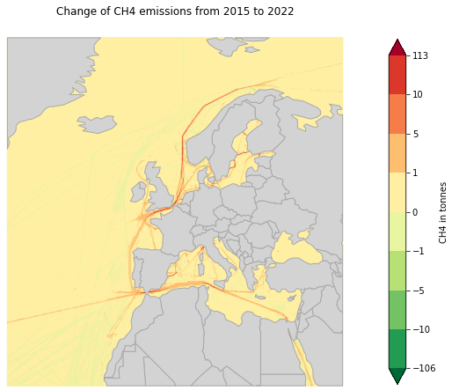
Map 2.3 Difference in CH₄ emissions in European shipping areas between 2015 and 2022.
Source: STEAM, FMI.
The model data by the STEAM model, provides the spatial distribution of CH₄ pollution across Europe (Map 2.3). Moreover, it shows that CH₄ emissions (accounted as methane slip) started to increase more significantly from 2018. This is associated with an increase of the overall number of LNG/LPG powered ships (Comer et al., 2024; EEA & EMSA, 2021). More specifically, in the 2018-2022 timeframe, CH₄ emissions have increased significantly across all EU marine regions with values of 773% for the Atlantic, 235% for the Baltic, 182% for the Mediterranean and 154% for the North Sea. In the same timeframe and for the same regions the variation in the distance travelled was respectively 208%, 13%, 20%, 23%. In the Arctic region, CH₄ emissions have grown by a factor of ten times, coinciding with a massive increase in the distance travelled of around five times in the area. This is of particular concern given the vulnerability of the region to the effects of CH₄ pollution, which is considered an important greenhouse gas after CO₂ (Prather et al., 2001).
In the period considered, the Atlantic had the highest average yearly CH₄ emissions, equal to 10 Gg/year, followed by the Mediterranean with 8 Gg/year and the North Sea, 6 Gg/year.

Air Quality
Sulphur Oxides (SOx)
Figure 2.9 shows that the contribution of the maritime sector to overall transport on SOx emissions in the EU-27 from 1990 to 2021 based on data from the Long Transboundary Air Pollution Convention (LRTAP). The figure shows a steadily increased over time, reaching a peak of 97% in 2005 which in absolute terms represents the emission of approximately 1500 Gg of SOx. Thereafter, it has slightly declined to approximately 92% of the transport total share (-6%), in 2021, where emissions from the sector were equal to 276 Gg.
In 2021, fisheries and domestic navigation constituted approximately 1% and 6% of the total maritime SOx emissions, with the remaining being international navigation. From 2019 to 2020 the overall emissions from the sector decreased by 60%, also due to the reduction of activity caused by the COVID-19 pandemic restrictions. In the same period, for the maritime sector, freight activity decreased by 6% while passenger activity decreased by 51%.
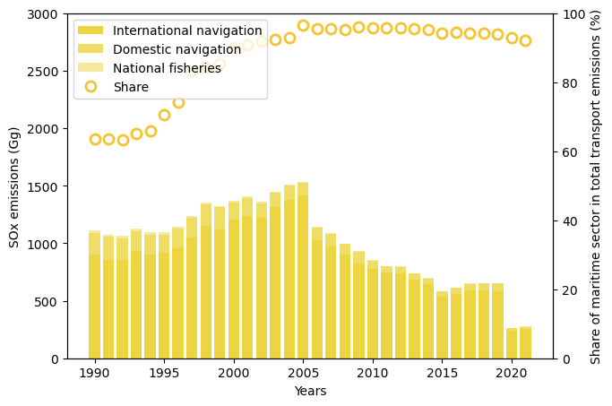
Figure 2.9 SOx emissions from the maritime sector (Gg) and their share in total transport emissions (%) between 1990 and 2021 in the EU-27.
Source: LRTAP.
The SOx Emission Control Areas (ECAs) and the Global Sulphur Cap have limited the content of sulphur in marine fuels. Based on the data from the STEAM model, Figure 2.10 shows that there has been a large reduction in the monthly SOx emissions for the EU region as a whole.
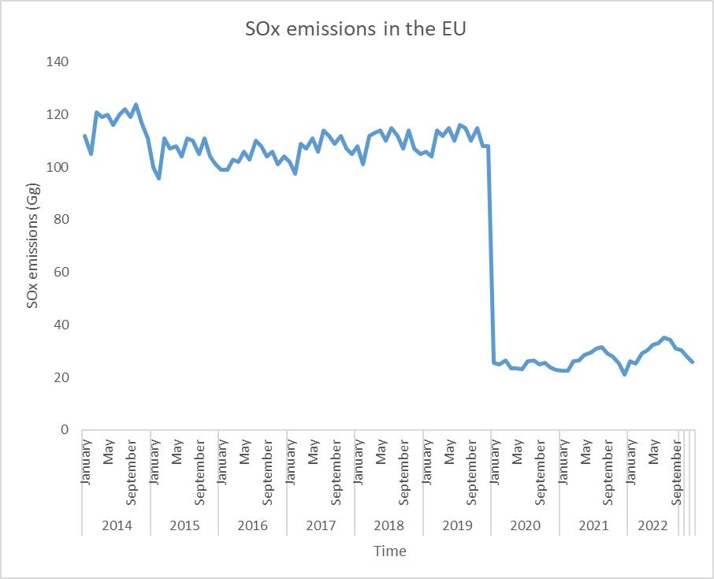
Figure 2.10 SOx emissions for EU, 2014-2022.
Source: STEAM, FMI.

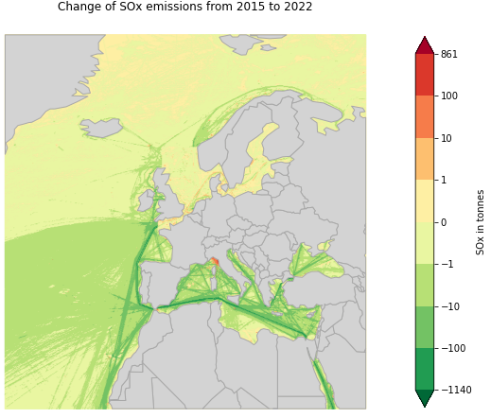
Map 2.4 Difference in SOx emissions in European shipping areas between 2015 and 2022.
Source: STEAM, FMI.
The STEAM modelled data allows a visual reflection of the uneven distribution of SOx emissions in the different regions of Europe (see Map 2.4). As for GHG emissions, it is important to consider that variables such as the traffic volume (in absolute number of vessel position messages) will influence the total air quality emissions. In the 2015-2022 timeframe, SOx emissions have decreased by 71%, 69%, and 61%, in the Mediterranean, Black and Atlantic regions respectively, while they have increased by 29% and 2% in the North and Baltic Seas. In the same timeframe and for the same regions, the variation in the distance travelled was respectively 20%, 7%, 208%, 23%, and 13% respectively. In the Arctic region, SOx emissions have increased by 62%, together with a significant increase in the distance travelled in the area, equal to five times. This is of particular concern given the vulnerability of the region to the effects of SOx pollution.
Within the same period, the Mediterranean had the highest average yearly SOx emissions, equal to 503 Gg/year, followed by the Atlantic with 270 Gg/year and the North Sea, 16 Gg/year.
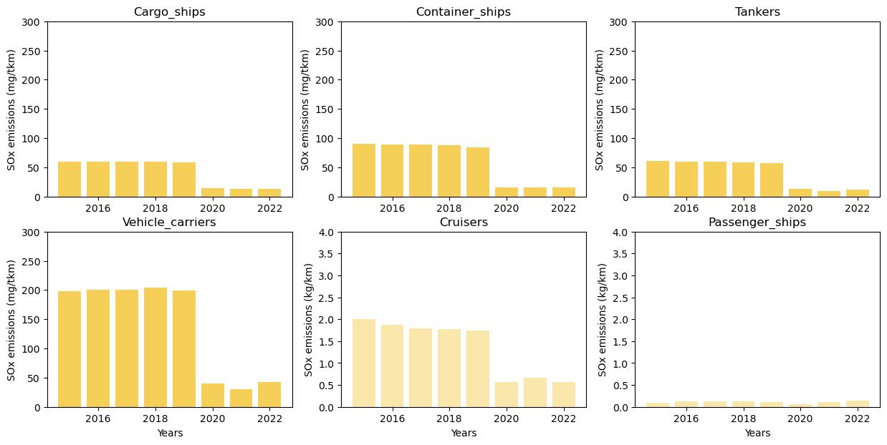
Figure 2.11 SOx specific emissions from selected freight and passenger ship types in (mg/tkm) or (kg/km) respectively, between 2015 and 2022 in the EU.
Source: STEAM, FMI.
SOx specific emissions have been declining for all the ship types during the period considered (see Figure 2.11). In particular, they decreased by 78%, 83%, 81% and 79% for cargo, containers, tanker, and vehicle carrier vessels, respectively. This is related to a combination of factors, including the increased average payload transported and the introduction of new policies such as the IMO SOx ECAs in force from 2015 and the Global Sulphur Cap in 2020. For reference, in the same region and timeframe, the payload carried by each ship type increased respectively by 39%, 22%, 44% and 8%. It is important to note that, notwithstanding the increased activity, there has been an overall absolute sulphur emission decrease of 70%, 79%, 73% and 77% respectively, showing the important role of cleaner fuels and aftertreatment technologies. Over the time period considered, tankers, cargo ships, and container ships had the lowest yearly emissions with 41 mg/tkm, 42 mg/tkm, and 61 mg/tkm. By contrast, vehicle carriers emitted 139 mg/tkm.
Specific emissions of cruisers in Europe have been decreasing by 72% during the period considered, with an increase in the distance travelled of 21%, in absolute terms, the emissions of this industry decreased by 66%. As the STEAM model separates the information from passenger ships and cruiser ships, it is possible to observe that in the passenger ships side, the emissions in the same timeframe increased by 35%, with a 3% increase in distance travelled and in absolute terms the emissions of SOx increased by 39%. It is important to highlight that in these two modes of passenger transport are of different magnitude, and that cruiser ships emitted on average of 1 kg/km per year, on the contrary on average, per year a conventional passenger ship emits 10 times less.
Finally, the STEAM data also shows that average emissions per ship of fishing has decreased by 44% from 2015. On average in 2020, a fishing vessel was emitting approximately 975 g of SOx per year. It is worth noting that the fishing fleet has only slightly decreased over the same period, i.e. 7%, while absolute SOx emissions decreased by 48%.
Nitrogen oxides (NOx)
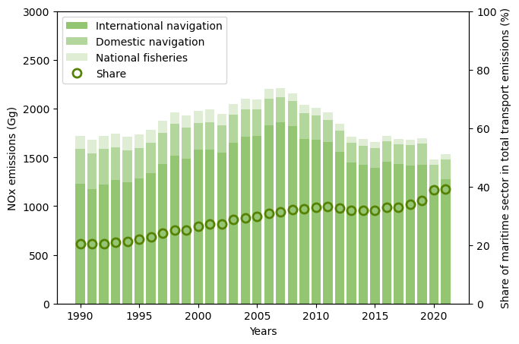
Figure 2.12 NOx emissions from the maritime sector (Gg) and their share in total transport emissions (%) between 1990 and 2021 in the EU-27.
Source: LRTAP.
Figure 2.12 shows the contribution of the maritime sector to overall transport NOx emissions in the EU-27 from 1990 to 2021 based on LRTAP data, highlighting how emissions have steadily increased over time, reaching approximately 39% in 2021. In 2021, emissions from the sector reached 1,531 Gg. From 2019 to 2020 the overall emissions from the sector decreased by 13%, in line with the reduction of activity caused by the COVID-19 pandemic restrictions. In 2021, fisheries and domestic navigation constituted approximately 4% and 13% of the total maritime emissions.
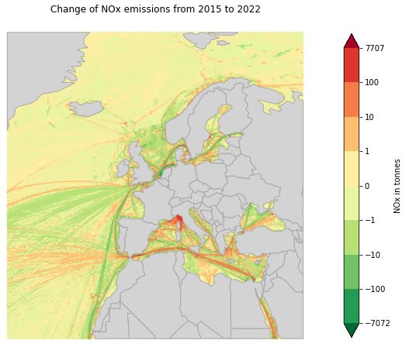
Map 2.5 Difference in NOx emissions in European shipping areas between 2015 and 2022.
Source: STEAM, FMI.
The STEAM modelled data allows to visualise the uneven distribution of NOx emissions in the different regions of Europe (see Map 2.5). In the period considered, the Mediterranean Sea had the higher average yearly NOx emissions, equal to 1,252 Gg/year, followed by the Atlantic with 660 Gg/year and the North Sea, 473 Gg/year.
In the 2015-2022 timeframe, NOx emissions have increased by respectively 96%, 27% and 21% in the Atlantic, Mediterranean Sea, and North Sea, while they have decreased by 5% and 4% in the Baltic and Black Seas. In the same timeframe and for the same regions, the variation in the shipping activity (via the proxy distance travelled) was respectively 208% (Atlantic), 20% (Mediterranean), 23% (North Sea), 13% (Baltic Sea), and 7% (Black Sea). In the Arctic region, NOx emissions have increased around 4 times and which distance travelled increased around five times. This is of particular concern given the vulnerability of the region to the effects of NOx pollution.
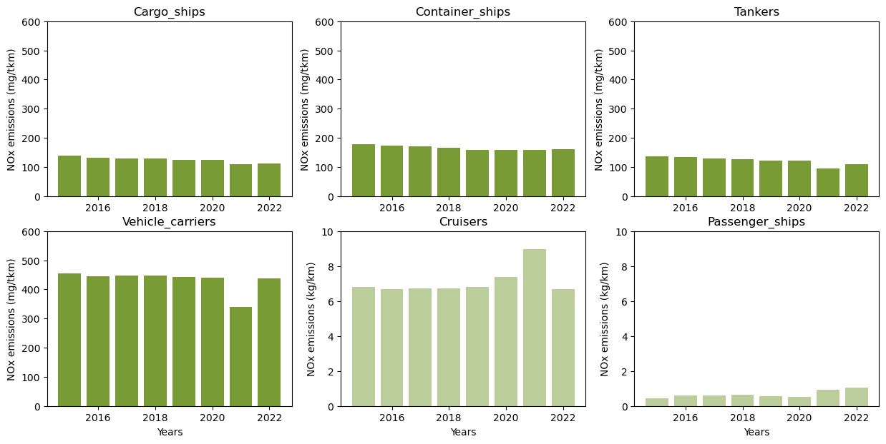
Figure 2.13 NOx specific emissions from selected freight and passenger ship types in (mg/tkm) or (kg/km) respectively, between 2015 and 2022 in the EU.
Source: STEAM, FMI.
Over the time period considered, cargo ships and tankers had the lowest yearly emission with 125 mg/tkm. By comparison, container ships emitted on average 166 mg/tkm, while vehicle carriers up to 432 mg/tkm (see Figure 2.13).
Specific emissions have been declining for all these ship types during the period considered. In particular, they decreased by 19%, 10%, 20% and 4% for cargo, containers, tanker, and vehicle carrier vessels respectively. This is related to a combination of factors, including the increased average payload transported. For reference, in the same region and timeframe, the payload carried increased respectively by 39%, 22%, 44%, and 8%. This overcompensated the absolute pollutant emission increase of 12%, 10%, 15%, and 4% respectively (not shown in the figure).
Specific emissions of cruisers in Europe have been decreasing by 1% during the period considered, with an increase in the distance travelled of 21%. In absolute terms the emissions of NOx increased by 19%. The situation is different for passenger ships for which emissions have increased significantly by 132% and a small increase on the distance travelled of 3% and in absolute terms the emissions of NOx increased by 139%.
Over the time period considered, cruiser ships emitted 7 kg/km. This is approximately 10 times more than what was emitted by conventional passenger ships in the same region and period, 0.7 kg/km.
Finally, the average emissions per ship of fishing vessels decreased by 4% from 2015. On average in 2020, a fishing vessel was emitting approximately 740g of NOx per year. It is worth noticing that the fishing fleet has slightly decreased over the same period, i.e. 7%, and absolute NOx emissions decreased by 10%.
Particulate Matter (PM)
The contribution of the maritime sector to the overall PM_{2.5} in transport emissions has slightly increased over time, peaking in 2019 (44%) and reaching approximately 42% in 2021 (Figure 2.14). In 2021, PM_{2.5} emissions from the sector reached 86 Gg.
LTRAP inventories data also show that in 2021, fisheries and domestic navigation constituted approximately 2% and 15% of the total maritime emissions. From 2019 to 2020 the overall emissions from the sector decreased by 22%, in line with the reduction of activity caused by the COVID-19 pandemic.

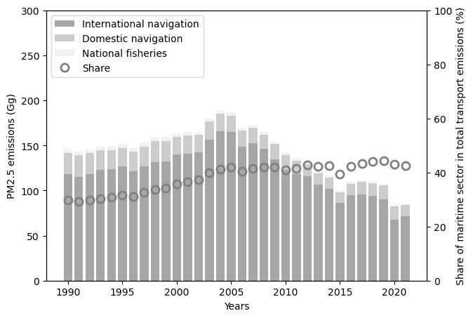
Figure 2.14 PM_{2.5} emissions from the maritime sector (Gg) and their share in total transport emissions (%) between 1990 and 2021 in the EU-27.
Source: LRTAP.
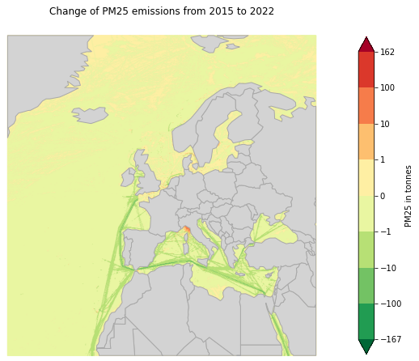
Map 2.6 Difference in PM_{2.5} emissions in European shipping areas between 2015 and 2022.
Source: STEAM, FMI.
The STEAM modelled data allows to visualise the uneven distribution of PM_{2.5} emissions in the different regions of Europe (see Map 2.6). In the period considered, the Mediterranean has the highest average yearly PM_{2.5} emissions, equal to 55 Gg/year, followed by the Atlantic with 29 Gg/year and the North Sea with 8 Gg/year.
In the 2015-2022 timeframe, PM_{2.5} emissions have decreased respectively by 56%, 53%, and 34%, in the Black Sea, Mediterranean Sea and Atlantic regions while they have increased by 29% and 6% in the North Sea and Baltic Sea, this can be aligned with the implementation of the SECAs that will directly have an effect on other pollutants and even outside those areas. In the same timeframe and for the same regions, the variation in the distance travelled was respectively 7%, 20%, 208%, 23%, and 13%. In the Arctic region, PM_{2.5} emissions have increased by 136%, linked to the significant rise in the distance travelled in the area, equal to five times.
In the period considered, the Mediterranean has the highest average yearly PM_{2.5} emissions, equal to 55 Gg/year, followed by the Atlantic with 29 Gg/year and the North Sea with 8 Gg/year.
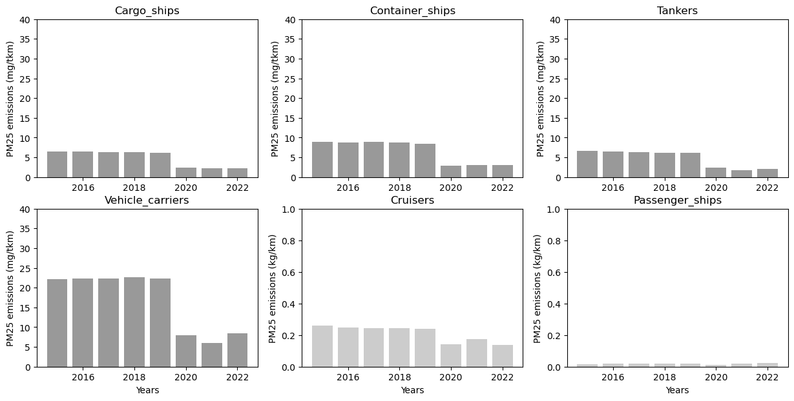
Figure 2.15 PM_{2.5} specific emissions from selected freight and passenger ship types in (mg/tkm) or (kg/km) respectively, between 2015 and 2022 in the EU.
Source: STEAM, FMI.
Over the time period considered, tankers, cargo ships and container ships had the lowest yearly emission with 5 mg/tkm, 5 mg/tkm, 7 mg/tkm. By comparison, vehicle carriers emitted up to 17 mg/tkm (Figure 2.15).
PM_{2.5} specific emissions have been declining for all these ship types during the period considered. In particular, cargo decreased by 65%, containers by 66%, tankers by 69% and vehicle carriers by 62%. This is related to a combination of factors, including the increased average payload transported and, especially the introduction of new policies such as the IMO Global Sulphur cap that has an indirect effect on the PM formation. For reference, in the same region and timeframe, the payload carried increased respectively by 39%, 22%, 44% and 8%. Nevertheless, the emission of PM_{2.5} saw an absolute decrease of 52%, 59%, 55% and 59% respectively, showing the important role of cleaner fuels and aftertreatment technologies.
Specific emissions of cruisers in Europe have been decreasing by 48% during the period considered, with an increase in the distance travelled of 21% in absolute terms the emissions decreased by 37%. The situation is different for passenger ships for which emissions have increased by 45% and a small increase on the distance travelled of 3% and in absolute terms the emissions increased by 49%.
However, passenger ships have considerably lower specific emissions compared to cruisers. Indeed, between 2015 and 2022, cruiser ships emitted on average 0.212 kg/km per year. This is approximately 11 times more than what is emitted on average per year by conventional passenger ships in the same region and period, i.e. 0.018 kg/km.
Finally, the average emissions per ship of fishing vessels decreased by 35% from 2015. On average in 2020, a fishing vessel was emitting approximately 174 kg of PM_{2.5} per year. It is noted that the fishing fleet has only slightly decreased over the same period, i.e. 7%, while absolute PM_{2.5} emissions decreased by 39%.
Black Carbon (Elemental Carbon)
It is estimated that black carbon (BC) emissions were responsible for 6.85 % of the global warming contribution from shipping in 2018, the second most significant contribution for voyage-based international emissions after CO₂ (IMO, 2020a). The contribution of the maritime sector to overall BC emissions in the EU-27 transport sector have steadily increased over time, reaching approximately 21% in 2021, with BC emissions from the sector reaching 12 Gg (Figure 2.16). In 2021, fisheries and domestic navigation constituted approximately 5% and 26% of the total maritime emissions. From 2019 to 2020 the overall emissions from the sector decreased by 19%, in line with the reduction of activity caused by the COVID-19 pandemic.
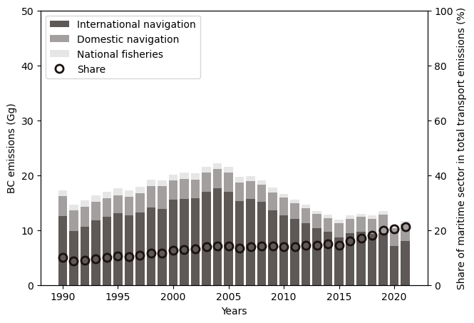
Figure 2.16 Black Carbon emissions from the maritime sector (Gg) and their share in total transport emissions (%) between 1990 and 2021 in the EU-27.
Source: LRTAP.
In the period considered, the Mediterranean Sea had the higher average yearly BC emissions, equal to 1.65 Gg/year, followed by the Atlantic with 0.75 Gg/year and the North Sea, 0.46 Gg/year.
Data obtained from the STEAM model show that in the 2015-2022 timeframe, BC emissions have increased respectively by 11%, 15% and 30% in the Atlantic, Baltic Sea and North Sea respectively, while they have decreased by 38% and 47% in the Mediterranean Sea and Black Sea. In the same timeframe and for the same regions, the variation in the distance travelled was respectively 208% in the Atlantic, 13% in the Baltic Sea, 23% in the North Sea, 20% in the Mediterranean Sea, and 7% in the Black Sea.
The major impacts of BC emissions are related with its presence and deposition in the Arctic region. The deposition in the Arctic snow and ice sheets, darkens the ice and reduces the surface albedo, thus increasing heat absorption and melting. In 2022 the BC emissions in the Arctic amounted to 0.017 Gg, constituting an increase of 206% in the considered timeframe. Peak emissions were reached in 2019 with 0.041 Gg (see Figure 2.17).

Figure 2.17 Black carbon emissions for the Arctic Ocean, 2015-2022.
Source: STEAM, FMI.

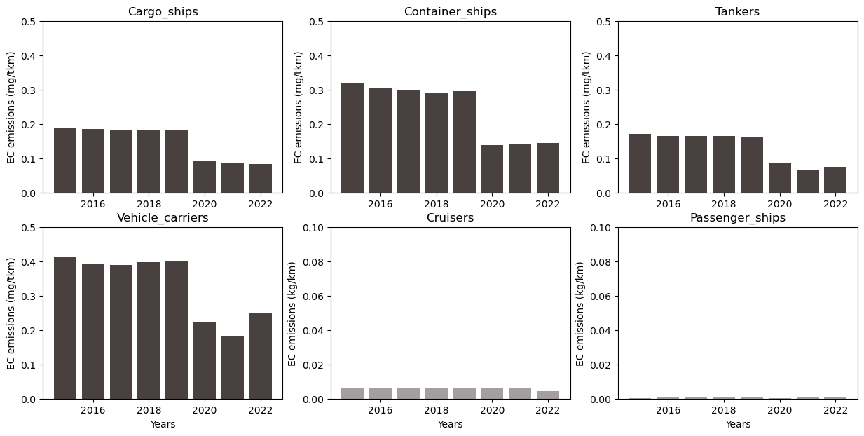
Figure 2.18 BC specific emissions from selected freight and passenger ship types in (mg/tkm) or (kg/km) respectively, between 2015 and 2022 in the EU.
Source: STEAM, FMI.
Over the time period considered, tankers, cargo ships and container ships had the lowest yearly emission with 0.131 mg/tkm, 0.147 mg/tkm, 0.241 mg/tkm. By comparison, vehicle carriers emitted up to 0.331 mg/tkm (see Figure 2.18).
BC specific emissions have been declining for all these ship types during the period considered. In particular, they decreased by 55% for cargo and containers, 56% for tankers and 40% for vehicle carrier vessels. This is related to a combination of factors, including the increased average payload transported as well as possibly the introduction of new policies such as Global Sulphur Cap. For reference, in the same region and timeframe, the payload carried increased respectively by 39%, 22%, 44% and 8%.
Specific emissions of cruisers in Europe have been decreasing by 32% during the period considered, with an increase in the distance travelled of 21% and a decrease of absolute emissions of 19%. The situation is different for passenger ships for which emissions have increased by 32% with a relatively modest increase of 3% in the distance travelled, in absolute emissions, passenger ships black carbon emissions increased by 36.
Finally, the average emissions per ship of fishing vessels decreased by 37% from 2015. It is noted that the fishing fleet has slightly decreased its emissions over the same period by 7%, while the absolute BC emissions have decreased by 41%.
It has been estimated that low sulphur fuels would reduce the emission of black carbon in 30-80% when compared with conventional high sulphur fuels (Lack & Corbett, 2012), although sulphur in fuels contributes to the creation of particulate matter, studies has shown that reducing sulphur content may not necessarily always reduce black carbon emissions. Low sulphur fuel blends, while reducing sulphur oxides emissions, may actually produce more black carbon (ICCT, 2019). Some new fuel blends designed to meet IMO’s 2020 0.50% sulphur regulation have higher aromatic contents, which result in higher black carbon emissions when burned than low-aromatic distillate fuels such as marine gas oil. A Finland-Germany joint study confirmed a correlation between higher aromatics and higher black carbon emissions (IMO, 2019b ).
Ozone depleting substances and fluorinated greenhouse gases (ODS and F-gases)
In the maritime sector, emissions of ozone depleting substances (ODS) and fluorinated gases (F-gases) into the atmosphere can occur due to the use of refrigeration and air-conditioning systems onboard vessels. These are estimated to amount to approximately 18.2 million tons of CO_{2e}, i.e. ca. 15% of the total EU F-gas emissions (based on EU NIR UNFCCC F-gas emissions for the same year) (IMO, 2020a). F-gases often show high global warming potentials which are up to several thousand times higher than the climate impact of CO₂.
These emissions can result from high annual leakage of the cooling systems deployed. Research from the United Nations Environment Programme (UNEP, 2011) and the European Commission (Birchby et al., 2022; Schwarz & Rhiemeier, 2007) indicates that cooling systems on ships typically show an average leakage rate of 40%, which is several times higher than leak rates of stationary systems. Ships exhibit specifically high emission rates due to many factors including: long piping systems, constant exposure to sea wave vibrations, motion, and insufficient crew expertise in refrigeration technologies so that leakage repair might not take place as needed. Limited onboard expertise poses challenges that are characteristic for the maritime sector, especially in case of maintenance and repair needs during extended voyages (UNEP, 2022). Technical data on the actual leakage rates of refrigeration and air conditioning systems on ships is usually not available.
In 2024, the EU adopted new F-gas and ODS Regulations to further address the impact of these substances on global warming. Emission reductions are crucial and need to consider all applications but especially refrigeration and air conditioning, including international maritime shipping. Due to the maritime sector’s relevance concerning emissions from cooling coupled with the considerable sector growth, transitioning to environment friendly alternatives needs to be fostered across different types of ships (IMO, 2020a). The technology used for refrigeration is heterogenous across the fleet, reflecting the diverse needs of different ship types. For example, passenger cruise ships can use 7,000-8,000 kg of refrigerant for the storage and provision of food, fishing vessels up to 1,500 kg to preserve fish catch, refrigerated containers (reefers) up to 6 kg of a mixture of refrigerants (per container) to prevent spoilage of the load and in general cargo ships, up to 150 kg mainly for air conditioning purposes.
The wide variety of types of refrigerants used in the systems mentioned above have diverse environmental performances and climate impacts (IMO, 2020a), making the impact of each of these emissions complex to estimate.
Observations from Remote Piloted Aircraft Systems
SOx Observations from Remote Piloted Aircraft Systems
During the EMSA 2021 Remote Piloted Aircraft Systems (RPAS) emission monitoring campaigns, 624 exhaust gas plume observations were acquired in the North Sea, Baltic Sea, and Central Atlantic. In 2022, the total number of observed ship plumes rose to 901, with campaigns extended to the Western Mediterranean Sea. Figure 2.19 provides histograms representing the distribution of the fuel sulphur content values (percentage) derived from the RPAS observations collected during 2021 and 2022 in Sulphur Emission Control Areas (SECA) and port areas where the emission limit is 0.10%. Figure 2.20 provides instead the values for the RPAS observations collected during the same period outside SECA and port areas where the limit is defined by the Global Sulphur Cap (0.50%).
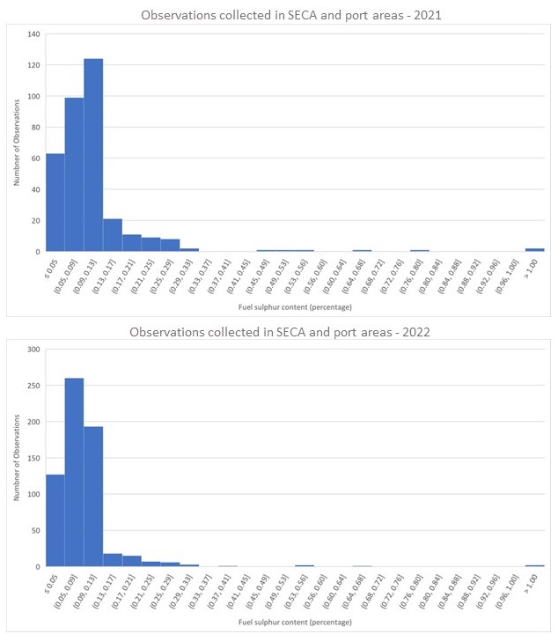
Figure 2.19 Distribution of sulphur emissions obtained through RPAS aerial measurements acquired in SECA and port areas during 2021 (above) and 2022 (below).
Source: EMSA, RPAS.

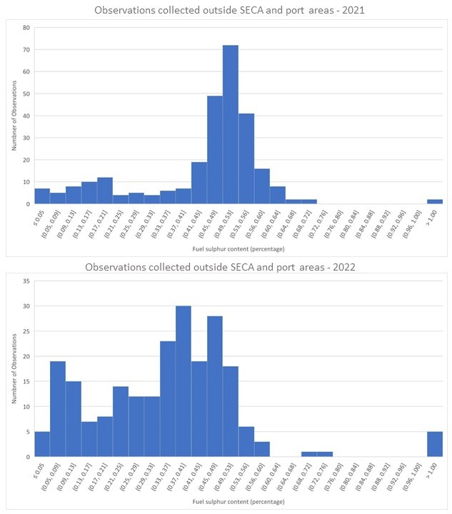
Figure 2.20 Distribution of sulphur emissions obtained through RPAS aerial measurements acquired outside SECA and port areas during 2021 (above) and 2022 (below).
Source: EMSA, RPAS.
In general terms, in both 2021 and 2022 the distribution of the measurements shows concentrations around the limit of the respective areas (0.10% and 0.50%), although in non-SECA areas there is a more even distribution towards the lower values. This might be due to possible mixture with low-sulphur fuels available in the tanks of the vessels. This is even more evident in 2022 compared to 2021.
In areas where the sulphur emission limit is 0.10%, the average fuel Sulphur content (FSC) derived from RPAS aerial observations was 0.11% FSC in 2021 and 0.09% FSC in 2022. In areas where the limit is 0.50%, the average FSC derived from RPAS aerial observations was 0.43% FSC in 2021 and 0.36% FSC in 2022.
From an air quality perspective, it is evident that the establishment of a SECA, has an impact on the overall SOx emissions from vessels. Therefore, one could assume that reducing the emission limits from 0.50% to 0.10% FSC in the Mediterranean Sea in 2025 can be a major step forward to reduce SOx emissions from shipping in the region, and hence improve air quality. Similarly, the establishment of new ECAs in the EU waters, for example in the North-East Atlantic, may also have a positive effect in terms of air quality.
In areas where the sulphur emissions limit is 0.10% FSC, the percentage of observations above the threshold, accounting for measurement uncertainty, was 17% in 2021 and 11% in 2022. Conversely, in areas with a 0.50% FSC limit, the percentage of observations exceeding the threshold, including uncertainty, was 8% in 2021 and less than 4% in 2022. Surveillance and inspections in areas with more stringent limits (e.g., 0.10% FSC) are crucial to ensure vessels adhere to regulations. This is also due to the higher costs for the ships’ operators to comply with the limits in those zones and the increased likelihood of infringements. The combination of port inspections, where infringements can be fully confirmed via accurate lab tests of fuel samples, and the use of remote sensing emission monitoring technologies that can be conducted in both coastal and open ocean to target ships which are potentially violating, paves the way to a powerful tool that can be used to enforce regulations.
The RPAS gas observations include geographic coordinates marking where each measurement was taken. This data was analysed to identify spatial trends and patterns within the available fuel sulphur datasets. Interestingly, it is possible to observe that the percentage of values exceeding permissible limits (accounting for measurement uncertainty) within a 500 km radius of the SECA border was 12% in 2021 and 11% in 2022. In contrast, the percentage of measurements surpassing limits (including instrumental uncertainty) collected beyond 500 km from the SECA border was under 5% for both years. Considering that most of the monitored vessels was entering to SECA, this discrepancy suggests that vessels might be delaying their switchover to low sulphur fuel. It is anyway not possible to say if a similar behaviour may happen when the vessels area leaving the SECA. Large vessels typically have multiple tanks storing fuels with varying sulphur content. When the switch from high sulphur fuel to SECA-compliant low sulphur fuel is made, remnants of the non-compliant fuel could remain in the pipelines, resulting in elevated emissions for several hours. Thus, if vessels switch fuels too late upon entering the SECA, they could emit more sulphur than permitted until the fuel transition is complete. To gain a clearer understanding of this behaviour, more comprehensive studies and targeted monitoring campaigns are needed.
The geographical location of the measurements can also be utilized to plot FSC values against the distance from the shore, as illustrated in Figure 2.21, where observations in SECA or port areas are denoted as blue marks, observations outside SECA or port areas in orange, observations of vessels not fitted with a scrubber are denoted by a cross and observations of vessels with a scrubber with a circle. Given that numerous maritime shipping routes are in close proximity to the shore, vessel emissions can significantly affect air quality even on land. As previously noted, this is especially pertinent in areas where emission limits are higher, such as regions where the Global Sulphur Cap is enforced (i.e. areas outside SECA and ports in orange). The datasets were gathered along shipping routes and within port areas, meaning this data distribution might not provide an accurate depiction of whether there is a correlation between sulphur values and the distance to the port of call. Therefore, further targeted data collection is required in this regard.
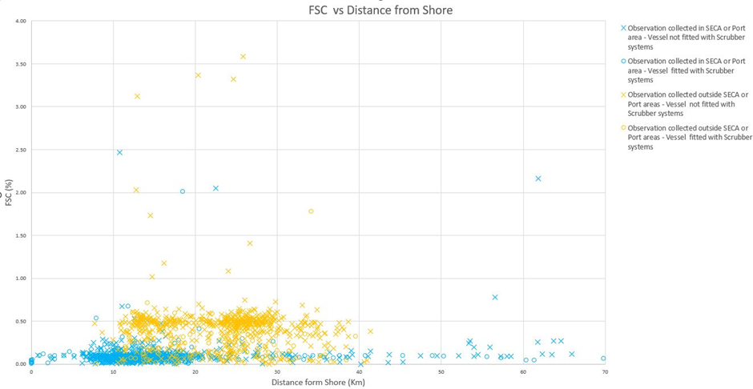
Figure 2.21 Distribution of FSC values obtained in RPAS deployments vs distance to shore for different areas (in/out SECA or port areas) and vessels (with/without scrubber) in 2021-2022.
Source: EMSA, RPAS.
Between 2021 and 2022, 317 vessels equipped with exhaust gas cleaning systems (EGCS) were evaluated during RPAS deployments. The FSC was derived from these measurements (represented as circle marks in Figure 2.21). Of these vessels, 26 (accounting for 8.2% of the observations) had FSC exceeding the permissible limits considering uncertainty, with some displaying exceptionally high values (greater than 1% FSC). Five of these vessels with excessive FSC were detected in non-SECA areas, while the rest (21 vessels) were found in SECA and Port Areas, thus a respective percentage of exceedances of 5.1% and 9.6%. In these instances, it is possible that the scrubbing system might be malfunctioning, or it might have been intentionally switched off. It is crucial, therefore, to conduct careful monitoring and control of vessels fitted with EGCS.
NOx Observations from Remote Piloted Aircraft Systems
NOx regulation and its enforcement is more complex compared to SOx. As mentioned above, limit values are tiered depending on keel laying date and are defined by the rated engine speed. Moreover, the limits in place represent an average of four different engine loads with different weighting factors (E3 cycle: 100% load with weighting factor 0.2; 75% load with weighting factor 0.5; 50% load with weighting factor 0.15; and 25% load with weighting factor 0.15). However, the regulation follows an approach based on certification and it lacks practical possibilities for enforcement and control of real-world emissions. Nevertheless, considering the environmental and health impacts of NOx, regulatory authorities are devising strategies to ensure vessels comply with the limits. As highlighted at the beginning of this section, the gas sensors equipped on EMSA RPAS have the potential of measuring NOx level as well. However, due to the complexity of determining exactly the engine load at the time of the measurement, as well as the specific fuel consumption to convert the measured NOx-CO₂ ratio to an emission factor in g/kWh, these measurements are currently not considered mature to be used for compliance monitoring. Notwithstanding, within the activities of the EU HORIZON 2020 financed SCIPPER project (SCIPPER, 2022), recordings of NOx emissions from vessels were remotely collected and analysed. The data originated from different measurement locations in the Baltic Sea and North Sea within 2022. The analysis shows that 50% of the emission measurements of ships that had to comply with the latest Tier III NOx levels, far exceed the expected emission levels (SCIPPER, 2023).

In addition to observations from Remote Piloted Aircraft Systems, it is important to highlight that a suite of other platforms are also used to provide very relevant and insightful SOx and NOx measurements. For example, Belgium is very active in the use of airborne monitoring techniques (more specifically through the use of sniffer sensors onboard Belgian coastguard aircrafts) to monitor air quality in the North Sea Emission Control Area (Van Roy, et al., 2022; Van Roy et al., 2023a; 2023b;).
Further to this, some Member States also operate fixed sensing stations. For example, Sweden operates two sensing stations for the control of sulphur oxide emissions by vessels in Swedish waters and ports, one station located on the Öresund bridge and the other is located on an island close to the entrance to the port of Gothenburg.
These stations carry out automatic measurements and calculate fuel sulphur content from SO₂/CO₂ observations and NOx emissions per kWh from NOx/CO₂ observations and send the data to a database, that communicates with different instruments and identifies the ship. When the measurements show a fuel sulphur content out of limits (0.10% sulphur content in this case), the database sends an alarm with the sulphur content measurement and ship information to relevant recipient users by e-mail. As an average these stations take between 1,600 and 1,900 valid measurements per year, and in 2021 and 2022 no alerts on not compliant vessels were reported from these stations.

Water Pollution

Oil spills
In 2022, EMSA’s CleanSeaNet service detected a total of 4,911 possible oil spills. The CleanSeaNet service uses a two-level classification system, namely Class A and Class B, to indicate the likelihood that a feature detected in a satellite image is a spill. Class A suggests that the detected spill has a higher (more than 50%) detection confidence level, implying that it is more likely to be an oil spill. Conversely, a Class B classification indicates a lower (less than 50%) detection confidence level, suggesting that it is less likely to be an oil spill. This two-level classification system helps Member States prioritise their response efforts accordingly.
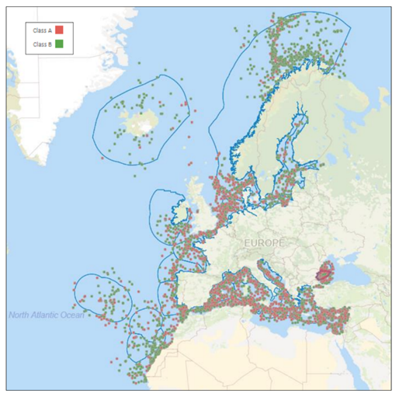
Map 2.7 Class A (52%) and Class B (48%) oil spill detections in 2022 (except French Outermost Regions).
Source: EMSA, CleanSeaNet.
Map 2.7 shows that there are more potential oil spills in the North Sea and Mediterranean Sea compared to other areas. Both regions experience high traffic, with a significant number of ships passing through daily, increasing the likelihood of illegal discharges and accidents. Furthermore, the North Sea is one of the world’s largest offshore oil and gas production regions, with numerous platforms and drilling rigs operating in the area. Accidental and operational spills associated with offshore oil and gas production could additionally contribute to the large number of potential pollution alerts. The Mediterranean Sea is a highly industrialised region, with numerous ports, refineries, and petrochemical plants located along its coastlines. Industrial activities elevate the risk of pollution incidents. For example, studies have shown how around 35% of oil that enters the sea comes from regular shipping operations, and around 45% of oil is input from land-based sources with municipal/industrial effluents and from routine oil rig operations, 10% from accidents of oil tankers, 5% natural sources, 5% undefined sources (World Ocean Review, 2014).
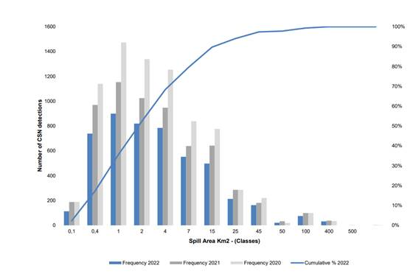
Figure 2.22 Histogram of CSN Oil spill detections according to areas classes (km2) 2020-2022.
Source: EMSA, CleanSeaNet (2023).
Overall, the number of detected potential pollution incidents has been reducing over time (see Figure 2.22). In 2022 52% of the CleanSeaNet detected potential pollution incidents were lower than 2 km² and 80% were lower than 7 km². While there is no apparent trend in the size of detected potential pollution incidents, it is possible to infer that large (hereby defined as >50km²) potential pollution incidents represent on average approximately 10% of all detected potential pollution incidents.
By analysing the CleanSeaNet data, it is possible to identify a decreasing trend in the number of possible pollution incidents detected per million km² between 2008 and 2015 (see Figure 2.23), with greater decrease between 2008 and 2010. This coincided the increased awareness of maritime pollution prevention and improvements in the provision of port reception facilities across the EU (UNCTAD, 2011). In 2022, the average number of pollution incidents detected by CleanSeaNet per million km² was 4.01, compared to 4.57 in 2021, demonstrating a 12% decrease and confirming this descending trend, as shown in Figure 2.23. The same figure also shows that from 2016 to 2018, there was a gradual growth in the number of alerts provided to national authorities, this is primarily due to the increased availability of satellite data that could detect smaller potential pollution incidents.

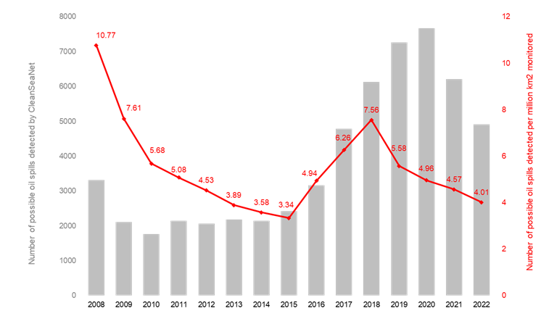
Figure 2.23 Trend in annual number of possible spills detected by CleanSeaNet and average number of possible spills per million km².
Source: EMSA, CSN.
When a possible spill is detected by CleanSeaNet, an alert is sent to the Member State and the responsible authorities can perform follow-up activities (i.e. feedback) that may include on-the-spot verification by patrol vessels, aerial surveillance, and other forms of follow-up. Figure 2.24 shows that in 2022 potential pollution incidents larger than 4 km² were verified more often on-the-spot (approximately 53%) whereas smaller potential pollution incidents (those ranging from 0.1 to 2 km²) received less attention (around 37%). This indicates that Member States tend to prioritize on-site verification of spills larger than 4 km².
In 2022, the total number of possible pollution incidents verified on-site was 1,351. Out of those, 5% were confirmed as "mineral oil", 22% as "other substance", 15% as "unknown feature", and 3% were "natural phenomena".

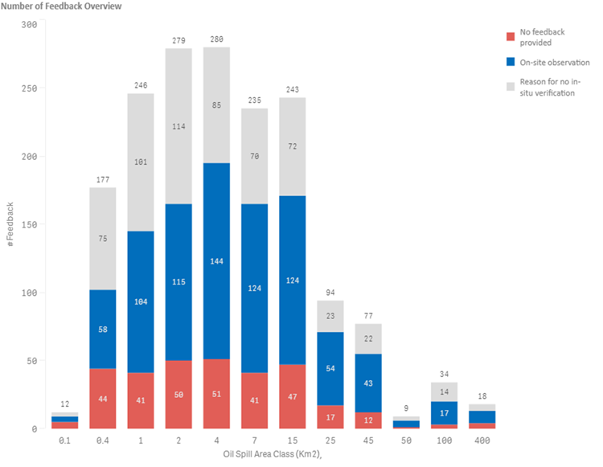
Figure 2.24 CleanSeaNet detections Class A - feedback to alerts and distribution per size of potential pollution incident in 2022 (absolute figures).
Source: EMSA, CSN (Data extracted on 29 May 2023).
Statistical data on oil tanker spills made available by the International Tanker Owners Pollution Federation (ITOPF) shows that in 2023 the percentage of spills from oil tankers in the EU was 12% (out of the total that took place worldwide), compared to 13% in 2019. More specifically, this decline is more noticeable for the large spills which have decreased to 13% in 2023, compared to 17% in 2019 (ITOPF, 2024).
Table 2.2 Number and percentage of oil spills from tankers inside and outside the EU by spill size, 2010-2023.
Source: ITOPF (2024).
Despite the steady decrease in potential pollution incidents detected by CleanSeaNet in Europe and the increased surveillance and enforcement efforts, illegal discharges of oil and other polluting substances persist in European waters. From the limited data available, the legal follow-up and penalties remain relatively low, despite the dissuasive effect of the CleanSeaNet service and other surveillance systems in place (EC, 2023e).

Discharge waters and contaminants
The analysis of the discharge waters data from the STEAM model reveals that from 2014 to 2022 their overall volume has constantly increased, while the composition of discharge waters remained the same (Figure 2.25).

Figure 2.25 Total discharge waters 2014 to 2022 (left with ECGS open loop discharges and right without).
Source: FMI, STEAM.
In the same time period for both passenger ships and fishing vessels, the major type of discharge water is grey water, and not Exhaust Gas Cleaning System (EGCS) discharges. Passenger ships (excluding cruisers) contribute on average only to 1% of the total discharges (with the majority stemming from grey waters: > 76%), while fishing vessel EGCS discharges contribute on average around 20% (while grey waters average 40%).

Figure 2.26 Water discharges composition in European waters in 2022 (left), and a close-up for the composition of discharges excluding open loop scrubbers (right).
Source: FMI, STEAM (2022).
When looking at data from 2022, and if open loop EGCS scrubbers are excluded from this analysis, more than 75% of discharge waters from all ship types originate from grey waters (see Figure 2.26). The STEAM model analysis underscores that cruise ships exhibit the highest volume of grey water among the various ship types. In 2022, cruise ships discharged a total of 20 kilolitres of grey water (equivalent to an average of 38.2 million litres per ship/year), marking a doubling since 2014. When analysing the freight sector, tankers discharged a total volume of 1.92 kilolitres in 2022 (equivalent to an average of 0.20 million litres per ship/year), reflecting a 29% increase since 2014.
The use of EGCS as an abatement technology rose in the past years as a technological advance in maritime sector, especially after the implementation of limits to the amount of sulphur in marine fuels. As shown above, the discharges of open loop scrubbers’ in European waters represent 98% of the total maritime water discharges, and therefore a more in-depth analysis is hereby provided. The IMO 2020 Global Sulphur Cap and the introduction of Sulphur ECAs, as well as the implementation of the Sulphur Directive have been successful in reducing SOx emissions to the atmosphere. However, as described by a comprehensive set of studies, the risk of transposing pollution from air to water, for example through the possible discharge of EGCS in water may directly impact marine life, causing immediate mortality of zooplankton due to the variety of pollutants discharged (Hassellöv et al., 2020; OSPAR, 2022). Other impacts to the marine environment include biogeochemical impacts such as bioaccumulation, acidification and eutrophication.
Regarding the market share of EGCS technologies, EMSA’s database reports a total of 5,613 ships currently equipped with scrubbers (data extracted on 17/01/2024). This number is higher compared to the total EGCS installations considered in the STEAM model, where a total of 4,593 ships are reported to have scrubbers installed in 2022. Data extracted from EMSA’s database notably shows that 75% of the scrubbers are open loop systems, 14% hybrid systems, and 1% closed loop systems. These numbers are similar with the information reported by the ImpEx study in 2022, through the IMO GISIS database, which reported a total of 3,729 ships, 86% of the registered ships with scrubbers were open loop, 13% hybrid, and 1% closed loop (Marin-Enriquez et al., 2023). According to EMSA’s database, the installation of scrubbers is predominant in bulk carriers (around 35%), oil/chemical tankers (28%) and containerships (22%), which is aligned with the IMO GISIS data.
When analysing the STEAM data on discharge waters from EGCS in the EU waters, a clear increase in open loop discharges can be noted from 2020 (Figure 2.27) and for closed loop scrubbers a clear increase is only noticed after 2021. The increase of the discharges from open-loop scrubbers is observed in all ship types and can be attributed to the IMO Global Sulphur Cap that entered into force in 2020, which resulted in the need for shipowners to equip their ships with emission abatement technologies such as EGCS. Data from passenger ships (excluding cruiser ships) is not shown in the graphic per ship types due to inconsistencies in the data for some years.
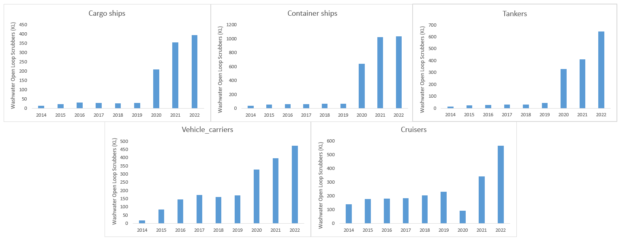
Figure 2.27 Wash water discharges from Open Loop scrubbers per ship type in EU waters.
Source: FMI, STEAM.
When analysing the data at regional level (Figure 2.28), two different patterns can be observed: 1) A stable trend for the existing SECA areas (i.e. North Sea and Baltic Sea), where ships were already either using low-sulphur fuel or equipped with EGCSs; 2) An increasing trend for those areas who had to comply to the measures of the IMO Global Sulphur Cap and the EU Sulphur Directive (i.e. Atlantic Ocean, Black Sea and the Mediterranean), where vessels had to systematically adapt to comply with the requirements of sulphur emissions by installing scrubbers (or utilising low-sulphur fuel).

Figure 2.28 Wash water discharges from Open Loop scrubbers per region in EU waters.
Source: STEAM, FMI.
Exhaust Gas Cleaning Systems’ residues
Wash waters discharges are allowed to be released outside areas with a specific ban. On the other hand, both wash waters in areas where bans are in force and discharge residues from the scrubbing process should be kept onboard to be delivered in port reception facilities. Within this context, the majority of the water resulting from close-loop scrubbers (except the bleed-off) is kept in a sludge tank and later disposed in port reception facilities (IMO, 2022b).
The Port Reception Facility (PRF) Directive includes the reception of EGCS residues as part of the MARPOL Annex VI - Air Pollution. Preliminary analysis from the PRF data shows that in 2022, a total volume of 1,405 m³ was delivered to ports in Europe, representing a 0.87% share of total volumes reported to PRF.
Addressing the negative impacts of the discharge waters from Exhaust Gas Cleaning Systems
To avoid the shift of pollution from air to the marine environment by the use of EGCS, one solution would be to phase-out HFO and to switch to compliant fuels. This solution would not only avoid the abovementioned pollution shift but would also avoid the risk of HFO spills which can result in severe environmental and economic consequences. In the case of spills of compliant low-sulphur blends (hybrid fuels), there is a risk of not being compatible with the available oil spill clean-up equipment even if the fuel physical properties are defined under ISO 8217 standard (Jönander & Dahllöf, 2020).This supports the preference of cleaner compliant marine fuels (e.g. marine gasoil, LNG, methanol and biofuels) that are reported to not have the same toxic molecules as residual fuels (Hassellöv et al., 2020; Hermansson et al., 2021). Shifting to cleaner and more sustainable fuels will not only discourage the use of such systems, but also facilitate the adoption of more advanced aftertreatments systems for pollutants such as selective catalytic reduction (SCR) for NOx reduction.
Another solution is to restrict the discharge of scrubber water. In the case of open-loop systems, switching to compliant fuels is required to comply with this measure. In the case of hybrid and closed systems, operation in zero-discharge mode is possible. The latter would result in the need of adequate PRF, increase of energy use on board, and higher costs of operation of scrubbers (for instance due to higher consumption of chemicals and disposal fees).

Ballast waters and non-indigenous species (NIS)
Ballast water and biofouling are the main vectors for introduction of harmful aquatic organisms in the European seas. The problem with ballast water is that the majority of organisms have a free-swimming phase in their reproductive cycle, or in the case of phytoplankton, zooplankton, bacteria and viruses can be found permanently in the water column. These organisms can be taken up in the ballast water and moved around the world, and when the ballast is discharged, they can create non-indigenous communities in the new environment. If these communities become detrimental to the local ecosystem, then they can be considered as Invasive Alien Species (IAS). Examples of this are invasions of Mnemiopsis leidyi, the North American Comb Jelly in the Black and Caspian Seas, Dreissena polymorpha, the zebra mussel in the Great Lakes and Undaria pinnatifida, the Asian Kelp in Australia and New Zealand. With respect to biofouling, organisms with a sedentary part of their lifestyle can settle on the hull of ships and be carried round the world. In these cases, if there is a significant population on the hull then they will release free-swimming larvae in new habitats where they can colonise.
The share of NIS introduced by shipping is 60% of all the NIS in marine environment and 56% in case of NIS which have become invasive in Europe (i.e. spread aggressively and cause adverse effects; EEA, 2023b). NIS introductions from maritime transport have increased for decades despite international efforts. Ballast water is controlled through the IMO’s International Ballast Water Management Convention and biofouling by IMO Guidelines that can be found in Resolution MEPC.378(80).
The introduction of NIS through biofouling and ballast water has gradually increased over the past decades, with higher numbers of NIS introduced over the last six-year cycles (Figure 2.29, left). However, the introduction of invasive IAS increases until the early 2000’s and is followed by a significant decrease in the last 6-year periods (Figure 2.29, right; the last period consists of only 3 years (2018-2020)). It should be noted that not all NIS cause damage to the ecosystems they become established in, or become IAS, although the same NIS species can be invasive in one area and effect the local ecosystem, whilst in others their presence is not detrimental. There is also a slight shift in shares between biofouling and ballast water pathways for IAS (Figure 2.29, right), where in last six-year periods, the majority of IAS were introduced by ballast water, in contrast to the first decades. This is also different to all NIS, where this shift is not apparent (Figure 2.29, left).
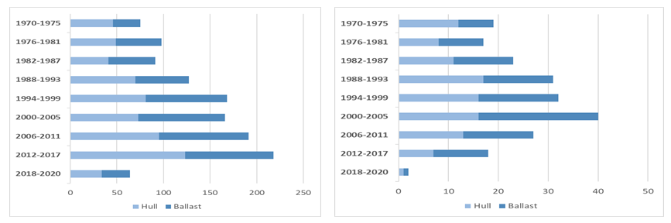
Figure 2.29 Number of non-indigenous species (left) and invasive alien species (right) introduced by biofouling and ballast water, by six-year periods.
Source: Teixeira et al. 2019 ETC technical report; EEA MAR002 Indicator (EEA, 2023).

The two subregions with the highest numbers of NIS and IAS in the European seas are Bay of Biscay and Western Mediterranean Sea. The share between introduction pathways moves towards biofouling in these two regions.
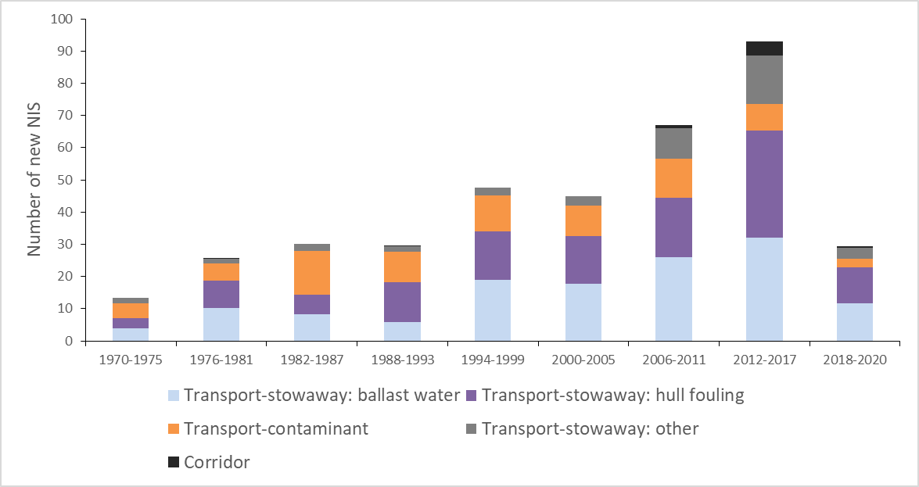
Figure 2.30 Number of new NIS introduced by maritime transport, by 6-year cycles.
Source: EEA, MAR002 indicator 2023.
The major vectors of introductions are the ships’ ballast water and ship hull- and niche areas (Figure 2.30). With the Ballast Water Management Convention coming into force in 2017, International Ballast Water Management Certificate is required for vessels of 400 GT (gross tonnage) and above and certifies that the vessel carries out ballast water management in accordance with the BWM Convention and specifies which standard (D-1 or D-2) the ship is complying with (IMO, 2017). Based on available data approximately 80,000 vessels worldwide need to carry this Certificate. However, the available and reliable data on Certificate status and related BWM standard is scarce, as the reporting is not mandatory. Available datasets thus rely on voluntary reporting and are not complete.
Out of 88,000 vessels (> 400 GT) from global fleet, approximately 25,000 vessels (31%) have reported an International Ballast Water Management Certificate (Figure 2.31). 18,676 (75%) of these vessels have installed a BWM system and are compliant with the D-2 BWM standard (23% of all vessels > 400 GT), while 6,263 (25%) vessels (8% of all vessels) either do not have BWM system installed, or do not use it, thus comply only with D-1 standard.
Based on this BWM Certificate analysis, it is assumed that around 15% of all vessels have not yet started using the soon-obligatory BWM system, while around 10% are yet to establish it. In conclusion, around 90% of vessels are ready to conform with the D-2 standard which threads a good way towards limiting the spread of non-indigenous species by ballast waters in European, as well as global, seas.
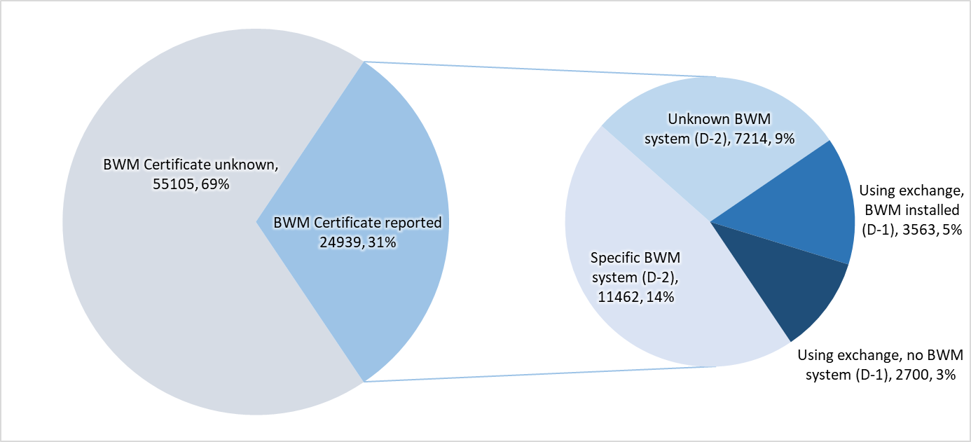
Figure 2.31 Reported Ballast Water Management (BWM) Certificates and BWM standard compliance of global vessel fleet (> 400 GT)
Source: EMSA, 2023.
Studies indicate that, under future climate conditions (e.g., increased water temperature and decreased salinity), non-indigenous species are in favourable position compared to native species (McKnight et al., 2021). Climate change may promote further expansion of NIS towards higher latitudes and increase the risk of introductions originating from warmer climate regions (Carlton, 2010). Climate change not only facilitates the introduction of NIS originating outside Europe but also NIS introduction from within Europe’s seas. Thus, for example, the warmer Black Sea allows for Mediterranean species to inhabit areas in the Black Sea, causing endemic species to relocate and retreat (Rotter et al., 2020).

Underwater radiated noise
While underwater radiated noise (URN) is a relatively new topic, substantial work has been performed in the last years on both the monitoring and estimation of the maritime transport sector contribution as well as its impacts on the environment (Cruz et al., 2021; IMO, 2023d; JRC, 2023; Thomsen et al., 2021; Sertleck et al., 2019). Both measurements and modelling of ship noise are important for effective mitigation, with the standardisation of terminology and procedures, as well as uncertainty quantification, being the focus of recent and ongoing work, both at EU (and regional) level (BLUES, 2021; PIAQUO, 2021; quietMED2, 2019; SATURN, 2020) and global level (IMO, 2023e).
A new element that can currently be provided are the results of an EMSA financed project called (NAVISON) which derives soundscape maps from a state-of-the-art URN continuous parametric noise source model which encompasses ship characteristics with ship traffic and an acoustic propagation model and aims to quantify the URN produced by ships in all of EU waters. By using the same approach for the entire EU sea basin, NAVISON permits for the first time like-with-like consistent comparison between regions over long-time scales.
Two parameters may be used to account for the level of URN in European sea: the sound pressure level (SPL) and the sound energy density (SED). SPL represent the spatially and temporally distributed/propagated sound sources (the noise). The SED provides a parameter which is independent of the spatial and temporal observation window, and hence may be used to compare URN between regions.
Map 2.8 shows the modelled sound pressure level for the European sea in 2022, at both 63 Hz and 125 Hz (SPL was calculated for each quarter and then integrated).
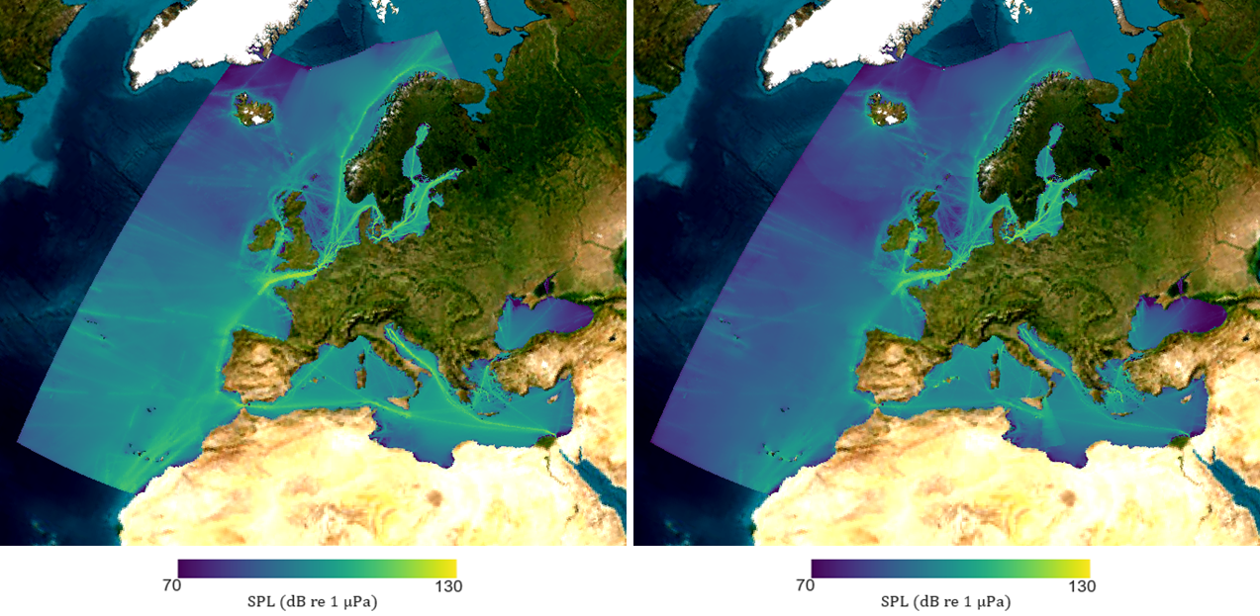
Map 2.8 Sound pressure level maps for different years for all ship types (at 63 Hz left and 125 Hz right).
Source: EMSA, NAVISON (2024).
To better understand the different regional components, together with their temporal trends, it is important to analyse the different regional sound energy densities (see Figure 2.32). When looking at the cumulative sound energy densities at European level one can observe an increase until 2019, ending abruptly in 2020 (COVID year), and thereafter slightly but steadily increasing in the modelled sound maps (note that the 2019 levels have still not been reached). The region with the highest sound energy density is the Baltic Sea, due to its shallow water and relatively high shipping density. There is, however, no specific signal (or trend) that may be highlighted, other than the drop registered for the COVID year of 2020. In the Baltic Sea the sound energy density is dominated by cargo vessels, followed by Ro-Ro and tankers at 63 Hz (Ro-Ro signal increases when looking at the 125 Hz frequency band). If one compares with the North Sea, one finds this same combination of shallow water and high shipping density in the south but not in the north. For this reason the average for the entire North Sea is lower because of the effect of the deeper water and hence lower energy density in the north. Here a slight increase in energy density can be observed. In the Mediterranean Sea, the sound energy density is dominated by tankers, which contribute more than the sum of the remaining ship types at 63 Hz. Interestingly, in the Mediterranean Sea the sound energy density at 125 Hz is a factor of one to two less than at 63 Hz.
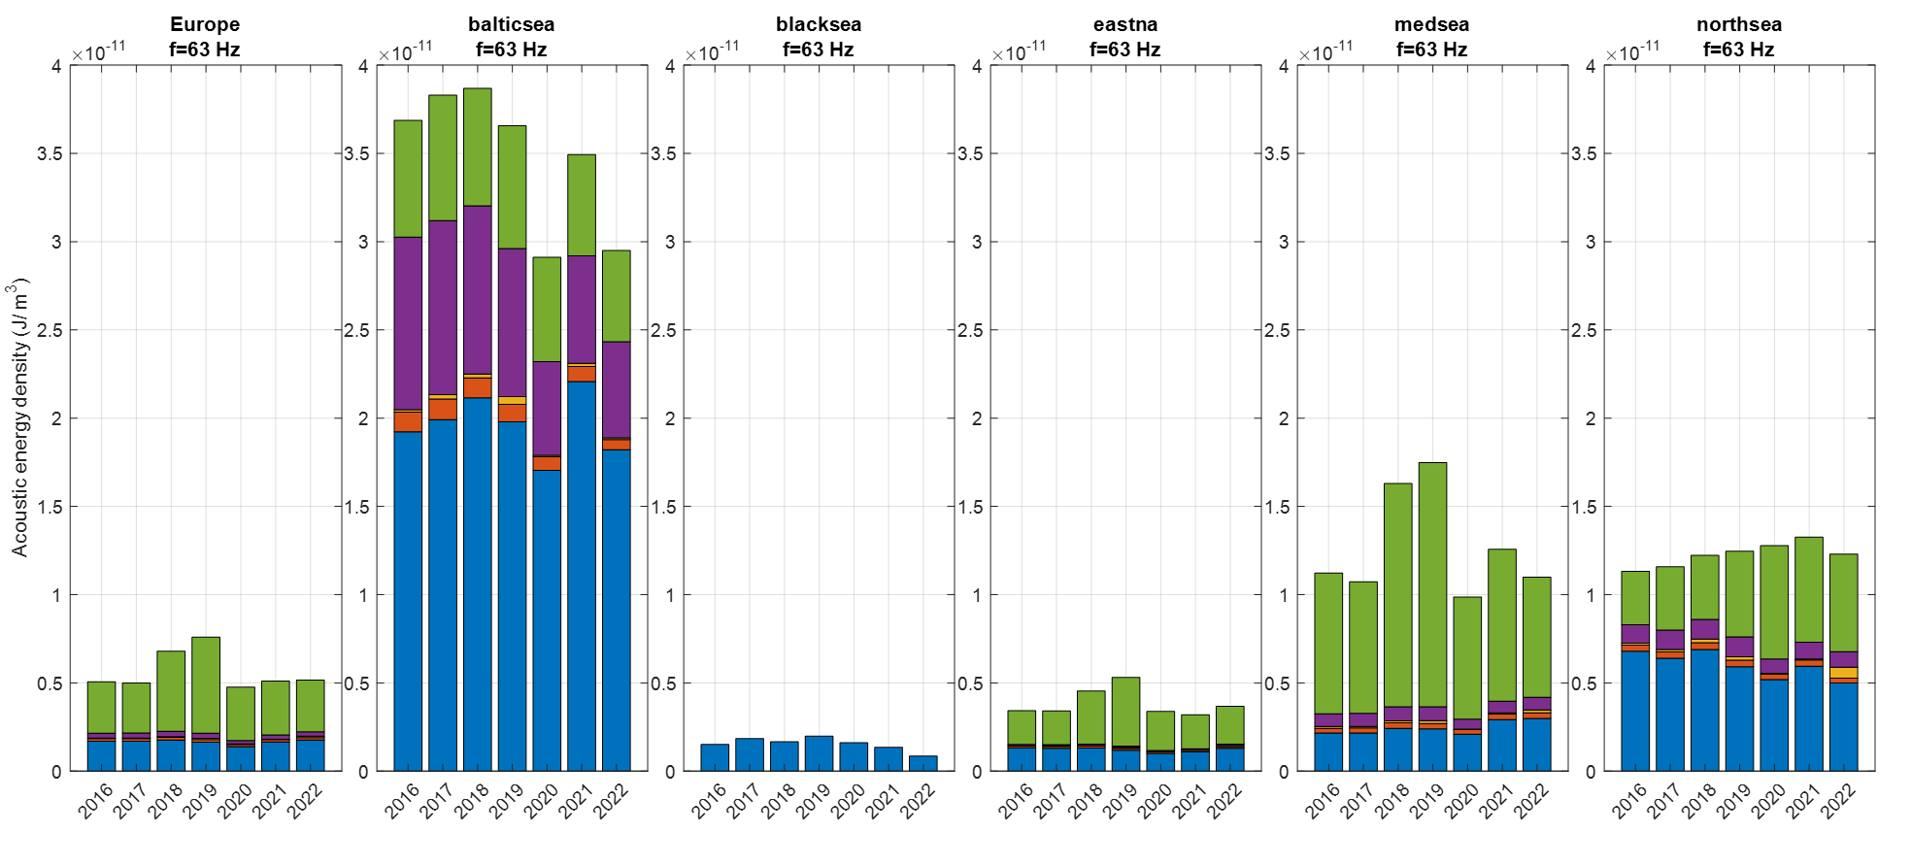
Figure 2.32 URN sound energy density at 63 Hz (Europe leftmost chart and regional seas) from 2016 to 2022.
Source: EMSA, NAVISON (2024).
When looking at the sound energy densities per ship type (see Figure 2.33) over the whole European seas, tankers and cargo ships have the highest contribution at 63 Hz. The modelled temporal trends are, once again, dominated by a steady increase until the COVID 2020 drop, and thereafter a smaller increase. Interestingly, the cargo ships contribution is low given to both the relatively small numbers and the lower frequency of sound generation. The Ro-ro signal, however, does contribute more significantly when looking at the sound energy densities at 125 Hz.
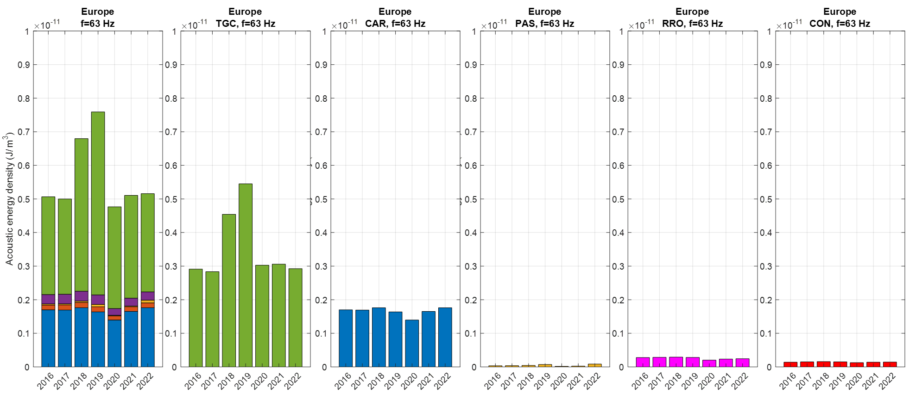
Figure 2.33 URN sound energy density at 63 Hz in Europe (total leftmost chart and by ship types) from 2016 to 2022.
Source: EMSA, NAVISON (2024).
Underwater radiated noise forecast
Further to the development of hindcasts and nowcasts of EU wide harmonised soundscape maps, it is important to assess the impact of different operational and technical mitigation responses for reducing under water radiated noise, as these will assist us in determining the role and magnitude of the possible URN mitigation measures. To perform this forecast exercise, the NAVISON project worked on four scenarios, designed for the years 2030, 2040 and 2050, looking at how URN may evolve under the following roadmaps: 1) Business as usual (BAU scenario); 2) Effect of IMO Greenhouse gas emission reduction roadmap on URN, but without applying URN mitigation measures (the GHG scenario); 3) URN management including technical and operational mitigation measures, but without considering the IMO GHG emissions reduction roadmap (the URN scenario); 4) URN management in addition to the IMO GHG emissions reduction roadmap (the GHG+URN scenario) (EMSA, in publication). These scenarios are based on applying six different URN and GHG mitigation measures with time-varying penetration rates within the fleet (speed reduction; more efficient propellers; quieter propellers; air injection systems; optimised hull form, and; hull and propeller cleaning). The resulting sound map layers are determined by combining mitigation measures according to their joint probabilities (some measures being mutually exclusive and others independent of each other). These aforementioned four scenarios were run for the five different EU basins and six ship types.
Preliminary results show that the distribution of ship types and operational profile of the ships have a large impact on the sound pressure levels under the four scenarios.
This is apparent when analysing the difference in sound pressure level maps between the BAU scenario and the GHG, URN and combined GHG&URN ones. For example, while for cargo vessels the reduction of SPL at 63 Hz is relatively homogenous in the GHG, URN and GHG&URN scenarios in 2050, for tankers and gas carriers, containers and Ro-ro, the GHG scenario yields regional increases. More specifically, for tankers and gas carriers, under the GHG scenario, which disregards the application of any URN management measures, the results show an increase in the SPL at 63 Hz in the North Sea and North-East Atlantic region, probably due to the increasing number of vessels in these area and their operational profile (as well as possibly the mutually exclusive nature of some URN and GHG mitigation measures, e.g. the quieter vs more efficient propeller mitigation measures). These results highlight the relevance of considering URN in the application of the GHG reduction strategy.
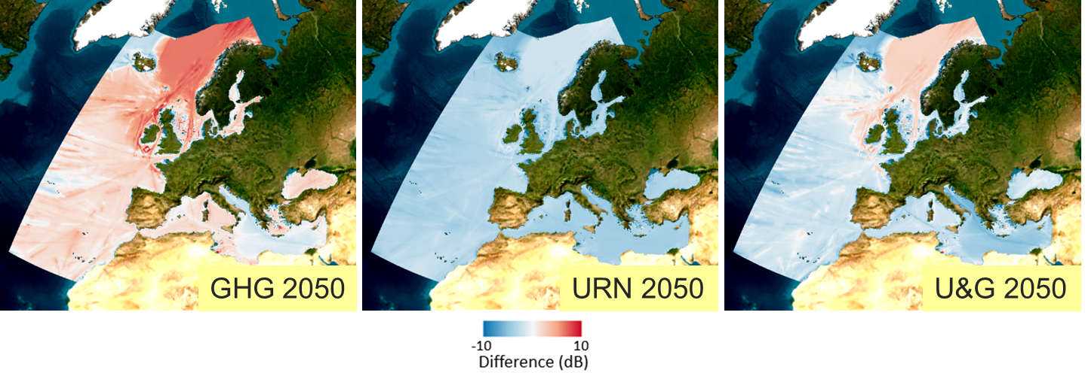
Figure 2.34 URN Forecast scenarios
Source: EMSA, NAVISON (2024).
This ship type and regional behaviour dependency of the scenarios output is also seen when analysing the sound energy densities. Results are being analysed and will be presented in the next version of the report.

Marine litter and waste generation

Marine litter, passively fished waste and container loss.
Marine Litter
Among all the marine litter affecting the European seas, 16% likely originate from maritime activities (see Figure 2.35).

Figure 2.35 Share of litter items likely originating from ‘maritime activities' in relation to the total litter recorded on beaches, by regional sea
Source: Compiled survey data of ‘EMODnet European beach litter standardized, harmonized and validated datasets 2001/2022 v2023’ and ‘EEA MarineLitterWatch v2023’.
Specifically for the categories of ‘shipping’ and ‘fisheries and mariculture’, 11% of European beach litter can be attributed to the latter and 2% to the former (see Figure 2.31). Shipping-originating litter varies in share between 1% (Black Sea and North-East Atlantic Ocean) and 3% (Baltic Sea). For fisheries and mariculture originating litter, it is the most abundant in the North-East Atlantic Ocean with 19% share; and the least abundant in the Black Sea with 3% share.

Figure 2.36 Share of litter items likely originating from 'shipping' and ‘fisheries and mariculture' in relation to the total litter recorded on beaches, by regional sea.
Source: Compiled survey data of ‘EMODnet European beach litter standardized, harmonized and validated datasets 2001/2022 v2023’ and ‘EEA MarineLitterWatch v2023.
Temporal trends are detected in the abundance of beach litter originating from maritime activities (see Figure 2.37). In a decade, the abundance of such litter has more than halved from 28 items per 100 m in 2013 to 14 items per 100 m in 2022. The trend of decrease has been particularly pronounced since 2018. These figures follow general trends of decreasing beach litter abundance, as detected by the MSFD beach monitoring.

Figure 2.37 Temporal distribution of litter items likely originating from maritime activities, 'shipping' and 'fisheries and mariculture', by year.
Source: Compiled survey data of ‘EMODnet European beach litter standardized, harmonized and validated datasets 2001/2022 v2023’ and ‘EEA MarineLitterWatch v2023’.

Microplastic pollution
Microplastics from shipping are generated after routine ship hull cleaning, mishandling of cargo comprising plastic items or accidental spills of industrial plastic resin pellets (GESAMP, 2021) or plastic polymers in solution (Suaria et al., 2018).
Recent findings show that the most important source of microplastics originating from shipping is from paints. In 2019, 1 374 kt of plastic were used globally to make marine paint. 66% of the total paint used in the marine sector eventually leaks into the environment, including 911 kt of plastic. Of this plastic, 816 kt would leak into oceans and waterways. 65% of the total leakage would be in the form of microplastic (Environmental action, 2022). While most leakage takes place in Asia-Pacific, where 96% of commercial ships are dismantled, the European environment is also pressured by leakages directly from the hull exteriors. Moreover, 56% of the global commercial ship fleet is owned by the European countries, thus making European enterprises contributing significantly to this type of plastic input into the sea (Environmental action, 2022).
In addition to paint, grey water from ships can also be an important source of microplastics from shipping (Peng et al., 2022).
Passively Fished Waste
In this section data is presented on marine litter and waste collected by European fishers during their fishing operations and delivered to EU ports under the auspices of the PRF Directive. For 2021, a total of 1220 m³ was reported to have been collected by 10 Member States. For 2022, a total of 697 m³ was reported by 9 Member States. For 2022, additional information on the type of waste was provided: 6% was classified as ALDFG (Abandoned Lost and Discarded Fishing Gear), 18% as Other Marine Litter, and 76% was not classified in terms of origin. Figure 2.38 shows the distribution of PFW waste type in terms of classification per composition of the collected materials in 2022.
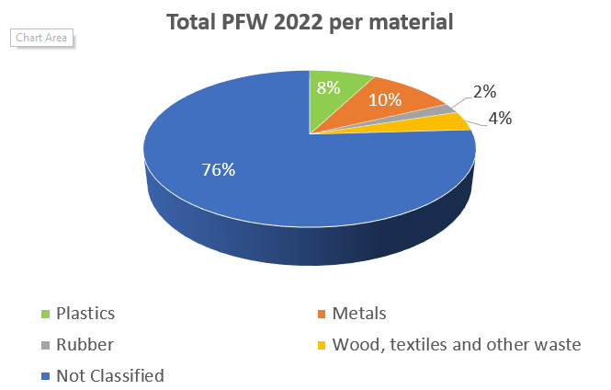
Figure 2.38 Total reported volume of passively fished waste per waste type in 2022.
Source: DONA and dataset of the European Commission.
Legal discharges at sea
From the inspection records it is also possible to assess the amounts of waste that have been reported to have been legally discharged at sea. Figure 2.39 displays these amounts, in absolute volume, as recorded in THETIS-EU since the alignment of the system with the new PRF Directive (i.e. July 2021) for the years 2022 and 2023.

Figure 2.39 Amounts of waste discharged at sea as reported by inspectors in the follow up of an inspection.
Source: EMSA, THETIS.
Lost containers
According to the World Shipping Council’s (WSC) annual survey (addressed to companies that operate more than 90% of the global containership capacity), in 2022, a total of 661 containers were lost at sea (Figure 2.40). This number represents 0.00048% of the 250 million packed and empty containers currently shipped each year globally (WSC, 2023). However, since 2019 there have been a number of notable incidents involving container loss, including the following three, which resulted in considerable impact on the marine environment:
- The MSC Zoe incident in 2019, which resulted in the loss of 342 containers overboard in EU waters;
- The ONE Apus incident in 2020 resulting in more than 1,800 containers overboard in the north Pacific Ocean, and;
- The Maersk Essen, in 2021 which resulted in a loss of more than 750 containers in the north Pacific Ocean.
The outlying number of containers lost in 2013 (Figure 2.40) is a result of the sinking of the MOL Comfort on the 17th of June 2013 in the Indian Ocean. The incident resulted in 4,382 container units (7,041 TEU) lost at sea. and is still considered the largest number of containers lost in a single event.
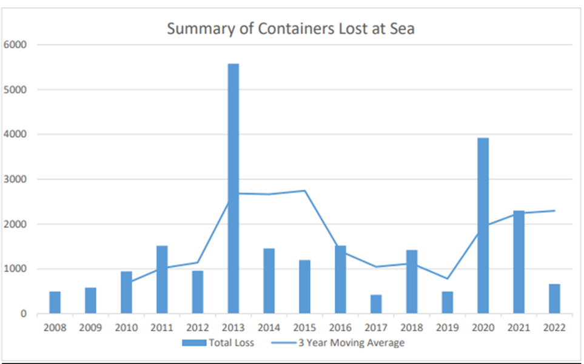
Figure 2.40 Total number of containers lost at sea at global level per year and 3-year moving average.
Source: World Shipping Council (2023).
From the European Union’s perspective, data from the European Marine Casualty Information Platform (EMCIP) shows that in the EU, for the period from 2011 until 2022, 76 single occurrences have been reported, resulting in a total of over 3,460 containers lost overboard (see Figure 2.41). Of these, the majority were lost in events that occurred in 2014, 2019 and 2021. 2021 saw four incidents with the loss of over 1100 containers (including MAERSK ESSEN, MAERSK EINDHOVEN, ZIM KINGSTON and MSC ARIES), while 2019 saw one main incident with the loss of over 340 containers (MSC ZOE), and 2014 saw another main incident contributing to the loss of over 500 containers (SVENDBORG MAERSK). 2015 was characterised by the sinking of one ro-ro cargo vessel resulting in the loss of 391 containers and 243 trucks with containers in the garage deck (EL FARO).

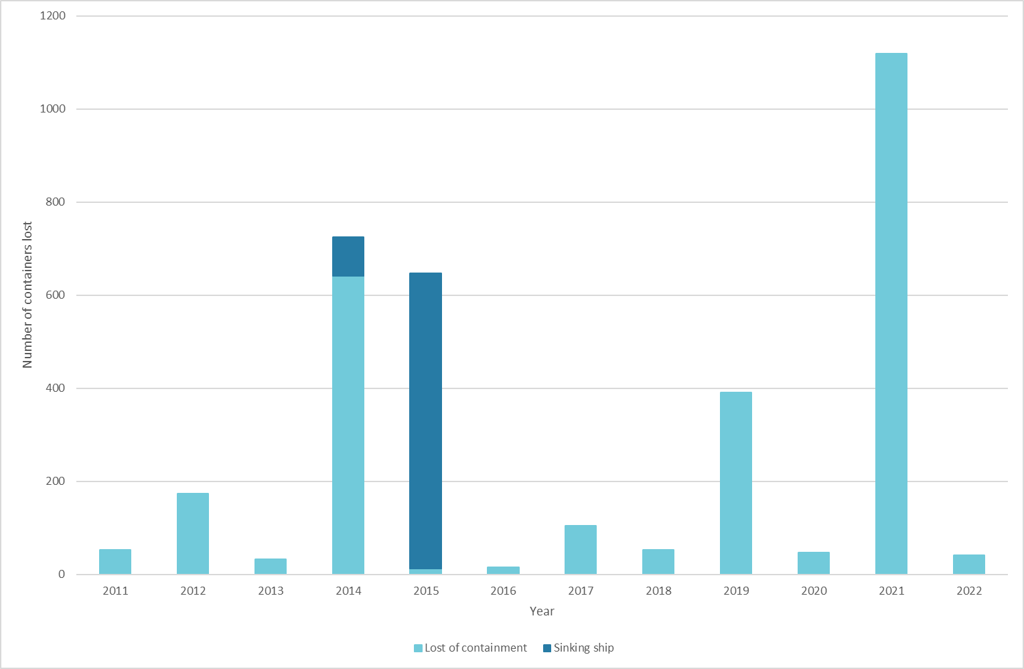
Figure 2.41 Total number of containers lost at sea events in the EU.
Source: EMSA, EMCIP (2023).

Waste reception at ports
When a ship delivers its waste at a port it receives a waste receipt to confirm the type and amounts of waste collected. From the analysis of the waste receipts notified electronically by the Member States, it is possible to gain knowledge about the types and amounts of waste delivered at European ports by ships.
Figure 2.42 indicates the amount of garbage delivered by ships (MAPROL Annex V type) and shows that domestic waste, plastics, operational waste and food waste are the types of garbage which are disposed to port reception facilities most often.
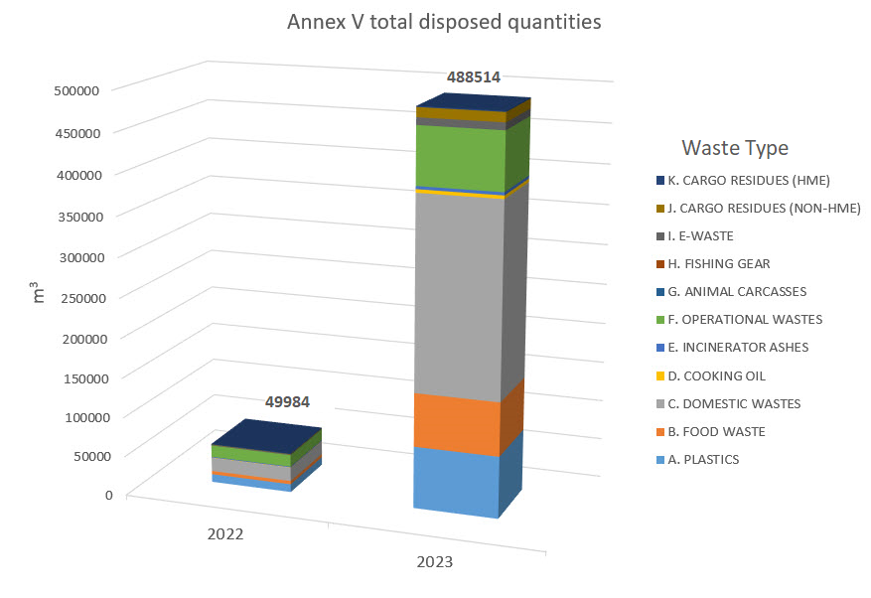
Figure 2.42 Garbage (MARPOL Annex V) total amount disposed at port reception facilities (reference waste receipt) in EU ports as well as Norway and Iceland in the period 2022 to 2023.
Source: EMSA, SafeSeaNet.
By analysing the total of waste from ships from all categories (Annex I, II, IV, V and VI) disposed at PRFs in European ports (as well as Norway and Iceland) according to the electronical waste receipts, it is possible to identify the 10 top ports in terms of reception of volumes (see Figure 2.43).
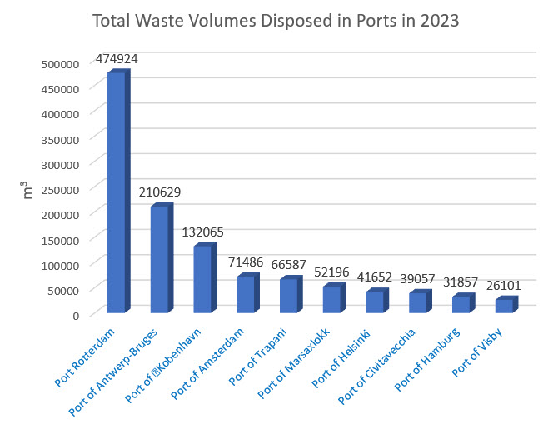
Figure 2.43 Top 10 ports in terms of total amounts of waste disposed at port reception facilities (reference waste receipts) in 2023.
Source: EMSA, SafeSeaNet.
When looking at the Annex I delivered waste, one can identify oily residues (sludge) and oily tanks washings (slops) as the main quantities disposed of, followed by oily bilge water (for a total of approximately 855,000 m³ currently reported for 2023). The Annex IV sewage waste type reported in 2023 currently amount to approximately 250,000 m³, while the Annex VI waste receipts, mainly exhaust gas cleaning residues, for 2023 currently amount to approximately 6,500 m³.

Ship recycling
An analysis of the information submitted by the Member States for their first triannual reports under article 21(1) of Regulation (EU) No 1257/2013 on Ship Recycling (EU, 2013) shows that a total of 85 ships were issued Ready for Recycling Certificates (RFRC) between 1st January 2019 to 31st December 2021. This is based on 26 reports (25 Member States and Norway), of which 10 Member States (and Norway) identified ships for which they have issued a RFRC. Of these vessels, a Statement of Completion (SOC) has been received for 41 of them (Table 2.3).

Member State | Number of vessels for which the following document were available:
Member State | Ready for Recycling Certificate | Ready for Recycling Certificate + Statement of Completion
Belgium | 2 | 2
Croatia | 1 | 1
Cyprus | 11 | 5
Denmark | 9  (3 extra vessels were reported where the RFRC has not been received but the SOC has) | 8  (including 2 where the RFRC has not been received but the SOC has)
Greece | 6 | 6
Italy | 6 | 4
Malta | 24
The Netherlands | 7 | 4
Spain | 1 | 0
Sweden | 1 | 1
MS Total | 68 | 31
EFTA Countries  Norway | 17 | 10
Total | 85 | 41
Table 2.3 List of countries with Ready for Recycling Certificates and Statement of Completion (note that if no data is provided then no documents were issued by that MS).
Source: EMSA, 2023.
These vessels were recycled in seven countries at Recycling Facilities that are on the European list of approved Recycling Facilities, with 57% being recycled in Türkiye (Table 2.4). After analysing the vessel size, vessel type, place of recycling, and country of recycling of these vessels it was found that no trends in ship recycling could be identified. This is due to the small dataset of only ten states providing information about certified ships.
Country of Recycling | Number of Ships where information was reported
Türkiye | 43
Denmark | 10
The Netherlands | 4
Norway | 4
Belgium | 3
Spain | 1
Italy | 1
Total | 66
Table 2.4 List of countries where the ships reported by the MS were recycled between 2019 and 2021.
Source: EMSA, 2023.
The dataset provided by these Member States was also compared with other information available through EMSA tools. It was found that there were 55 additional vessels that have been registered as recycled between 2019 and 2021 (Table 2.5).
Country of Recycling | Number of Ships
Denmark | 14
Norway | 9
Belgium | 8
Türkiye | 7
Unknown | 3
The Netherlands | 3
Spain | 2
Latvia | 2
France | 2
Lithuania | 1
Romania | 1
Pakistan | 1
India | 1
USA | 1
Total | 55
Table 2.5 List of countries where the 55 additional vessels were recycled from 2019 to 2021.
Source: EMSA.
Analysis of this data shows that although Ready for Recycling Certificates are being given to ships by the MS and Statements of Completion are being received by them, this is not happening in every case where a ship has been recycled.

Hazards and physical disturbance of seabed

Collisions with animals
With the increase of maritime traffic over the past decades, the probability of collisions has also increased. However, such events are rarely recorded, and often the collision is not even detected by the vessel crew. Quality data on collision events is therefore scarce, so the risk of collisions with animals is assessed by a proxy indicator (i.e. the collision risk index).
In general, the Greater North Sea, including the Kattegat and the English Channel, is the marine subregion with the highest collision risk values for whale and turtle species. This subregion is highly affected by intensive maritime traffic due to several important ports and shipping lanes. High collision risk for whales and turtles is also prominent in the Adriatic Sea and the Western Mediterranean Sea, where there is a high occurrence of species (especially turtles) on one hand and, intensive marine traffic areas on the other hand (Gibraltar).
There are four marine subregions with more than 60% of area where the collision risk index for whales and turtles has increased in 2022, compared to 2017: Western Mediterranean Sea, Aegean-Levantine Sea, Greater North Sea and Baltic Sea (whales only) (Figure 2.44). Subregions with largest areas of collision index decrease are Macaronesia (78%), Bay of Biscay, Iberian Coast (61%), and Black Sea (59%).
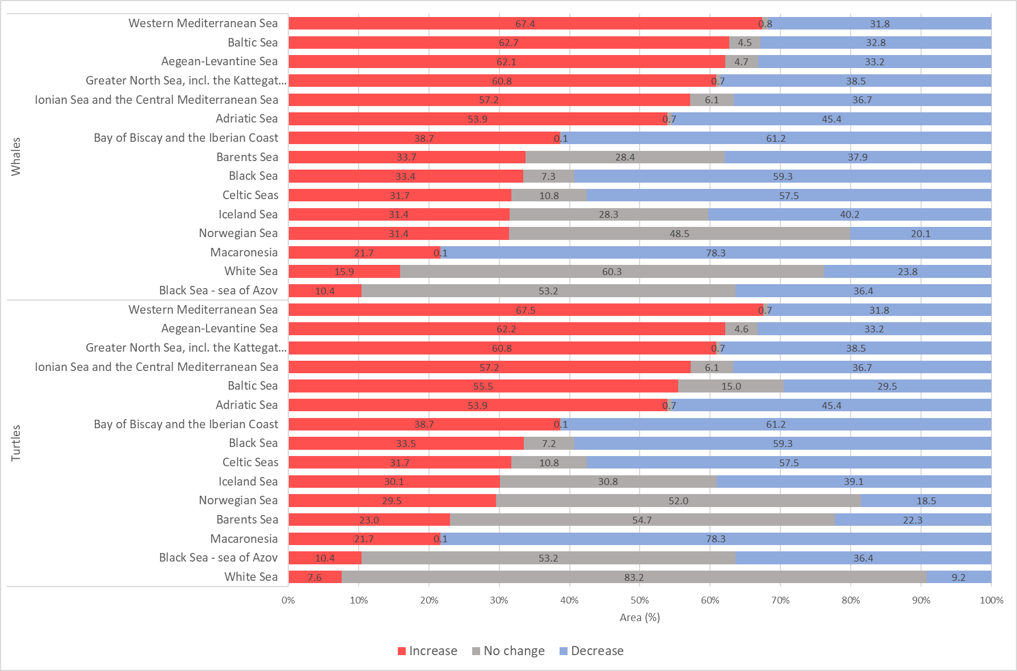
Figure 2.44 Collision risk (% of area) for whales and turtles between 2017 and 2022, by marine subregion.
Source: Aquamaps, EMODnet.
There are hotspot areas with significant increase of collision risk between 2017 and 2022 (Map 2.9). These areas are Greater North Sea (and Norway coast) and Bay of Biscay with increase of collision index, wider area around Gibraltar and East Mediterranean. On the other hand, decrease in collision risk is noticeable on the western coast of Iberian Peninsula, Celtic Seas, partially in Icelandic Sea (whales only), parts of Adriatic Sea and Black Sea (whales, turtles).

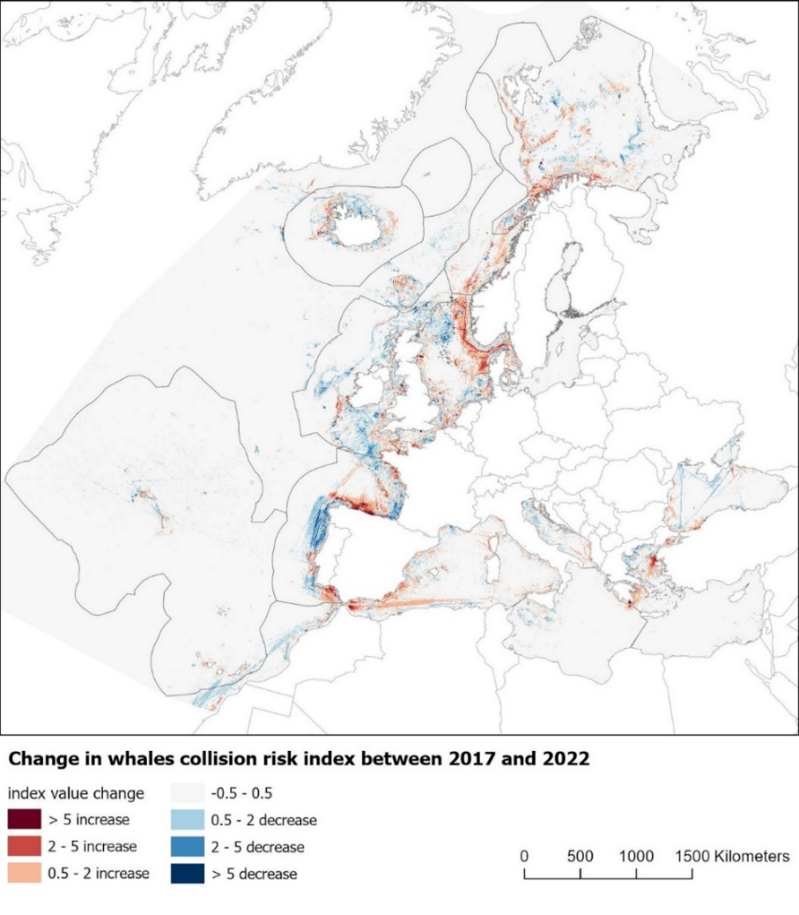
Map 2.9 Changes in collision risk index for whales between 2017 and 2022
Source: Aquamaps, EMODnet.
According to the International Whaling Commission (Cates et al., 2017), high-risk areas for ship collisions in Europe are the Canary Islands (especially for sperm whale), Strait of Gibraltar (for fin whale and sperm whale), Balearic Islands (for fin whale and sperm whale), Eastern Alboran Sea (for fin whale and sperm whale), and Hellenic Trench (for sperm whales).
There is a clear increasing trend with higher collision risk index values in Natura 2000 areas (Figure 2.45) in all marine regions. Natura 2000 sites can be designated in near-shore areas, as well as intersect with high intensity shipping lanes.

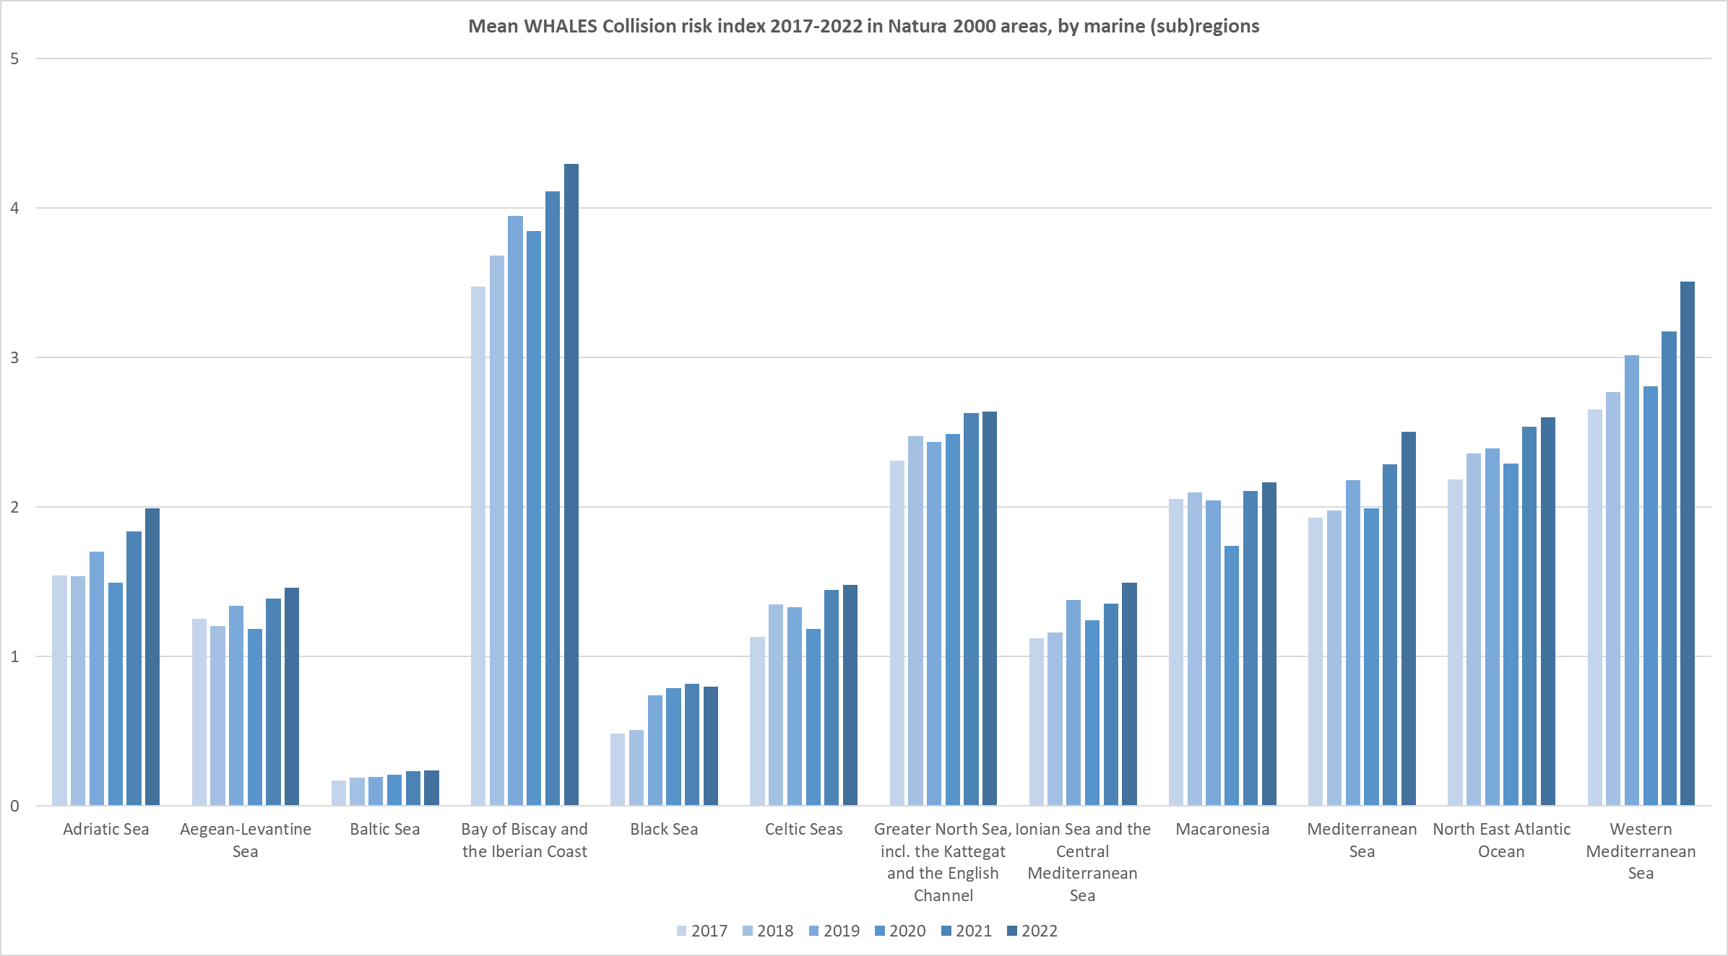
Figure 2.45 Mean whales collision risk index inside Natura 2000 areas in 2017-2022 period, by marine subregion.
Source: Aquamaps, EMODnet.
23 red-listed cetacean species are considered, with 19 of these being recognised as protected or important species within Natura 2000 areas. Some of the latter are present in Natura 2000 sites displaying high mean collision indices.
Maritime transport is assessed as having an important impact on red-list species within Natura 2000 sites in marine regions (Figure 2.46). There are 171 Natura 2000 sites where "shipping lanes, ports, marine constructions" are listed as a significant impact to red-list species. More than 80 sites are in the North-East Atlantic Ocean, 15 of these sites have high impact on 9 whale species. 32 Natura 2000 sites with 18 whale species are exposed to medium impact of shipping (Figure 2.46, left). In the Mediterranean Sea, there are 8 Natura 2000 sites exposed to high impact, with 8 whale species present at these sites.
Turtles are more exposed to impacts in the Mediterranean Sea, where 28 Natura 2000 sites have shipping identified as a medium or high risk. In these areas, four red-list turtle species are present (Figure 2.46, right).

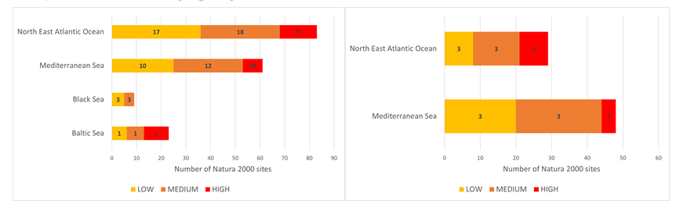
Figure 2.46 Natura 2000 sites with red-list whales (left) and turtles (right) species where "shipping lanes, ports, marine constructions" are an identified impact.
Note: Number of sites and impact intensity classes. Values inside bars represent number of species in impact intensity class.
Source: Aquamaps, EMODnet.
The overall speed of ships in Europe’s seas has on average increased marginally by 1% between 2017 and 2022 (EMSA, 2023a). The impact on the collision risk is therefore assessed as marginal.

Physical disturbance of the seabed
Wake-induced habitat disturbance – turbidity
In the Baltic Sea, Adriatic Sea, Greater North Sea, incl. the Kattegat and the English Channel marine subregions, more than 6 % of total area is impacted by ship-generated turbidity. These seas have a significant share of marine area impacted by high shipping traffic in areas not deeper than 30 metres. Nevertheless, most of the affected areas in the European Seas are subject to low pressure causing only minor impact to marine habitats.
Dredging
In the past ten years, there has been more than 1700 dredging activities reported in Europe. Extracted amount of dredged material in that period exceeded 300 million tonnes. 90% of these activities are associated with maintenance and capital dredging (EMODnet, 2023). The purpose of maintenance dredging is to deepen or maintain navigable waterways or channels which are threatened to become silted with the passage of time, due to sedimented sand and mud, whereas the capital dredging is carried out to create a new harbour, berth, or waterway, or to deepen existing facilities to allow access to larger ships (IADC, 2023).
Anchoring
An area of 11,475 km² – representing less than 0.6 % of Europe’s seas shallow areas, with depths not exceeding 110 meters are potentially affected by the pressure of anchoring. Nevertheless, since this pressure takes place within shallow near-shore areas where biodiversity is rich, it can still negatively affect benthic habitats. The marine subregions with the largest estimated anchoring areas are the Greater North Sea (3,074 km²), the Black Sea (1,492 km²), and the Aegean-Levantine Sea (1,400 km²).
Combined multiple pressures
Physical disturbance is caused by several human activities that affect the seabed either directly or indirectly. The following indicator shows the combined effects of maritime traffic, including port activities (e.g. expansion of port facilities, harbour dredging), ship lane maintenance by dredging, ship anchoring, as well as shipping related turbidity. Pressure and impacts layers, analysed in the sections above, have been combined into a composite indicator where the intensity of the pressures has been estimated on a scale from 0.1 (Low pressure) to 1 (High pressure) (Map 2.10). The cumulative effect of these pressures is damaging the state of marine ecosystem.
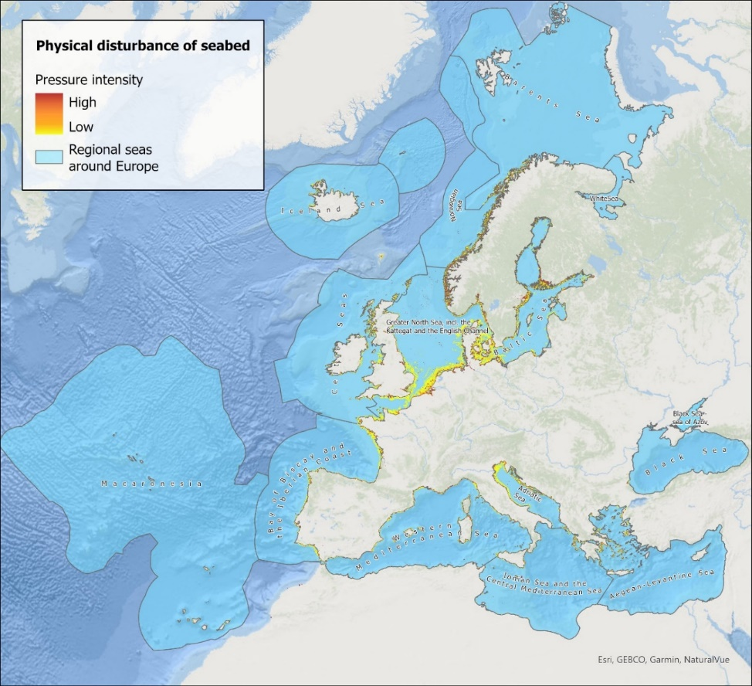
Map 2.10 Physical disturbance of seabed from maritime traffic – effects of multiple pressures (ports, dredging, anchoring and shipping-generated turbidity) to seabed.
Source: EMODNET bathymetry, Regional Seas Around Europe, EMODNet benthic habitats, MSFD Benthic Broad Habitat Types, EMODNET vessel density, EMODENT dredging, Copernicus Corine Land Cover (2018).
About 170,000 km² of Europe’s seas, or 1.2 %, are subject to physical disturbance of seabed by maritime transport only, with notable subregional differences. The MSFD threshold value for GES in relation with seabed disturbance is 2% for all human activities.
The highest percentage of impacted area is in the Greater North Sea, incl. the Kattegat and the English Channel (10.4 %), Adriatic Sea (8.7 %) and Baltic Sea (8.4 %). These seas have a significant share of marine area impacted by high shipping traffic in areas not deeper than 30 metres.
In Map 2.11, the yellow colour shows moderate impact to physical disturbance of seabed in Kattegat, mainly caused by turbidity of vessels. High impact (red colour) mostly occurs at ports and their vicinity, where seafloor is deepened to maintain navigable waterways. Marine habitats in such areas are assessed as highly physically disturbed or even completely degraded.

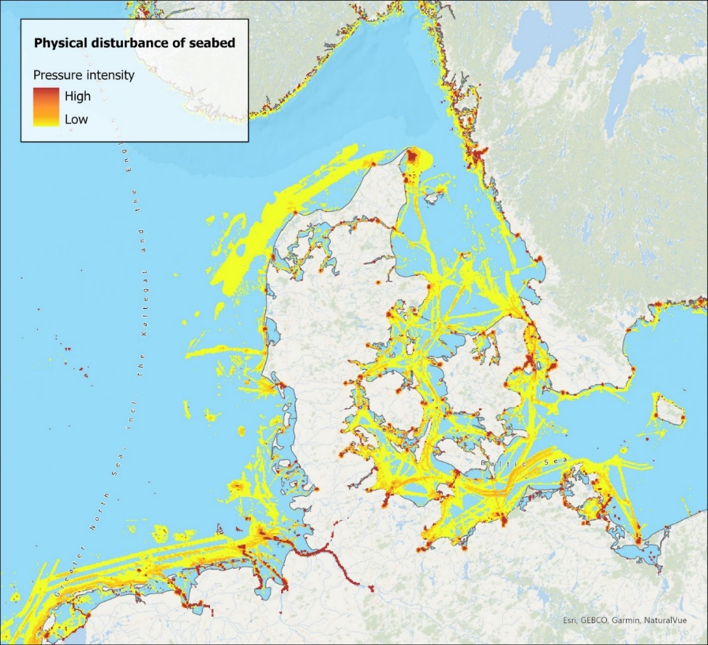
Map 2.11 Intensity of physical disturbance of seabed at the Kattegat.
Source: EMODNET bathymetry, Regional Seas Around Europe, EMODNet benthic habitats, MSFD Benthic Broad Habitat Types, EMODNET vessel density, EMODENT dredging, Copernicus Corine Land Cover (2018).
Biodiversity is the richest in near-shore waters, where land and sea meet. Near-shore habitats, which may be affected by marine traffic, are also among the most productive and vulnerable ecosystems, as they are the interface between freshwater and marine waters.
Analyses indicate that 27% of the seabed in near-shore marine waters, extending up to one nautical mile from the coastline, experiences physical disturbance from maritime traffic, with 5% of the area being subject to high impact. The level of impact diminishes with increasing distance from the coastline. It is estimated that 10% of territorial waters (1-12 nautical miles from the coastline) are affected. Beyond 12 nautical miles from the coastline, in the offshore waters, only 0.4% of seabed are impacted by marine traffic.

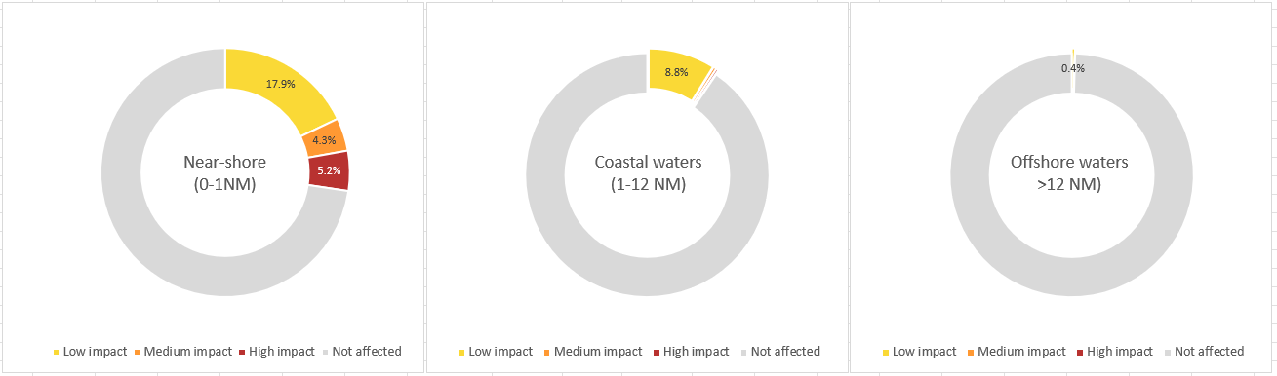
Figure 2.47 Percentage of physically disturbed seabed in near-shore (0-1NM), coastal (1-12 NM) and offshore (>12 NM) waters
Source: EMODnet Digital Bathymetry, MSFD Benthic Broad Habitat Types , EMODNET vessel density, EMODnet Human Activities – Dredging , EEA marine assessment areas buffer zones.

Seabed disturbance: A special focus on ports
Ports represent the core of the maritime shipping industry, functioning as the departure, entry, and transfer points for a vast spectrum of goods, services, and individuals transported via ships. Port expansion in Europe has experienced a significant surge between 2000-2018, resulting in a 13% increase in port area (see Figure 2.48). The expansion has been the most prominent in the Black Sea, (17% or 9 km²), followed by the Mediterranean Sea (12% or 35 km²), the North-East Atlantic Ocean (11% or 53 km²) and the Baltic Sea (8% or 14 km²). This surge in port development can be mainly attributed to an increase in international cargo movement (EEA & EMSA, 2021). The rise in tourism and recreational activities has also led to an increased demand for marinas to accommodate private boats and yachts. European countries, particularly those with attractive coastlines and waterfronts, have expanded marina facilities to cater to this growing demand, promoting tourism, and supporting local economies.

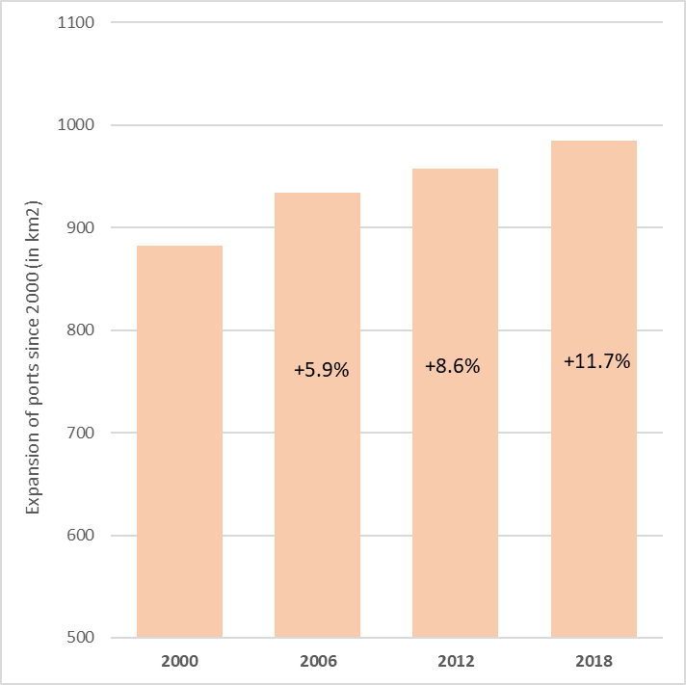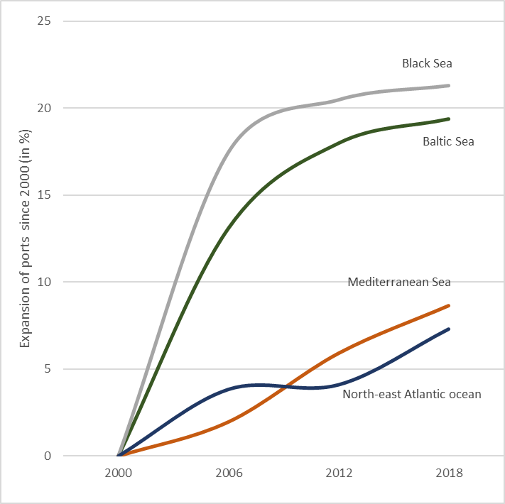
Figure 2.48 Expansion of ports between 2000-2018 in Europe (left) and per marine region (right).
Source: Copernicus Corine Land Cover (2018, 2012, 2006, 2000), Regional seas around Europe.
Almost 3 % of European coastline is occupied by ports. The port area is the largest in North-east Atlantic Ocean, where the largest ports such as Rotterdam (400 million tonnes per year) in the Netherlands, Hamburg in Germany (200 million tonnes per year), and Antwerp in Belgium (100 million tonnes per year) are leading ports in terms of inward and outward transferred tonnes. Even though the total area of ports in the Black Sea is relatively small, accounting for only 51 km² or 5% of Europe's total, it is the region with the highest percentage (5.9% or 249 km) of coastline affected by ports (Figure 2.49). The lowest percentage of coastline affected by ports is the Baltic Sea (1.2 % or 757 km), and this is caused by the very long and rugged coastline composed by numerous islands and archipelagos.
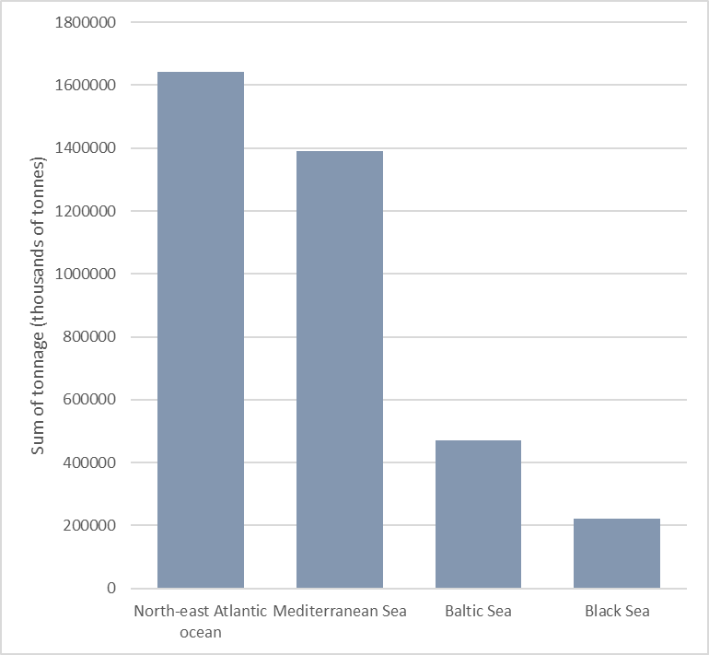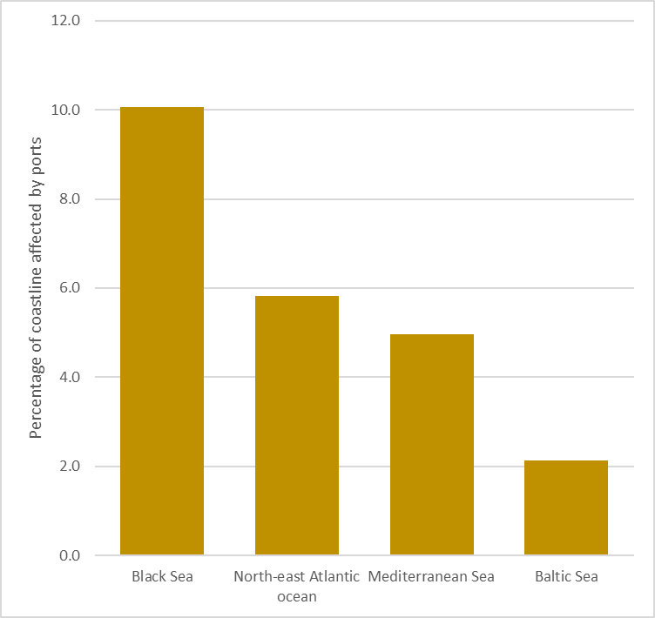
Figure 2.49 Transferred goods in thousands of tonnes in 2021 (left) and percentage of coastline affected by ports (right).
Source: EMODNET main ports (goods traffic 2021), Regional seas around Europe, EEA marine assessment areas buffer zones.
The process of constructing port infrastructure involves activities like land conversion, reclamation, breakwater construction, pile driving, and extensive earthworks, all of which contribute to considerable degradation of marine habitats. In addition, operational port activities such as ship manoeuvres and seabed modifications impact the area as well. Infralittoral biological zone (shallow water closest to the shore) is subject to the most intense and widespread degradation, whereas other biological zones (e.g., shallow circalittoral, circalittoral) are significantly less impacted (Figure 2.50).
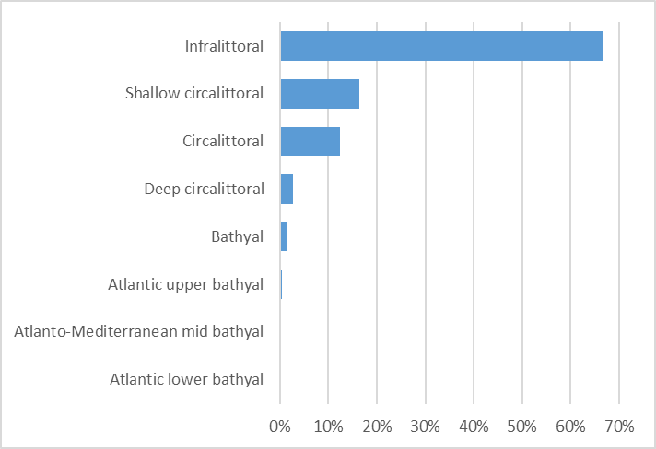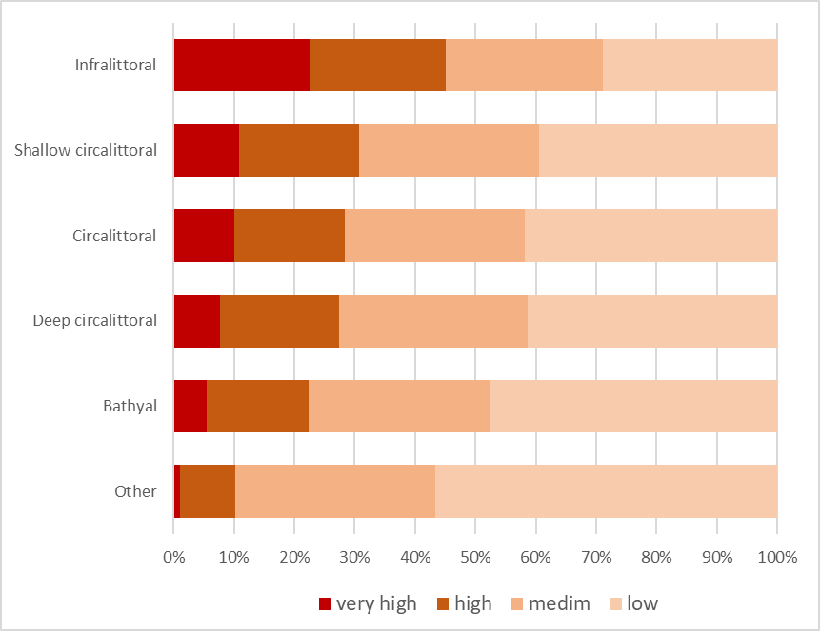
Figure 2.50 Percentage of biological zones affected by ports facilities and intensity of port pressure to biological zones.
Source: MSFD Benthic Broad Habitat Types, Copernicus Corine Land Cover (2018).
The damage caused by ports create a range of issues, such as diminished water quality, alterations in coastal morphology and hydrology, and the deterioration of sand and mud substrates (Figure 2.51). The most impacted substrate is sand (28% of affected habitats) followed by muddy sand (12%), and sandy mud (9%). The sand and mud substrata present important habitats for seagrass, microalgae, mangroves, saltmarsh, prawns, bivalves, mud crabs, and fish: all of which can be severely degraded due to ports and port related activities (e.g., dredging, turbidity).
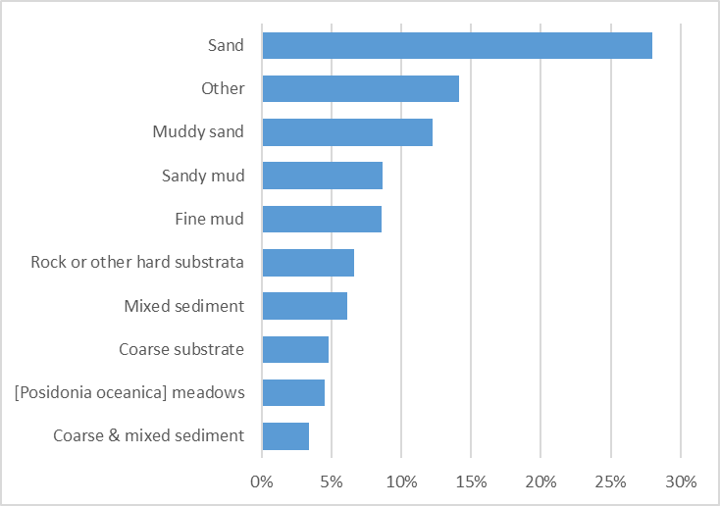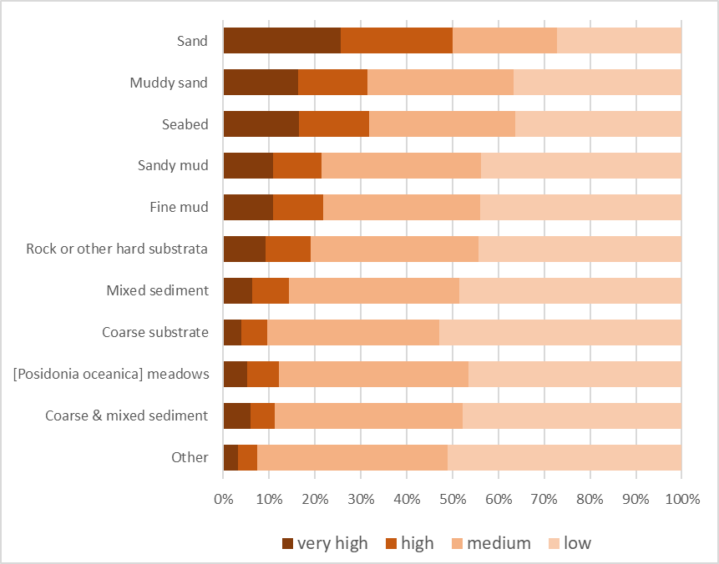
Figure 2.51 Percentage of substrata affected by ports facilities and intensity of port pressure to biological zones.
Source: MSFD Benthic Broad Habitat Types, Copernicus Corine Land Cover (2018).

Achieving decarbonisation targets
Spurred by the ambition of the European Green Deal, this chapter reviews the “EU basket of measures” reflecting the EU's goal to cut greenhouse gas emissions, analyses the CO₂ emission outlook scenarios of the maritime sector, and describes the major alternative energy carrier solutions to reach the required CO₂ targets. It has a particular focus on the “Fit-for-55” proposals related to the decarbonisation of the maritime transport sector, which focus on the introduction of market-based measures and the uptake of new renewable energy sources, as well as the global targets as agreed in the new IMO GHG Strategy. In addition, it will bring together the aforementioned sections and provide an energy transition foresight analysis, firstly to 2030 and in a second instance to 2050. This will enable to assess the challenges and opportunities the sector is facing in the implementation of the new decarbonisation targets.

An EU basket of measures
In 2021, all EU Member States committed to turn the EU into the first climate neutral continent by 2050. To meet this ambition, the European Commission proposed a basket of measures to increase the contribution of maritime transport to the EU climate efforts. These measures, part of the ‘Fit for 55' package of legislation to reduce EU greenhouse gas emissions by at least 55% by 2030 compared to 1990 levels (EC, 2021c), were adopted in 2023 and include the EU ETS extension to maritime transport, the revised FuelEU Maritime Regulation (EU, 2023b), the Alternative Fuel Infrastructure Regulation (AFIR) (EU, 2023d), the Renewable Energy Directive (RED) (EC, 2021i), and the Energy Taxation Directive (ETD) (EP, 2021). The EU measures under the Fit for 55 package sit along those to be agreed at global level within the IMO (see new IMO GHG Strategy; IMO, 2023a).

EU Emission Trading System
In the course of 2023, the extension of the European Union Emission Trading System (EU ETS) was adopted to cover, as of January 2024, greenhouse gas emissions from all large ships (of 5 000 gross tonnage and above) entering EEA ports, regardless of the flag they fly (EC, 2020d). Under the scheme shipping companies will have to purchase and surrender EU ETS emission allowances for each tonne of reported greenhouse gas emissions in the scope of the EU ETS system, which will cover carbon dioxide (CO₂) as of 2024 and additionally, methane (CH₄) and nitrous oxide (N₂O) as of 2026. Shipping companies will only have to surrender allowances for a portion of their emissions during an initial phase-in period: for 40% of their verified emissions as of 2024, for 70% as of 2025, and for 100% as of 2026. It should be noted that the EU ETS extension to maritime covers Tank to Wake (TTW) emissions.
Emissions from maritime transport are included in the overall ETS cap, which defines the maximum amount of greenhouse gases that can be emitted under the system. The cap is reduced over time to achieve an overall emission reduction of 61 % by 2030 compared to 2005, so that all ETS sectors contribute to the EU’s climate objectives. This will incentivise energy efficiency, low-carbon solutions, and reductions of the price difference between alternative fuels and traditional maritime fuels therefore allowing the maritime transport sector to actively contribute to the EU's decarbonization goals. The EU ETS has been a crucial tool in the European Union's efforts to combat climate change.

Fuel EU Maritime
The FuelEU Maritime Regulation (EU, 2023b) on the use of renewable and low-carbon fuels in maritime transport will apply from 1 January 2025. The Regulation aims to increase the use of low and zero carbon fuels in maritime transport, by requiring a progressive reduction of the GHG intensity of the energy used on board ships above 5 000 gross tonnage calling at EU ports. The yearly average GHG intensity of the energy used on board ships (measured in gCO₂eq/MJ) will have to reduce by a minimum of 2% in 2025 and 6% in 2030, and afterwards in 5-year steps up to 80% by 2050. Reductions are required to be measured from a reference value calculated on the basis of data reported under MRV for 2020 (91.16 gCO₂eq/MJ).
In addition, the Regulation includes specific incentive measures for the introduction of renewable energy in shipping through the uptake of the specific a family of fuels: the renewable fuels of non-biological origin (RFNBO). It rewards ships making use of RFNBOs by multiplying by “2” the energy related to the use of such fuels when calculating the GHG intensity of the energy used onboard for compliance with FuelEU until the end of 2033. The Regulation is based on a life cycle, Well-to-Wake methodology accounting for emissions in production, distribution and use of the fuels onboard ships. In addition to CO₂ emissions, also methane (CH₄) and nitrous oxide (N₂O) emissions are taken into account for the total CO₂-equivalent calculation. Setting the criteria for the eligibility of fuels to contribute to GHG intensity reduction is relevant to the implementation of the Regulation, and the Renewable Energy Directive (RED) is the main reference for their certification. The Regulation will also mandate the use of onshore power supply (OPS), for passenger ships and container ships above 5 000 gross tonnes, in main EU ports, from 1 January 2030, and in all ports that develop such capacity from 1 January 2035.

Alternative Fuel Infrastructure Regulation
The new Alternative Fuels Infrastructure Regulation (AFIR) (Regulation (EU) 2023/1804) has three main objectives: i) to ensure that there is sufficient infrastructure network for the (re)charging and (re)fuelling with alternative fuels; ii) to provide alternatives to the use of onboard engines that are powered with fossil fuels for vessels at berth, and; iii) to ensure that the infrastructure is operational and user friendly. It requires Trans-European Network (TEN-T) maritime ports to install electricity supply to serve the demand of at least 90% of containerships and passenger ships above 5,000GT calling at that port, by 1 January 2030. This requirement applies specifically to ports having port call thresholds of 100, 40 and 25 port calls/year for containerships, passenger ferries and cruise ships respectively. In addition, AFIR requires designated ports to provide an appropriate number of refuelling points for liquified methane by January 2025, as well as to develop and submit plans for the deployment of hydrogen, methanol and ammonia refuelling points (EU, 2023d).

Renewable Energy Directive
A new Renewable Energy Directive (RED III) was adopted to allow Member States to choose one of two binding targets applicable to the overall transport sector (EU, 2023a). The first target aims to reduce by 14.5% the greenhouse gas intensity of transport fuels from the use of renewables by 2030, while the second target aims to achieve an absolute rate of 29% of renewable energy in final energy consumption across all transport sectors by 2030. The revised Directive also includes a target of 42.5% of renewable energy by 2030 to which maritime transport can contribute, representing an increase of 28.5% from the previous binding target of 14%. Other binding targets include a combined sub-target of 5.5% of advanced biofuels and renewable fuels of non-biological origin (RFNBOs), with a minimum level of 1% of RFNBOs. Furthermore, RED III includes a first-ever indicative target of 1.2% of renewables in the maritime transport fuels sector, and a limitation of the amount of energy supplied to maritime transport of 13% of the Member State’s gross final energy consumption for the calculation of both the GHG intensity reduction and the renewable energy share in transport.

Energy Taxation Directive
The revision of the Energy Taxation Directive, which was first published in 2003, aims to align the taxation of energy products with EU energy and climate policies. It promotes clean technologies and removes outdated exemptions and reduced rates that currently encourage the use of fossil fuels. Under the proposal for the revised Directive launched in 2021, marine fuels used by maritime transport will no longer be fully exempted from energy taxation for intra-EU voyages in the EU. Other revisions include measures to avoid the double taxation of stored electricity or the recognition of hydrogen as an energy product (EP, 2021).

Climate neutral energy solutions

Biofuels
The ‘drop-in’ characteristics of biofuels, although most of them not being CO₂-neutral on a Well-to-Wake basis, offer an attractive solution for quick adoption by the existing fleet. Such ability of being used without substantial modifications to engines, fuel tanks, fuel pumps or fuel supply systems, and the possibility of biofuels to blend-in with existing fossil fuels makes them relevant in the context of the initial gradual decarbonisation targets.
In terms of future demand, the shipping sector will have to compete with other sectors. This competition for biomass is expected to grow after 2030, resulting in an increase in prices, possibly making biofuels not attractive for shipping. In addition, projections on the amount of sustainable biomass are uncertain. Furthermore, there are concerns regarding the availability, and the capacity to scale up the necessary biofuel production to reduce shipping GHG emissions.
With a view to mitigate the risk of excessive pressure in terms of indirect land use and deforestation, the FuelEU includes a safeguard against the use of food and feed crop biofuels thus promoting advanced biofuels, and waste or advanced RED Annex-IX feedstocks.
The available feedstock biomass for 2030 has been estimated to be between 7.3 and 18 EJ whereas for 2050, the estimation is between 7.0 and 19 EJ (EMSA, 2023c). It should be highlighted that the global energy demand from shipping in 2018 was approximately 14 EJ (IMO, 2020a), and this is expected to rise since the demand for maritime transport volumes is also expected to rise.
Looking into the different biofuels, those with a greater potential of being applied by shipping can be ranked based on sustainability, availability, technology readiness level (TRL) for production, suitability, and projected costs. Based on that, the most promising are biomethanol, Fischer-Tropsch (FT) diesel, biomethane from digestion of waste and residues, and dimethyl ester (DME). Fatty acid methyl esters (FAME) from fat, oil or grease feedstocks (FOG), and biomethane from gasification could also be suitable options. FAME from vegetable oils, hydrotreated vegetable oils (HVO) from FOGs or from vegetable oils would perhaps be in a lower ranking position.

Methanol
Methanol is suited for internal combustion engines, gas turbines, and fuel cells and it is easier to store compared to the other alternative fuels. The ICE technology currently available and being developed makes it an alternative not only for new builds but also for retrofits. Currently retrofitting solutions of existing engines to dual-fuel engine for operation on methanol are being developed (e.g. MAN is developing four-stroke engine retrofits to run on methanol; the FASTWATER project is developing and demonstrating retrofit kits for dual fuel ICE engines to run on methanol (FASTWATER, 2020); the HE project SYNERGETICS – set to end in 2026 – will compare two different methanol retrofits, in a test environment with respect to a range of performance parameters (SYNERGETICS, 2023)). A wide set of ship types is exploring methanol, such as tugboats. For example, the Zero Emission Waterborne Transport (ZEWT) partnership has set the objective to demonstrate by 2030 the integration of safe storage and maintenance guidelines as well as state-of-the-art power conversion technologies, both on newbuilds and retrofits (ZEWT, 2021). Methanol is widely available and there is a well-developed supply chain in place as it is used extensively in the chemical industry. It is available in over 100 ports worldwide as a commodity. Although ethanol has physical properties that are like methanol, the latter is simpler to produce and is therefore expected to be significantly cheaper (currently, there is no vessel burning ethanol).

Hydrogen
Hydrogen fuel is a new renewable feedstock for production of other types of fuels and chemicals, and it can be used directly as a fuel or clean-energy source. While shipping has limited experience using hydrogen as a fuel and some of the key technologies (such as engines) remain under development, there is sufficient land-based experience with its production and use that would serve as a sound basis for its transition to a marine fuel. However, there are some barriers, such as hydrogen’s low energy density (around 4 time less than marine diesel) which would increase the storage needs onboard a ship or the frequency of bunkering, the cost of the equipment and significant need to expand the global capacity to distribute and produce green hydrogen.
Currently, hydrogen is produced using fossil energy carriers, mostly natural gas in steam reformers. In the future, hydrogen can be expected to be produced on larger scale using renewable energy. There are different production pathways for green hydrogen: electrolysis (using renewable electricity), direct solar hydrogen production, biomass fermentation, and thermochemical biomass conversion. Currently, the global production of green hydrogen is less than 0.1 million tonnes per year. Comparatively, the current global energy demand of international shipping is estimated to be about the equivalent of 95 million tonnes hydrogen per year.
Well-to-Tank GHG emissions of green hydrogen produced by means of water electrolysis are expected to be close to zero except for leaks from the supply chain. Additionally, the combustion of green hydrogen does not directly generate greenhouse gas (GHG) emissions but only as a result from the combustion of pilot fuels required to start the combustion of hydrogen if used in an internal combustion engine. Using hydrogen in an internal combustion engine does not emit sulphur dioxide, carbon monoxide, heavy metals, hydrocarbons, polycyclic aromatic hydrocarbons (PAHs), and limited particulate matter (PM). The combustion of hydrogen can lead to the thermal formation of nitrogen oxides (NOx). NOx emissions however can be controlled through primary measures such as the optimisation of the combustion process and secondary ones, such as aftertreatment systems like Selective Catalytic Reduction (SCR) devices which however could lead to the production of GHG such as N₂O.
Storing hydrogen can be technically challenging, largely depending on the specific ship general arrangement, with compressed gas storage suffering from low storage densities, even at high pressures, and liquid hydrogen needing to be stored in specialised, highly insulated or vacuum-insulated tanks (EMSA, 2023b). Another issue is the energy consumption from pressurization and cooling of the stored hydrogen, reducing the energy efficiency of this fuel pathway. The storage capacity of hydrogen, in either liquid or compressed state, will be a challenge for certain ship types. Vessels plying short-sea routes – primarily coastal vessels – have the potential to adopt hydrogen as a fuel because their frequency of port calls and bunkering would support lower bunker capacities once hydrogen-bunkering infrastructure becomes available. Other major concerns related to hydrogen as marine fuel are related to its wide flammability range, leakage potential, being able to permeate through a large range of metals, flame speed, and detonation/deflagration issues.
In addition to the use of hydrogen bunkered and stored in its hydrogen form, to avoid the foresaid challenges posed by hydrogen at those stages, other hydrogen-based compounds like ammonia, methanol and other liquid organic hydrogen carriers are being explored as hydrogen carriers for maritime uses.

Synthetic fuels
Synthetic fuels are a group of compounds that are currently an interesting option for the replacement of traditional fuels. Novel technologies have allowed for the appearance of two main classes of synthetic fuels: renewable fuels of non-biological origins (RFNBOs) and electro-fuels (e-fuels). They mimic the chemical-physical characteristics of typical fossil fuels, but are produced with no biomass, renewable and non-fossil feedstocks. This new type of energy source has been studied to potentially offer medium- and long-term marine fuel alternatives. Even more so than other alternatives, these types of fuels also offer the potential to reduce carbon output to zero, or very close to it and are only paralleled by waste biofuels and blue synthetic fuels with carbon capture, utilisation, and storage (CCUS).
Fuels produced using renewable sources other than biomass include diesel, methanol, ammonia (NH₃), hydrogen (H₂), liquified petroleum gas (LPG), dimethyl ether (DME), compressed natural gas (CNG), ethane, and ethanol (IMO, 2023c). Similarly, the FuelEU Maritime Initiative (EU,2023b) mentions e-diesel, e-methanol, e-LNG, e-H₂, e-NH₃, e-LPG, and e-DME. The majority of these fuels are commonly composed from a mixture of synthetically assembled/synthesised hydrocarbon molecules. Possible production pathways for renewable hydrogen are (from most to least promising): electrolysis, artificial photosynthesis, solar power, and microbial electrolysis. Whereas renewable CO₂ is obtained through the capture of CO₂ from the processes of direct air capture (DAC) and oceanwater capture.
Synthetic fuels offer the potential for high decarbonisation and have been estimated to have a GHG emission reduction of 94% including manufacturing emissions (Concawe, 2022). Nevertheless, both RFNBOs and e-fuels pose several risks, such as methane evaporation and hydrogen leakage (EMSA, in publication), that could account for possible increases in GHG emissions. Other concerns refer to the various pathways used for the generation of renewable electricity, including the energy conversion process, land and sea surface area used, and potentially polluting waste. In fact, large-scale operations create the need for a considerable growth of renewable electricity plants, electrolyser, DAC plants, and e-fuel synthesis plants. It is predicted that, while the scale of production of renewable electricity could be able to follow the growth of this large-scale production, the bottleneck is the capacity to perform DAC. By 2030, renewable electricity production worldwide could be large enough to enable the global fleet to use e-fuels, but the DAC capacity is not expected to be able to realise the same growth. In addition, the shipping sector will not be the only sector needing and using renewable electricity, green hydrogen, and renewable carbon dioxide; it will have to compete with other sectors, with direct uses such as electric road vehicles, and electric boilers and furnaces. There seems to be enough suitable locations at which renewable electricity can be produced and meet global energy consumption standards, however, there is still a limit on the capacity of countries and economies to build solar and wind parks, conversion systems, and transport and distribution infrastructure.
Overall, the challenge seems to be concentrated on the fact that the technology and knowledge around this method are still lacking. For example, DAC technology is currently considered “non-mature”, and almost none of the e-fuel production pathways (e-methanol and its “Point Source carbon capture” is a notable exception) are therefore considered technologically advanced enough to enter the market. There is also lack of information on the potential effects of e-fuel spills on the environment, which adds to the uncertainty regarding the usage of these novel alternative fuels.

Ammonia
Among the broad spectrum of potential pathways for technologies and fuel solutions made available, anhydrous ammonia (NH₃) although facing substantial safety concerns due to its toxicity, has been identified as a potential long-term fuel that could offer an alternative particularly for deep sea cargo vessels. Issues related to concerns on nitrogen oxide (NOx) and nitrous oxide (N₂O) emissions, as well as the detrimental effects of ammonia slip from engines would need to be addressed.
On a Tank-to-Wake basis, ammonia is, by definition, zero-carbon. E-ammonia offers a potential climate neutral solution on a Well-to-Wake basis, while grey ammonia (produced from fossil methane or coal) is a worse climate solution than conventional fuel oils.
The ammonia production industry has announced a total of 112 projects aimed at producing green and blue ammonia (predominantly green), with a total production of 182 Mt/year globally. These projects have a completion duration between 2 and 24 years. Most of the projects (96%) aim to be completed within 10 years from the announcement to build the plant. If all plants were to be completed on time, their production capacity would be 146 Mt/year in 2030. The projects are distributed globally. About 33% of the production is planned in Oceania, 28% in Asia, 20% in Africa, 9% in North America, 7% in South America, and 3% in Europe.
Green ammonia for shipping fuel is targeted by 16 projects in 6 countries with combined output of 16.6 Mt/year. AREH in Australia is the largest project with 9.9 Mt/year (~60% share), while the remaining fifteen projects have yearly output 0.1-1.5 Mt/year. In Europe, there are projects in Norway, with four projects amounting to 0.8Mt/year and Germany, with one project of 0.1 Mt/year. In the most realistic scenario, out of the 182 Mt/year projected, 33 Mt/year is estimated to be available in the most realistic scenario, of which 11 Mt/year would be blue.
The estimated final energy demand of global maritime shipping is projected to be between 12.1 to 14.2 EJ in 2030, and between 10.2 to 23.2 EJ in 2050 (EMSA, 2023c; IMO, 2020). This projected energy demand is much higher than current green development plans for green ammonia, which are a mere 5 Mt/year. Assuming that the current production of grey ammonia, around 235 Mt/year, is converted into green ammonia production still it would need to increase by a factor of 3-4 to support the demand. Against this, it is possible to try and assume the required production capacity of renewable electricity. With an electrolyser efficiency of 65% and an electricity use from the ammonia synthesis process of 640 kWh per tonne of ammonia, 5,800 to 9,800 terawatt hours (TWh) of renewable electricity would be needed in 2040 to enable the complete switch of global maritime shipping to green ammonia. This level of demand is in the same range as current global renewable electricity production. The worldwide renewable electricity production in 2018 was about 6,600 TWh, 63% of which was from hydropower, 19% from wind, 8% from bioenergy, 9% from solar, and 1% from geothermal (IRENA, 2020). There is a projected global renewable electricity production of 15,000-30,000 TWh in 2040, indicating that production is expected to increase by a factor of 2 to 5 between 2018 and 2040. These volumes would be sufficient to produce 600 to 1,000 Mt/year of green ammonia for the maritime sector, but a large share of the renewable electricity produced will feed into the power grids to supply worldwide demand for electricity.

Wind assistance
Wind-assisted propulsion systems (WAPSs) have been identified as a technology that could offer a reduction in fuel consumption and consequently reduce GHG emissions from shipping. Wind propulsion systems are designed to transform wind energy into ship propulsion power. WAPS can be used to replace, at least partly, the main engine power by wind power and this can, if adequately used and suitable designed for the operating profile of the ship, contribute to a reduction of a ship’s GHG emissions, air pollution and underwater noise emissions. Replacing main engine power translates to less fuel consumption and corresponding energy used or emissions, for the same transport work. The FuelEU Maritime rewards ships using wind-assisted propulsion systems, which are considered as an energy efficiency technology through rewarding factors in the calculation of the energy GHG intensity.
The actual reduction of the fuel consumption that can be achieved by means of WAPSs depends on a variety of factors, ranging from technological to environmental factors but also on how a ship is operated. This creates some uncertainty when it comes to assessing the effectiveness of the systems in general. As an example, the speed of the vessel has an impact on the potential savings. In general, a higher vessel speed leads to lower per voyage savings. Container ships, passenger ships, Ro-Ro cargo and refrigerated cargo ships sail relatively fast. This does not mean that the use of WAPSs cannot be profitable for those ships, but the payback time of the investment into a WAPS can expected to be comparatively longer. Also, the higher the percentage of main engine power compared to auxiliary power, the higher the potential for savings. Looking the WAPS from a different perspective, the wind power can be used to add to the main engine power instead. Then the ship would be able to sail at a higher speed without increasing its fuel consumption. In this case, the use of the WAPS would not contribute to a reduction of the fuel consumption but will also not increase it or its GHG emissions.
Most WAPSs require deck space in order to be installed. The availability of deck space depends on the ship type and size. As an example, containerships and passenger ships have limited deck space and passenger ships relatively little deck space available compared to for example bulk carriers or tankers. For ships with relatively little deck space a kite or other innovative solutions, could then be an alternative option. For containerships, containerised WAPSs have also been developed. Interference with cargo handling and on land infrastructure is also another issue that needs to be addressed. This is tackled by foldable or tiltable solutions, which are very common. Such solutions, also limit the undesired effects at high wind speeds. Additionally, there are some other placement criteria which have to be fulfilled to allow for a safe and comfortable use of WAPS (e.g., avoid creation of blind spots, or avoid placing WAPSs next to a cabin on a passenger ship).
The weight of the devices varies significantly between the different types of WAPSs, however the effect on the cargo capacity of the vessels will not be considered crucial. From a design viewpoint, the ship structure should allow a safe transmittance of the forces generated by the WAPS onto the ship so this might require reinforcement of the ship in that area, but this is not considered to be a technical barrier. The availability of wind will have an impact on the efficiency of WAPS. This depends on the specific route, the route direction, the seasonal variations and the openness and closeness to land. To gain maximal efficiency from WAPS, trade routes would have to be adjusted via route optimisation to find a balance between wind availability and route length. Up to now, WAPS solutions have already delivered yearly fuel saving of between 5% and 9% for certain ships and, the most promising technologies claim to have the potential for energy savings of up to 30% (e.g. CHEK project (CHEK, 2020) or the European Institute of Innovation & Technology bound4blue project (bound4blue, 2015)); by 2027 the project Orcelle is expected to demonstrate more than 50% energy gains in a Ro-Ro vessel (Wallenius Wilhelmsen, 2022).
Other direct renewable solutions like solar or wave energy are being explored, either individually or combined, like wind-solar power systems (WSHPS) (e.g. Project WHISPER) (WHISPER, 2023).

Batteries
Although batteries are commonly used on board ships, heavy-duty batteries of the kind needed for power needs such as propulsion and energy, can only be provided by traction batteries. Batteries can be used on all-electric ships, or as part of hybrid electric solutions, or even as a zero-emission technology for FuelEU Maritime compliance at berth. Current traction batteries are to a large extent based on lithium-ion (Li-ion) chemistry however their low energy density remains as one of the main challenges. The most promising technology on the horizon appears to be solid state electrolyte, which may have particular advantages for the maritime environment with regard to safety and energy density.
Currently, the entire maritime market to date comprises less than 1% of the total amount of lithium-ion batteries produced yearly and to some extent this explains the greater costs associated to introducing a marine battery system. In 2023 there were 439 ships with batteries in order, and 183 ships with batteries in operation (see Figure 3.1). The leading ship types in using batteries are ferry ships, offshore supply and fishing vessels. Currently, most ships with batteries use hybrid systems.
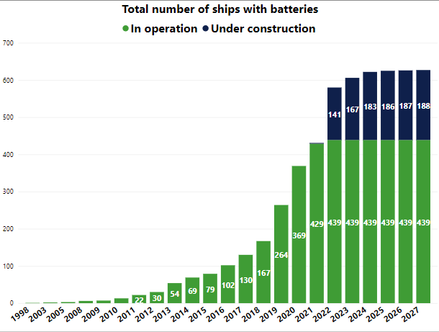
Figure 3.1 Total number of ships with batteries and projected values for 2024-2027.
Source: The ship register — Maritime Battery Forum, 2023.
The predictability and limited operational profile of ferry ships has made them the most suitable ship type to be fully electrified through the incorporation of battery energy storage systems (examples are “Ellen”, from the project H2020 project E-FERRY (E-FERRY, 2020), currently operating a 22 nm and the “MS Medstraum", from the H2020 project TrAM, the first fast ferry, operating at a typical cruising speed of 23 knots (TrAM, 2020)). However, it is expected that more powerful and energy storage capacity will foster that a wider set of ship types will fully or partially use batteries in the near future. This will require the implementation of fast, standardized, modular and scalable charging solutions currently unavailable. In parallel, swappable batteries are being explored (e.g. H2020 project CURRENT DIRECT or HE project SYNERGETICS (CURRENT DIRECT, 2020; SYNERGETICS, 2023)). Innovative grid architecture is also required to enable operational flexibility through the hybridisation of storage units.

Fuel cells
A fuel cell power pack consists of a fuel and gas processing system and a stack of fuel cells that convert the chemical energy of the fuel to electric power through electrochemical reactions. Different fuel cell types are available which can be characterised by the materials used in the membrane. The most common fuel cell types are the Polymer Electrolyte Membrane Fuel Cell (PEMFC) and the Solid Oxide Fuel Cell (SOFC). In fact, planar SOFC systems seem to be the most energy efficient, as they allow for high fuel utilisation paired with high cell voltages (Blum et al., 2011). Another differentiation between fuel cells is low versus high temperature fuel cells. The formers only require pure hydrogen as a fuel, which produces CO- and sulphur-free waste. Alcohol fuels may also be used for on-site or on-board reforming for at lower temperatures, giving the advantage of being ultra-clean and sulphur-free. Alternatively, high temperature fuel cells may use both H2 and CO as fuels, which implies that (1) fuel processing can be achieved in less steps, (2) there is the advantage of the availability of existing infrastructure of production, and (3) the higher energy density of hydrocarbon fuels (Song, 2002).
Fuel cells may have useful applications also in connection to the FuelEU Maritime regulation. An important element is that no air pollutants such as SOx or NOx are generated (or at least in negligible amounts), together with CO or particulate matter. In addition, no methane slippage is produced due to the almost immediate conversion of the molecule into hydrogen and CO₂. Finally, fuel cells can make use of advanced biofuels, RFNBO’s, and recycled carbon fuels (RCF) which favours compliance with the RED targets while at berth.
The total shipment of fuel cells in 2015 amounts to 335 MW, with the transport sector standing for 178 MW and the stationary sector for 157 MW. The largest manufacturers are in South Korea and the USA, with Japan following.

Nuclear propulsion
Nuclear propulsion has been identified as an alternative power system for the shipping industry to achieve net zero emissions. However, concerns on the inclusion of nuclear power in the merchant fleet are centred on the lack of sector-related policies and regulations, as well as safety risk concerns (both at sea and at port), high costs, stigma, lack of civil acceptance, and potentially significant environmental impacts in case of accidents. In addition, there are also concerns around the management and final disposal of resulting radioactive waste. So far, few commercial ships have made use of nuclear propulsion systems such as icebreakers (Raymond, et al., 2022).
Various options using nuclear power have been identified: zero-emission ships using electrification methods, the direct use of micro or small modular nuclear reactors, or the storage and transfer of energy to the vessels from on-shore nuclear power plants located near ports (Bhattacharyya et al., 2023). Moreover, there is the hypothesis of including nuclear energy as a cogeneration element to produce green fuels such as nuclear-based pathways for hydrogen, ammonia, or methanol.
It may not be possible to convert or retrofit existing merchant ships into nuclear-powered ships. However, it seems that, in the long run, nuclear power could become a financially viable option when compared to other proposed alternative fuels, such as ammonia or hydrogen, due to its high energy efficiency and overall low resource use (Bhattacharyya et al., 2023), provided that safety and environmental risks associated to nuclear technology application to commercial maritime transport are duly assessed and mitigated.
There are three main types of nuclear reactor designs to be used onboard ships: the Pressurised Water Reactor (PWR), the Heat pipe, and the Molten Salt Reactor (MSR) (Lloyds Register, 2023). Notably, the MSR stands out as the most likely to be implemented. It is a type of reactor developed in the 1950s that is starting to be tested onboard ships due to its small size and modular characteristic when compared with conventional reactors. Furthermore, other characteristics, such as its high efficiency, low waste generation, and more importantly the fact that it operates at low pressures, all improve operational safety. Nevertheless, it is important to note that the temperatures for operation are higher than in other reactors, which may create further operational concerns (ANSTO, 2023; Bhattacharyya et al., 2023). Challenges may include high corrosiveness of the molten salts used, elevated operating temperatures and possible damage to materials from high-energy particles created by the fission processes. The major concern of the MSR is the corrosivity of the molten salts as well as its impurities (the selection of materials is very important). Due to the chemical nature of the circulating salts, oxidation of the inner metal surfaces may not occur as in other type of reactor designs, leaving them less protected (Calderoni & Cabet, 2012; Roper et al., 2022). Training and regulation are other main topics of discussion in the sphere of nuclear power onboard ships.

Carbon capture and storage
Carbon capture and storage (CCS) technology is currently being examined as an alternative or current solution, in the absence of mature applications for clean fuels as well as the uncertainty over whether the demand could be met. CCS technology refers to the capture, separation of CO₂ from various sources and the conversion into other substances for further use or transport. Particularly, CO₂ is collected, purified, and used as a raw material in other industries or permanently stored under the land or ocean bottom (Wang et al., 2022). Currently, research on carbon capture and storage mainly focuses on thermal power generation, coal chemical industry, and cement production, while there are few studies on carbon capture based on the shipping industry (Hua et al., 2023). The uniqueness of CCS for the shipping industry results from the fact that there is limited space to utilise on board the ship. Furthermore, the design and placing of the CO₂ storage tank on board the vessel must be taken into consideration as well as the ship characteristics (power limitations, operational patterns, etc.). Stability issues may also arise due to ships’ nature of constantly sailing offshore.
Another relevant issue relates to the transport of CO₂ captured to the place of use or storage by the shipping sector, which may require a specialised fleet. CO₂ is liquefied and stored in tanks before being loaded onto ships for transport. Ships transporting CO₂ can adopt a semi-refrigerated type, in which the optimal pressure of the storage tank should reach 1.5 MPa and the temperature should be about − 27 °C (Seo et al., 2016). Currently, there are only four ships transporting CO₂ globally, mainly serving the food processing and beverage. Although the technology is mature and has been practiced for more than 30 years, the scale is not large, with only 3 Mt CO₂ transported every year. Existing small CO₂ transportation ships have a capacity of about 850-1,400 tons, which cannot meet the needs of large-scale CCS applications (Hua et al., 2023). There are currently no large ships suitable for CO₂ transportation. However, considering that CO₂ would have similar characteristics to LNG and LPG, it would be safe to say that LPG and LNG carriers could be considered suitable for CO₂ transportation. It is estimated that the capacity of CO₂ transportation by a single ship can reach 10,000–100,000 tonnes (Brownsort, 2015).
Regarding safety issues, the storage of CO₂, both gaseous and liquid, poses certain risks. If liquid CO₂ leaks, the cryogenic gases could cause damage to the ship structure or crew. Besides, if the liquid CO₂ tank encounters high temperature, the gasification will increase the pressure in the tank, and there is a risk of explosion. This puts forward higher requirements for CO₂ purity, CO₂ storage tanks, and sealing systems.

Onshore Power Supply
There is a limited number of ships in the world equipped with the necessary elements for high-voltage OPS, with the European Alternative Fuels Observatory (EAFO) reporting this number to be 33 ships (EAFO, 2023). In the EU, there are three container ships, nine cruise ships and 15 Ro-pax ships calling at ports equipped with high-voltage OPS. In addition, there are also ships that are designed and built as ‘OPS ready’, preparing them for a simplified conversion once the decision to retrofit OPS equipment is made. The elements provided in OPS-ready ships are typically space-related, allowing room for growth not only in the ship’s general arrangement and the specific structural spaces for cable routing, but also in the main switchboards.
Based on information from the EAFO, at least 96 ports from 19 EU Member States have already implemented onshore power connections. This means that, at present, in the EU there is a total of 556 berths with available shore-to-ship power supply facilities (see Figure 3.2).
For the cruise sector, in Europe as per April 2023 there were 6 ports with at least one berth with OPS, 4 already funded and 14 planed. Furthermore, according with the CLIA State of the Cruise industry report, 30% of ships which represent 40% of capacity are plug-ready and 30% are to be retrofitted (CLIA, 2023).

Figure 3.2 European ports and number of berths with OPS connection.
Source: EAFO, 2023.

Energy transition foresight

CO₂ emissions outlook
While shipping is considered one of the least carbon intensive modes of transport, it emits 3-4% of all EU CO₂ emissions, and these are projected to grow quickly if mitigation measures are not swiftly introduced (EC, 2023c). Since 1990, CO₂ emissions from fuel sold in the EU for international navigation have increased by around 36%, contrary to domestic navigation emissions that have decreased by 26% over the same period. Today, CO₂ emissions from international navigation represent close to 90% of all EU seaborne navigation emissions and according to projections, these could grow by around 14% between 2015 and 2030 and 34% between 2015 and 2050 in a business-as-usual scenario (EP, 2021).
Despite the marked increase in ambitions, CO₂ emissions have increased every year since the Paris Conference of Parties (COP) in 2015 (except for the 2020 pandemic year) (IEA, 2021). A report published by the “Getting to Zero Coalition” and commissioned by the World Economic Forum examines multiple ways to reduce GHG emissions from shipping, including reducing demand for shipping, increasing the energy efficiency of the sector to reduce use of fossil fuels, and reducing the GHG intensity of shipping’s fuels (WEF, 2021). A more recent report by the United Nations Convention on Trade and Development (UNCTAD), shows that while the total emitted CO₂ from the sector is still growing at global level, the emissions per ton-mile for the three top emitting ship types are decreasing (see Figure 3.3) (UNCTAD, 2023). Although achieving further reductions in energy demand (and, therefore in CO₂ emissions) through increasing energy efficiencies is possible, introducing sustainable fuels is also necessary.
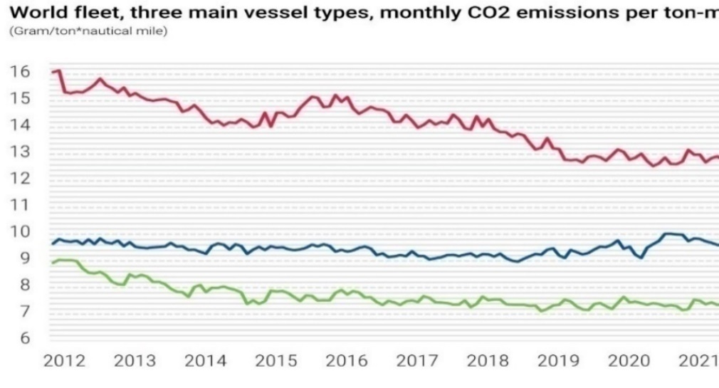
Figure 3.3 Total CO₂ emissions per ship type, 2012-2023 (above); World fleet monthly top three CO₂ emissions per ton mile, 2012-2023 (below).
Source: UNCTAD, 2023.
The Maritime decarbonisation strategy published by Maersk Mc-Kinney Moller Centre for Zero Carbon Shipping (MMMCZCS), analyses Well-to-Wake (WTW) emissions under different scenarios (MMMCZCS, 2022). The report mentions that in order to reduce our emissions by 45% in 2030 (compared with 2010), the fossil fuel consumption should be limited to approximately 6 EJ of the total energy demand from the global fleet (the estimated energy demand by the global fleet is projected to be 12.1 to 14.2 EJ in 2030) (see Figure 3.4). Leaving aside the alternative of reducing the activity of the sector, this can be achieved by implementing both energy efficiency measures and replacing fossil fuels with low-emission alternative fuels. In other words, limiting the sector emissions requires using both less and greener fuels.
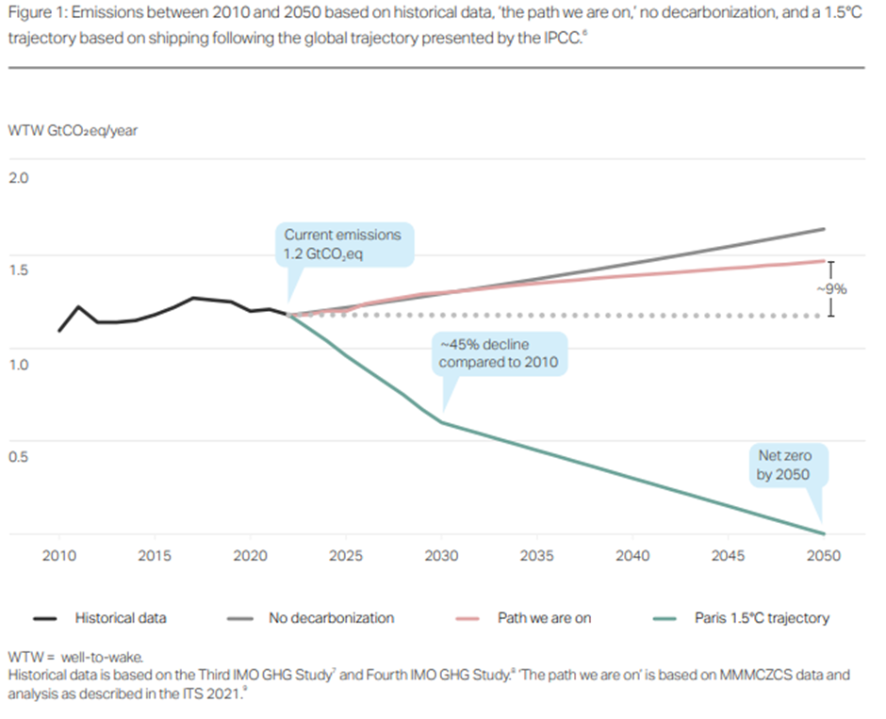
Figure 3.4 Emissions based on three scenarios, ’no decarbonisation’ ’business as usual’ ’Paris 1.5 trajectory’’ between 2010 and 2050 based on IPCC global trajectory.
Source: Maritime Decarbonisation Strategy 2022, Maersk Mc-Kinney Moller Centre.

Roadmap to energy transition in 2030 and 2050
Based on the 2023 IMO GHG strategy, by 2030 international shipping should reduce the total annual GHG emissions by at least 20%, striving for 30%, as well as reducing its carbon intensity by at least 40% compared to 2008. In contrast, the EU targets by 2030 set the maximum GHG intensity of the energy used on board ships to be 85.6904 CO₂eq/MJ (from a baseline of 91.16 CO₂eq/MJ in 2020). In addition, a share of 1% in renewable fuels of non-biological origin (RFNBO) (i.e. synthetic fuels) in the energy used on board (in 2031) would also be required.
The above targets already provide some important indications of the necessary adaptations the maritime industry must make in the coming decades. The shipping global energy consumption is of approximately 14 EJ/year (IMO, 2020a), equivalent to 3.2% of the global primary energy consumption of 442 EJ/year (2022; IEA, 2023). In order to achieve the expected emission reductions and energy intensity expected from the various provisions by 2030, fossil fuel consumption should be limited to approximately 11.28 EJ of the total energy demand.
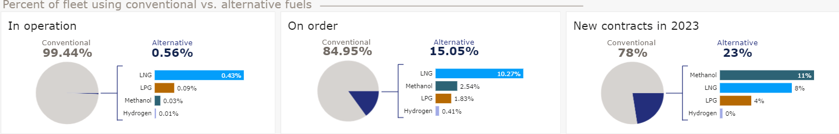
Figure 3.5 Percentage of global fleet using conventional vs alternative fuels per vessels in operation, on order and regarding the new contracts in 2023.
Source: DNV – AFI, 2023.
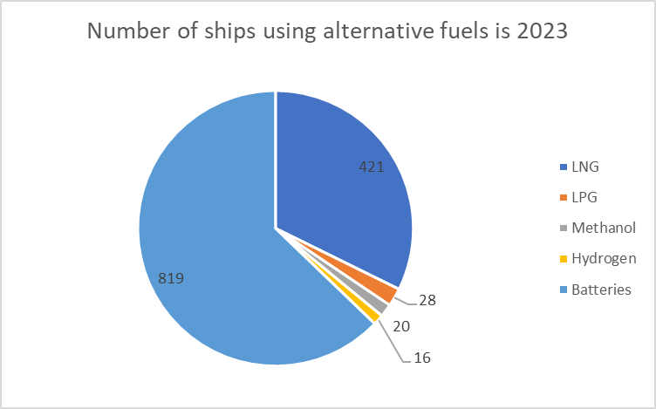
Figure 3.6 Global number of vessels using or capable of using alternative fuels (in operation or on order) 2023.
Source: EAFO, 2023.
RED certified sustainable biofuels with at least 65% less well-to-wake GHG emissions compared with fossil fuels can use reduced CO₂-emission factors. This, together with their drop-in characteristics, means that biofuels should become an immediate, attractive, and cost-effective solution for the existing fleet.
The projections for the availability of sustainable biomass volumes vary considerably. Projections for 2030 forecast between 6.3 to 8.0 exajoules (EJ) of available biomass volume in the EU and increasing to 6.7 to 14.7 EJ by 2050. In 2030, maritime shipping is projected to consume 1 to 2.4% of the EU’s potential biomass. Among the different biofuels, looking into their potential based on their sustainability, availability, technology readiness level (TRL) for production, suitability, and projected cost, the most promising are bio-methanol, synthetic Fischer-Tropsch (FT) diesel, biomethane from digestion of waste and residues, and Dimethyl ether (DME). In 2030, the total cost of ownership (TCO) of some biofuels (i.e. hydrotreated vegetable oil and FT) is at a similar level as the estimated TCO for a conventional marine fossil fuel oil. For the other biofuels, the TCO would still remain higher compared to marine fossil fuels, though clearly the difference would be lower than in 2022 (see Table 3.1).
Table 3.1 Comparison of biofuel cost developments.
Source: EMSA, in publication.
The LNG fleet has been growing on a yearly basis. From 2021 to 2022 the fleet grew by 32.2%. In total there are 79 bunkering facilities worldwide, of which 33 are in Europe. The total capacity from the 33 bunkering facilities in Europe is 163,796 m³. The use of LNG as fuel remains as the main alternative of the technological options (EAFO, 2023) available to shipowners for car carriers and container ships, and it is also becoming significant for tankers and bulk carriers.
Although LNG, the liquid form of natural gas, which is composed mostly of methane, is a hydrocarbon-based source of energy. LNG combustion determines lower GHG emissions compared to marine diesel but also entails emissions from non-combusted methane (i.e. slipped emissions). In addition, methane emissions from leakage during extraction, processing, and transport phases as well as from unburned methane are questioning the contribution of using LNG in shipping to achieving the GHG emission targets.
From the forecast of EAFO until 2026, among the various power solutions under construction and their delivery date, LNG continues to be one of the main alternatives to conventional marine fuel oil onboard ships, followed by batteries in the present and in the coming years (Figure 3.7).
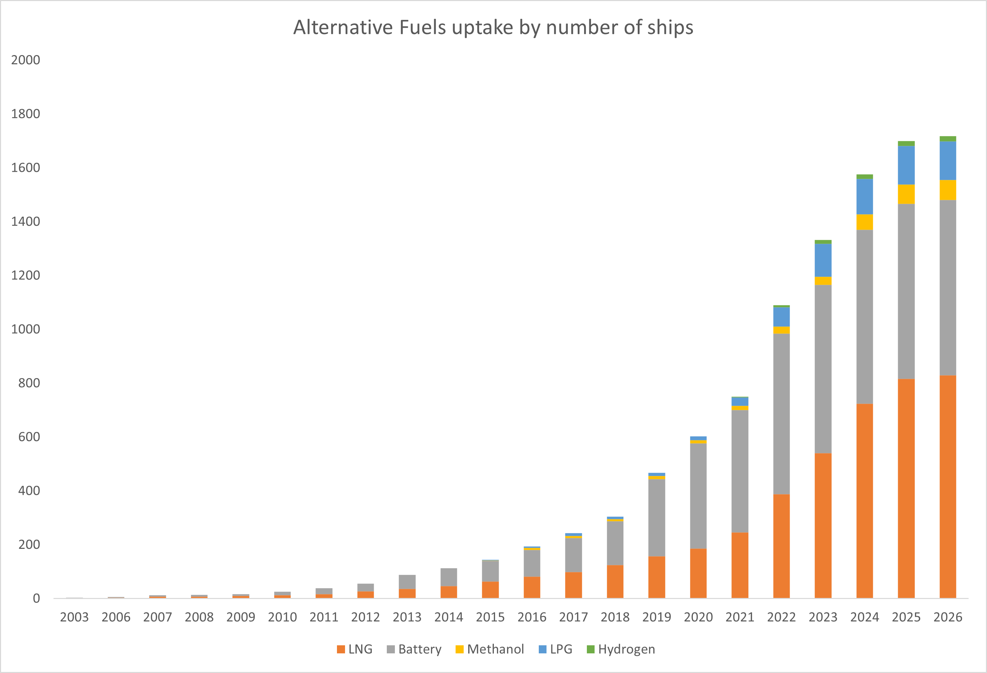
Figure 3.7 Alternative power solutions by number of ships in the EU (2003-2023) and forecast (2024-2026).
Source: EAFO, 2023.
The demand for methanol is expected to increase. The number of ships using methanol is still very low (20 ships) but increasing. However in 2023, 142 ships able to use methanol as fuel have been placed on order (DNV, 2023b). Together with biofuels replacing fully or partially the existing power solutions for maritime, synthetic fuels, including e-fuels, can be considered advantageous as ‘drop-in’ fuels, and are also expected to replace fossil fuels in the future. The existing standards and regulations, as well as the ongoing regulatory development, industry guidance and best-practice publications are expected to facilitate to some extent their adoption as marine fuels. However, for a wide adoption of these fuels, there is still a need for further development. Renewable e-fuels (i.e. fuels made from renewable hydrogen (produced using renewable electricity and water electrolysis) and renewable CO₂, if required) can include notably e-diesel, e-methane, e-methanol or, in the longer term, e-ammonia. The most practical way to introduce e-fuels in shipping is either by fully replacing fuel oils or by blending e-fuels with compatible fossil-based marine fuels in quantities verified by equipment suppliers and engine designers. The introduction of drop-in e-fuels such as e-diesel and e-methane allows for the continued use of current fuel infrastructure and ship engines. Early estimations indicate that the cost of these e- fuels (in EUR/GJ) would still be significantly higher compared to that of marine fossil fuels (Figure 3.8).
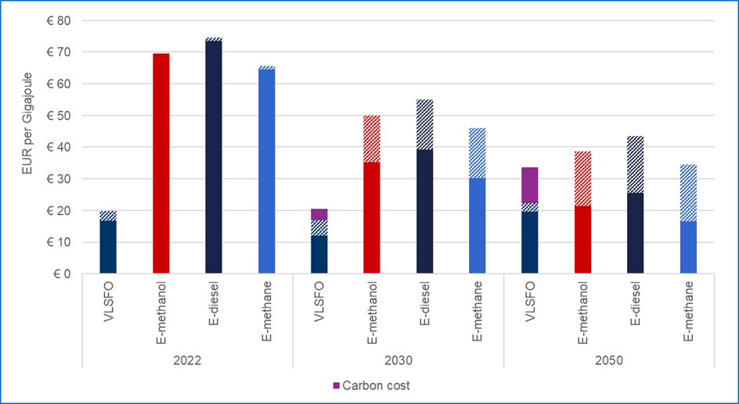
Figure 3.8 Projected fuel cost of e-fuels and VLSFO Including carbon cost).
Source: EMSA, in publication.
Electrification will play an important role in short-range waterborne applications, and in hybrid power solutions. This is a pattern for the wider transport sector; the AFIR and FuelEU Maritime requirements on OPS by 2030 will encourage the adoption of electric solutions for maritime applications. The ZEWT partnership has the objective of demonstrating by 2030 the technologies that will enable vessels no navigate up to 150-200 nm, integrating high-capacity batteries solutions as single energy source (ZEWT, 2021). To achieve that goal, further developments can be expected on the integration of low weight and high-power capacity battery systems in high voltage AC and DC distribution systems. For longer distance applications using fuel cells, the electrification of the distribution system will be required. The application of DC grids on-board is expected to increase due to a reduction of complexity, increased modularity, and improved integration.
In the roadmap towards 2030, retrofits will support the fleet to achieve the goals set by then. The main solutions revolve around improving the ship efficiency (e.g. air lubrication systems, smart energy management, holistic hydrodynamic, and operational optimisation or engine retrofits), exploiting renewables or zero emission energy sources (such as wind assisted propulsion, solar energy or hybridisation of the propulsion system), and emission reductions not linked to energy sources (e.g. better on-board treatment of solid or liquid waste from ship exploitation)
When looking at the investment required for new vessels that can operate using zero-emission fuels, it is critical to highlight that vessels have a lifetime of 20-35 years. This means that investments in new vessels today will have a huge impact on the ability of the sector to achieve the decarbonisation targets in 20 to 30 years from now (i.e. around 2050). In 2022, the first ammonia-ready vessel was delivered and there has been substantial progress in the development of zero-emission fuel technologies globally. The International Energy Agency identified that, to avoid sunk costs on fossil-fuelled vessels, new ships should be designed to be able to convert to zero-emission fuels in the future (IEA, 2022).
Ammonia is expected to be produced on a larger scale in the future. It is widely considered as a hydrogen energy carrier: renewable hydrogen could be efficiently shipped after its conversion to ammonia. Although ammonia is not currently used as a fuel by ocean-going ships, recent analysis of the required land storage and distribution, onboard storage, and conversion to energy – in either an internal combustion engine or a fuel cell – have revealed no insurmountable barriers to the use of ammonia as a marine fuel. Several research and development projects are in progress, and standards for the use of ammonia as a fuel are being developed. Marine engine makers generally agree that initially the Diesel cycle is found to be best suited for combustion of ammonia, but research is ongoing for both combustion concepts with no engine yet available in the market. Availability of these options is expected during the second half of this decade.
To produce the renewable hydrogen required for the production of ammonia or e- fuels, the process of water electrolysis is used. Although different electrolyser technologies exist, newer technologies are still under development. The renewable electricity available for the renewable hydrogen production, along with the global electrolyser capacity, are still low. By 2030 the renewable electricity production capacity could be high enough to meet the global maritime hydrogen-based fuel demand. However, in practice, a large share of the produced renewable electricity will feed into the power grids to supply worldwide demand for this energy source in other industries. It is estimated that between 1,300 to 1,900 GW of electrolyser capacity would be needed to produce enough hydrogen-based fuels to supply the entire maritime sector in 2030. However, the announced electrolyser projects worldwide would lead to an installed electrolyser capacity of 170 to 365 GW by 2030. The projects announced to date are an important step compared to the worldwide capacity in 2020 which was 0.3 GW, and to the sum of electrolyser projects planned for the 2021-2026 period which is 16.7 GW. Assuming that the projected electrolyser capacity volumes are realised, the global capacity in 2030 could produce hydrogen-based fuels for 13% to 19% of the global maritime fleet.
Currently, wind assisted propulsion systems have been installed on 30 ships in total and installation is ongoing on another 26. Of these ships, 16 are newbuilds, 38 are being retrofitted, (two kite installations are also ongoing on either newbuilds or existing ships) (see Figure 3.9). More than one third of the wind-assisted ships are equipped with rotor sails, which is the most popular form of wind-assisted propulsion at the moment. Estimating the associated fuel consumption reductions from the wind technologies depends on several factors, including characteristics of the technology (e.g. type, number and dimension of units) and the ship, together with the operation and environmental factors. Although a big variation in the savings has been observed, it can be concluded that savings can be significant. For example, rotor sails have been found to account for up to 30% savings. It is certain that wind assisted technologies can contribute to achieving the GHG reduction targets, making this technology vital in the shipping sector's low-carbon transition up to 2050.
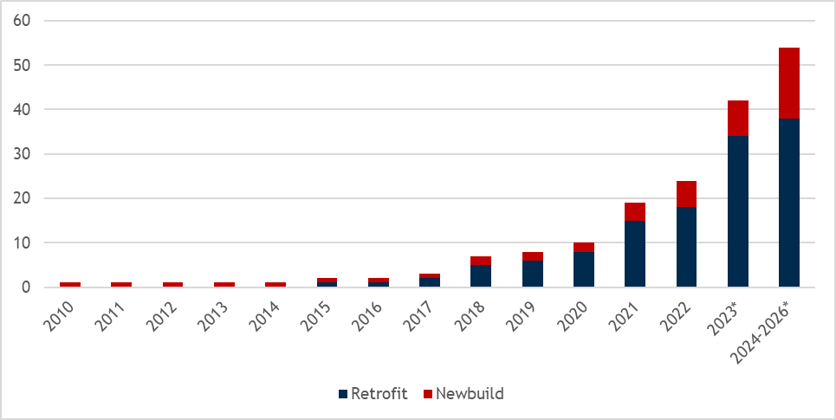
Figure 3.9 Number of ships (*planned to be) equipped with a wind propulsion systems.
Source: EMSA, in publication.
Other energy efficiency solutions based on the propulsion and reconfiguration of the ship architecture and operation will contribute to the mix of applications towards zero-emission shipping, particularly for long distance shipping. The physical improvements of vessels will be paired with digital solutions that will enhance their application as well as provide operational and maintenance decision-making improvements. Energy efficiency retrofit solutions will support the current fleet efforts in lowering emissions by 2030, while newbuilds should already incorporate energy efficient applications by design in order to maximise their performance and sustainability by 2050. Some of the technologies being developed range from monitoring and forecasting the full spectrum of the ship energy needs and operating profiles (feeding into digital twins models of the vessel), optimisation of port call and bunkering, both from the ship and port side, waste heat recovery solutions, hull improved performance solutions, or novel propulsion systems promising up to 20% efficiency.
Fuel cells can also provide a suitable alternative also in combination with zero carbon fuels. Although more expensive than combustion engines, they offer higher efficiencies and different emission footprints from the conversion of molecules. Among them, Solid Oxide fuel cells are highly efficient, moderately sized fuel cells. The high operating temperatures means that, with heat recovery, the total fuel efficiency can reach about 85% and possibly increase more with further development.

Green corridors
As stated in the previous sections, reducing emissions from shipping requires major investments in infrastructure for production and supply of alternative fuels. Considering the international nature of the sector, these investments have to be developed at a global level. The Clydebank Declaration for Green Shipping Corridors, announced at COP 26, supports the establishment of at least six green corridors – zero-emission maritime routes with further development in the next decades (UNFCCC, 2022). In the meantime, 44 Green Corridors are under development as reported by the Global Maritime Forum in the 2023 Annual progress report on green shipping corridors. Green corridors are routes from port to port on which the decarbonisation of the shipping sector and its fuel supply is accelerated by private and public action with a participation from ports, ship operators, and others along the value chain. Green corridors will contribute to the development of alternative fuel supply chains, speed up the scaling process by offering real life demonstration of solutions and technologies, and unite individual first mover actions across the value chain. Since shipping will be competing with other industrial sectors for the same fuels, it is paramount that this industry use such fuels efficiently and promotes energy-efficiency technologies in this context. In particular, corridors can act as a key enabler of investments, which will create hubs for new energy production and use that can scale up rapidly and attract further investment.
GHG emission abatement is the obvious goal in any green corridor, with availability of zero-emission fuels that can be stored and re-fuel in accordance with the same standards and safety requirements. Since those can look very different based on the regions, the initial phase is critical. In some regions the availability of a specific zero-GHG energy carriers might make a certain vessel segments the most relevant to look at, while in others it can be secondary attributes, like availability of local workforce, infrastructural development opportunities, or the opportunity to increase technical insights. Furthermore, at port level, the planning for investments in infrastructure is based on estimations of the future demand of alternative fuels which, considering the uncertainty and complexity of the future fuel mix, poses a great challenge for ports.
Along a green corridor, policy makers can put in place mechanisms that will enable the transition of the industry such as regulatory measures, financial incentives, or safety regulations, while engaging all the stakeholders (fuel producers and suppliers, port operators, ship owners, ship operators, cargo owners, specialist and experts, shipyards, financial institutions, etc.) (EC, 2023d).

Human element and seafarer training outlook
The increased use of any alternative fuels and new ship technology necessary for the sustainable transition of the maritime sector comes with several human element-related challenges. For example, the experience so far highlights the need for additional specialised seafarer training on board vessels in areas such as fuel storage, personal protection, emergencies, and transport of fuels in order to ensure a safe operation.
According to the scenario by Lloyds Register and University Maritime Advisory Services (UMAS) where alternative fuel-use ramps-up in the 2020s, and envisioning reaching net-zero GHG emissions from international shipping by 2050, it will be required that 450,000 seafarers receive additional training by 2030 and 800,000 by the mid-2030s (Raymond et al., 2022).
At an international level, the shipping industry is developing and calling for the adoption of interim guidelines on the training of seafarers on ships that use alternative energy sources. This will guarantee harmonised training processes and a coherent approach prior to the establishment of specific guidance and requirements of minimum training in the STCW Convention and Code. Due to the several different strategies regarding decarbonisation, the disparity in knowledge and experience makes this a complex task. In addition, the current slow uptake of alternative energy sources, as compared to conventional fuels, may create a bottleneck on the training of seafarers that are required to gain experience. Technology can facilitate those aspects through tools such as simulators. Some already exist, including engine-room training, bridge training, and LNG cargo-handling simulators (IMO, 2023b).

Knowledge gaps
This EMTER report has further highlighted the environmental challenges and the opportunities faced by the maritime transport sector. New and ambitious targets have been set to reach the goals of the European Green Deal, and shipping is now an integral part of this endeavour. While we strive to analyse the trends and prospects of how the sector is performing in terms of environmental sustainability, it is important to identify the information gaps that still exist, and recognise the role of research and innovation both for closing these gaps, and accelerating this transition. While currently most of the attention is focussed on the efforts required by the decarbonisation of the sector by 2050, there are still domains where additional data, information and knowledge would be needed to overcome the other environmental challenges that lie ahead.

Gaps
The maritime transport sector faces a number of gaps in knowledge, information, and data when it comes to environmental reporting, and ultimately these gaps can hinder effective monitoring and regulation of the sector’s environmental impact. The report highlights how a lack of standardized methodologies for data collection and reporting across the different domains poses a challenge, and notes that standardized guidelines for measuring emissions, being these to the atmosphere or to the sea, are essential for accurate and comparable reporting.
The absence of mandatory reporting requirements for some domains contributes to incomplete information about the environmental impact of maritime activities. For example, the sector is a significant emitter of several pollutants that are currently not regulated despite the availability of suitable technological solutions to both reduce and monitor these emissions, as discussed both in Section 2.1.1 and Annex A1.1. The lack of regulation for some pollutant often coincides with a reduced monitoring and limited direct measurements in representative conditions. Indeed, a limited infrastructure for real-time monitoring and a lack of enforceable regulations make it difficult to track and control the environmental impact of vessels operating in high sea areas in real world conditions. Improved international cooperation is essential to address this gap. As already discussed in Section 2.1.2, this may result in disproportionately higher emissions of some pollutants in real operating conditions, leading ultimately to an underestimation of the sector’s impacts.
The environmental impact of the maritime sector extends beyond vessel operations to include shipbuilding, maintenance, and end-of-life processes. While comprehensive assessments of the entire maritime supply chain has not been a focus of the EMTER report, it is important to highlight that understanding the life cycle emissions of vessels requires data on manufacturing processes, shipbreaking practices, and maintenance activities, which are often not readily available, as also discussed in Section 2.3.3 and in Annex A1.1.9. Indeed, monitoring and enforcing sustainable practises in these sectors is not easy for many reasons, including the international dimension of the issues. Today the existing regulation is largely circumvented by ship owners re-flagging their ships to non-EU flag, in particular flag of convenience, with the view to dismantle the ships in facilities with lower environmental standards.
Rapid advancements in maritime technologies, including the adoption of alternative fuels and propulsion systems, create challenges in accurately tracking and assessing emissions. The sector is in a state of transition, with new technologies being introduced to reduce environmental impact. During this transition, the lack of data or the limited knowledge on the impact that the adoption of some of these technologies may have, is an important element to consider. For example, the large-scale adoption of alternative fuels, such as NH₃ or methanol, would result in safety challenges and in emissions of currently unmonitored and/or unregulated substances, for example, N₂O or Formaldehyde (HCHO), that would require to have adequate policy safeguards, environmental monitoring frameworks as well as pollution response guidances in place.
Addressing these gaps requires international collaboration, the development of standardized reporting frameworks, and increased regulatory measures to ensure transparency and accountability in the maritime transport sector's environmental reporting. This is where the EU and its member states have made an important step forward, as the European Green Deal and the related ‘EU basket of measures’ linked to the Fit-for-55 package, offer a set of regulatory and monitoring frameworks to close these gaps.

The role of research and innovation
The Innovation Fund, financed by EU Emissions Trading System revenues, is one of the world’s largest funding programmes for the demonstration of innovative low-carbon technologies. The Fund focuses on highly innovative clean technologies and big flagship projects with European added value that can bring significant pollutants and greenhouse gases emissions reductions. Innovation Fund projects cover a wide range of innovative technologies in areas such as energy- intensive industries, renewables, energy storage, net-zero mobility and buildings, hydrogen, and carbon capture, use and storage. The EU funding for research has already supported more than 300 shipping projects with some 400 million Euro and 20 million ETS emission allowances (i.e., about €1.6 billion with a price of €80 per allowance) which should be deployed up to 2030 via the Innovation Fund to support the decarbonisation of the maritime sector.
The European Union strategic research agenda is aimed to support the development and technology readiness in a number of areas, including:
- Alternative Fuels and Green Technologies:
  - Research into alternative fuels such as hydrogen, ammonia, and biofuels to reduce greenhouse gas emissions.
  - Innovation in energy-efficient propulsion systems, including wind assisted propulsion, electric and hybrid technologies for vessels.
  - Development of sustainable and eco-friendly ship designs to enhance overall energy efficiency.
- Decarbonization, Emission Monitoring and Reduction:
  - Advancing technologies to decarbonize maritime transport, including carbon capture and storage (CCS) solutions.
  - Research on emission abatement technologies to reduce air pollutants such as sulphur oxides (SOx), nitrogen oxides (NOx), and particulate matter.
  - Real-time monitoring of air and water emissions at sea and in ports.
- Digitalization and Smart Shipping:
  - Integration of digital technologies, IoT (Internet of Things), and big data analytics for real-time monitoring of vessel performance, route optimization, and predictive maintenance.
  - Development of autonomous and semi-autonomous vessels to improve safety, reduce human error, and optimize operational efficiency.
- Port Automation and Infrastructure:
  - Research on automation and optimization of port operations to enhance efficiency, reduce congestion, and minimize environmental impact.
  - Innovative solutions for shore power and onshore infrastructure to support clean energy adoption in ports.
- Waste Management and Circular Economy:
  - Research on sustainable waste management practices, including waste reduction, recycling, and disposal of hazardous materials.
  - Implementation of circular economy principles to promote the reuse and recycling of materials in shipbuilding and maintenance.
- Human Element and Training:
  - Research on human factors in maritime transport, including crew well-being, fatigue management, and training programs.
  - Development of innovative training methodologies, simulators, and virtual reality tools to enhance the skills of maritime professionals.
- Climate Resilience and Adaptation:
  - Research on the impact of climate change on maritime infrastructure and operations.
  - Development of strategies and technologies to adapt to changing weather patterns, rising sea levels, and extreme events.
- Cross-Sector Collaboration:
  - Encouraging collaboration between the maritime sector, academia, research institutions, and other industries to foster interdisciplinary solutions.
  - Partnerships to share data, best practices, and technological advancements for sustainable maritime development.

Within this context there are two additional key overarching components which will need to be considered. Firstly, it is critical that both safety and environmental aspects are included in the development and evaluation of the technological and operational solutions. Secondly, it is key to consider these solutions holistically, that is to say to explore possible synergies. For example, on the safety aspect, new hazardous scenarios and response operations must be duly factored in. At the same time, solutions addressing energy efficiency/carbon intensity should be developed considering their impact of other type of emissions and pollutions (see for example the ongoing work to determine scenarios to combine energy efficiency measures with underwater radiated noise reduction).

A new integrated monitoring infrastructure
The EU Copernicus services have shown the potential of using satellite, modelling and in-situ data for environmental monitoring purposes. Nevertheless, the maritime transport sector has not benefited enough from the development of such services. This is mainly due to the technical difficulties associated with the monitoring of moving point sources (vessels) over high resolution temporal and spatial scales, as well as the sensibility of sensors required to capture and characterise emissions of vessels to the water and atmosphere. However, new services and tools are in the process of being developed where the needs and requirements of the maritime transport should not be neglected. For example, the EU Destination Earth initiative and the Digital Twin of the Ocean, programme can play crucial roles in monitoring emissions from the maritime transport sector by leveraging advanced technologies and data analytics.
The Destination Earth initiative aims to enhance the use of Earth observation data to create digital replicas of the Earth's environment. By utilizing satellite data and remote sensing technologies, it can provide real-time and historical information on various environmental parameters. By employing advanced modelling techniques, it will be able to simulate and predict the impact of maritime activities on the environment, including forecasting emissions to the atmosphere and water pollution discharges based on shipping routes, traffic density, and vessel types.
The Digital Twin of the Ocean programme involves creating a digital replica of the ocean, integrating information obtained from multiple sources such as real-time data from sensors, including on-board ones, satellites, and others. This enables continuous monitoring of maritime activities, including vessel movements and emissions. By employing machine learning algorithms, the digital twin can learn and adapt to patterns in maritime emissions. This can help identify anomalies, track changes over time, and enhance the accuracy of emission estimates. The project aims to provide a collaborative platform for sharing data and insights, facilitating cooperation between stakeholders such as shipping companies, regulators, and environmental organisations, improving transparency and data accuracy.
Together, these initiatives would contribute to a more technologically advanced approach to monitoring emissions, able to integrate multiple sources of information to provide a comprehensive view on the maritime transport sector. Indeed, by combining Earth observation data, predictive modelling, real-time monitoring, and collaborative platforms, the EU Destination Earth initiative and the Digital Twin of the Ocean programme may significantly enhance our understanding and management of the environmental impact of maritime activities. However, for this to happen, the maritime transport sector must be an integral part of the requirements and development process, failing this, the services built will not adequately fulfil the sectors’ needs.

List of abbreviations
Abbreviation | Name
AFID | Alternative Fuel Infrastructure Directive
AFIR | Alternative Fuel Infrastructure Regulation
AIS | Automatic Identification System
AQG | Air quality guidelines
ATS | After treatment system
BC | Black carbon
BWM | Convention for the Control and Management of Ships’ Ballast Water and Sediments
BWMP | Ballast Water Management Plan
BWRB | Ballast Water Record Book
CCS | Carbon Capture and Storage
CEAP | Circular Economy Action Plan
CH₄ | Methane
CII | Carbon Intensity Indicator
CO | Carbon monoxide
CO₂ | Carbon dioxide
COP | Conference of the Parties
CSN | CleanSeaNet
DAC | Direct Air Capture
DCS | Data Collection System
DME | Dimethyl ether
EAFO | European Alternative Fuels Observatory
EC | European Commission
ECA | Emission Control Areas
ECD | Environmental Crime Directive
ECHO | Enhancing Cetacean Habitat and Observation
EEA | European Economic Area
EEDI | Energy Efficiency Design Index
EEXI | Energy Efficiency Existing Ships Index
EEZ | Economic Exclusive Zone
EFTA | European Free Trade Association
EGCS | Exhaust Gas Cleaning System
EGD | European Green Deal
EIA | Environmental Impact Assessment
EIT | European Institute of Innovation & Technology
EIV | Estimated Index Value
EMCIP | European Marine Casualty Information Platform
EMEP | European Monitoring and Evaluation Programme
EMTER | European Maritime Transport Environment Report
EIAPP | Engine International Air Pollution Prevention
ETD | Energy Taxation Directive
ETS | Emission Trading System
EU | European Union
FSC | Fuel Sulphur Content
GES | Good Environmental Status
GHG | Greenhouse gas
GT | Gross tonnage
HBCDD | Hexabromocyclododecane
HCB | Hexachlorobenzene
HCHO | Formaldehyde
HCFCs | Chlorofluorocarbon
HFO | Heavy fuel oil
HKC | Hong Kong Convention
IAPP | International Air Pollution Prevention Certificate
IAS | Invasive alien species
IEA | International Energy Agency
IHM | Inventory of hazardous materials
IMO | International Maritime Organization
IOPP | International Oil Pollution Prevention (Certificate)
IT | Information Technology
kW | Kilowatt
LCA | Life cycle analysis
LNG | Liquified natural gas
LRTAP | Long-Range Transboundary Air Pollution
MARPOL | International Convention for the Prevention of Pollution from Ships
MDO | Marine diesel oil
MED | Mediterranean Sea
MEPC | Marine Environment Protection Committee
MGO | Marine gas oil
MJ | Megajoule
MMMCZCS | Mærsk Mc-Kinney Møller Center for Zero Carbon Shipping
MRV | Monitoring, Reporting and Verification (Regulation)
MS | Member States
MSR | Molten Salt Reactor
MSFD | Marine Strategy Framework Directive
MSPD | Marine Spatial Planning Directive
N₂O | Nitrous oxide
NEC | National Emission Reduction Commitments (Directive)
NECA | Nitrogen oxides Emission Control Area
NH₃ | Ammonia
NIS | Non-indigenous species
NM | Nautical mile
NMVOCs | Non-methane volatile organic compound
NOx | Nitrogen oxides
NSN | North Sea Network of Investigators and Prosecutors
ODS | Ozone depleting substances
OECD | Organization for Economic Cooperation and Development
OPS | Onshore power supply
PAH | Polycyclic aromatic hydrocarbon
PCBs | Polychlorinated biphenyls
PFOS | Perfluorooctane sulfonic acid
PFW | Passively fished waste
PM | Particulate matter
POP | Persistent organic pollutants
PRF | Port Reception Facilities (Directive)
PSC | Port State Control
PVCs | Polyvinyl chlorides
PWR | Pressurised Water Reactor
RED | Renewable Energy Directive
RFNBO | Renewable fuels of non-biological origin
RFRC | Ready for Recycling Certificates
RPAS | Remotely Piloted Aircraft Systems
SCR | Selective Catalytic Reduction
SECA or SOx ECA | Sulphur oxides Emission Control Area
SO2 | Sulphur dioxide
SOC | Statement of Completion
SOx | Sulphur oxides
SRR | Ship Recycling Facilities
SSN | SafeSeaNet
SSP | Ship Source Pollution (Directive)
STEAM | Ship Traffic Emission Assessment Model
TEN-T | Trans-European Transport Network (TEN-T)
TEU | Twenty-foot equivalent unit
THETIS | The Hybrid European Targeting and Inspection System
TPS | Thermoplastic starch
TtW | Tank-to-Wake
TWh | Terawatt hours
UNCLOS | United Nations Convention on the Law of the Sea
UNCTAD | United Nations Conference on Trade and Development
UNEA | United Nations Environment Assembly
UNEP | United Nations Environment Programme
URN | Underwater Radiated Noise
VOC | Volatile organic compounds
WHO | World Health Organization
WtT | Well-to-Tank
WtW | Well-to-Wake
ZPAP | Zero Pollution Action Plan
% m/m | Mass/mass percentage

References
AMAP. (2021). Arctic Climate Change Update 2021: Key trends and impacts. Summary for policy-makers. Arctic Monitoring and Assessment Programme, Tromsø, Norway. https://www.amap.no/documents/doc/arctic-climate-change-update-2021-key-trends-and-impacts.-summary-for-policy-makers/3508
ANSTO. (2023). The evolution of molten salt reactors. Australian Nuclear Science and Technology Organisation. https://www.ansto.gov.au/our-science/nuclear-technologies/reactor-systems/advanced-reactors/evolution-of-molten-salt
Bhattacharyya, R., El-Emam, R. S., & Khalid, F. (2023). Climate action for the shipping industry: Some perspectives on the role of nuclear power in maritime decarbonization. E-Prime - Advances in Electrical Engineering, Electronics and Energy, 4, 100132. https://doi.org/10.1016/j.prime.2023.100132
Birchby, D., Dubey, J., Johansen, B., Hekman, J., Gschrey, B., Behringer, D., Kleinschmidt, J., Jörß, W., Liste, V., Ludig, S., & Wissner, N. (2022). Support contract for an Evaluation and Impact assessment for amending Regulation (EU) No 517/2014 on fluorinated greenhouse gases. DG CLIMA. https://climate.ec.europa.eu/system/files/2022-04/f-gas_evaluation_report_en.pdf
BLUES. (2021). HELCOM Blues. https://blues.helcom.fi/
Blum, L., Deja, R., Peters, R., & Stolten, D. (2011). Comparison of efficiencies of low, mean and high temperature fuel cell Systems. International Journal of Hydrogen Energy, 36(17), 11056–11067. https://doi.org/10.1016/j.ijhydene.2011.05.122
bound4blue. (2015). Bound4blue project—Powering ships with wind. https://bound4blue.com/
Brownsort, P. (2015). Ship transport of CO2 for Enhanced Oil Recovery – Literature Survey. https://era.ed.ac.uk/handle/1842/15727
Calderoni, P., & Cabet, C. (2012). Corrosion issues in molten salt reactor (MSR) systems. In Nuclear Corrosion Science and Engineering (pp. 842–865). Elsevier. https://doi.org/10.1533/9780857095343.6.842
CDNI. (2017). Resolution CDNI 2017-I-4. Revision of the Convention on the collection, deposit and reception of waste generated during navigation on the Rhine and other inland waterways (CDNI) and its Implementing Regulation. Provisions on the handling of gaseous residues from liquid fuel (vapours). Convention on the collection, Deposit and reception of waste generated during Navigation on the Rhine and other Inland waterways. https://www.cdni-iwt.org/wp-content/uploads/2020/04/Resolution-2017-1-4_en.pdf
CHEK. (2020). Project CHEK—Decarbonising shipping. https://www.projectchek.eu/
CLIA. (2023). State of the cruise industry report. Cruise Lines International Association. https://cruising.org/-/media/clia-media/research/2023/2023-clia-state-of-the-cruise-industry-report_low-res.ashx
Comer, B., Beecken, J., Vermeulen, R., Sturrup, E., Paschinger, P., Osipova, L., Gore, K., Delahaye, A., Verhagen, V., Knudsen, B., Knudsen, J., & Verbeek, R. (2024). Fugitive and unburned methane emissions from ships (FUMES). Characterizing methane emissions from LNG-fueled ships using drones, helicopters, and onboard measurements. International Council on Clean Transportation. https://theicct.org/wp-content/uploads/2023/11/ID-64-%E2%80%93-FUMES-ships-Report-A4-60037-FV.pdf
Comer, B., Olmer, N., Mao, X., Roy, B., & Rutherford, D. (2015). Black carbon emissions and fuel use in shipping, 2015 (p. 103). International Council of Clean Transportation. https://theicct.org/wp-content/uploads/2021/06/Global-Marine-BC-Inventory-2015_ICCT-Report_15122017_vF.pdf
Concawe. (2022). E-Fuels: A techno-economic assessment of European domestic production and imports towards 2050. Concawe. https://www.concawe.eu/wp-content/uploads/Rpt_22-17.pdf
Cruz, E., Lloyd, T., Bosschers, J., Lafeber, F.H., Vinagre, P., & Vaz, G. (2021). Study on inventory of existing policy, research and impacts of continuous underwater noise in Europe. EMSA report EMSA/NEG/21/2020. WavEC Offshore Renewables and Maritime Research Institute Netherlands. https://www.emsa.europa.eu/newsroom/latest-news/download/6881/4569/23.html
CURRENT DIRECT. (2020). Current Direct project. https://currentdirect.eu/
DNV. (2016). Particulate matter and black carbon safer, smarter, greener the global impact and what this means for shipping (p. 16). https://www.safety4sea.com/wp-content/uploads/2016/06/DNV-GL-Brochure-Black-Carbon-2016_06.pdf
DNV. (2023a). Alternative Fuels Insight. https://afi.dnv.com/
DNV. (2023b). Energy transition outlook—maritime forecast to 2050. DNV. https://www.dnv.com/Default
Duarte, C. M., Chapuis, L., Collin, S. P., Costa, D. P., Eguiluz, V., Erbe, C., Halpern, B. S., Havlik, M. N., Gordon, T. A. C., Merchant, N. D., Meekan, M., Miksis-Olds, J. L., Parsons, M., Predragovic, M., Radford, A. N., Radford, C. A., Simpson, S. D., Slabbekoorn, H., Staaterman, E., … Juanes, F. (2021). The soundscape of the Anthropocene Ocean. Science, 371(6529). https://doi.org/DOI: 10.1126/science.aba4658
EAFO. (2023). Maritime | European Alternative Fuels Observatory. https://alternative-fuels-observatory.ec.europa.eu/transport-mode/maritime-sea
EC. (2008). Directive 2008/50/EC of the European Parliament and of the Council of 21 May 2008 on ambient air quality and cleaner air for Europe. European Parliament and Council. https://eur-lex.europa.eu/legal-content/EN/TXT/?uri=CELEX%3A02008L0050-20150918
EC. (2010). Directive 2009/147/EC of the European Parliament and of the Council of 30 November 2009 on the conservation of wild birds (codified version of Directive 79/409/EEC as amended). http://eur-lex.europa.eu/LexUriServ/LexUriServ.do?uri=OJ:L:2010:020:0007:0025:EN:PDF
EC. (2013). Council Directive 92/43/EEC of 21 May 1992 on the conservation of natural habitats and of wild fauna and flora. http://data.europa.eu/eli/dir/1992/43/2013-07-01/eng
EC. (2015). Commission Implementing Decision (EU) 2015/253 of 16 February 2015 laying down the rules concerning the sampling and reporting under Council Directive 1999/32/EC as regards the sulphur content of marine fuels. European Commission. http://data.europa.eu/eli/dec_impl/2015/253/ojhttp://data.europa.eu/eli/dec_impl/2015/253/oj
EC. (2017). Commission Regulation (EU) 2017/1151 of 1 June 2017 supplementing Regulation (EC) No 715/2007 of the European Parliament and of the Council on type-approval of motor vehicles with respect to emissions from light passenger and commercial vehicles (Euro 5 and Euro 6) and on access to vehicle repair and maintenance information, amending Directive 2007/46/EC of the European Parliament and of the Council, Commission Regulation (EC) No 692/2008 and Commission Regulation (EU) No 1230/2012 and repealing Commission Regulation (EC) No 692/2008 (Text with EEA relevance). http://data.europa.eu/eli/reg/2017/1151/oj/eng
EC. (2018). Commission Staff Working Document Impact assessment accompanying the document Proposal for a Directive of the European Parliament and of the Council on port reception facilities for the delivery of waste from ships, repealing Directive 2000/59/EC and amending Directive 2009/16/EC and Directive 2010/65/EU. https://eur-lex.europa.eu/legal-content/EN/TXT/?uri=CELEX:52018SC0021
EC. (2020a). Commission Staff Working Document full-length report accompanying the document, Report from the Commission 2019 annual report on CO2 emissions from maritime transport. European Commission. https://climate.ec.europa.eu/system/files/2020-05/swd_2020_82_en.pdf
EC. (2020b). Communication from the Commission to the European Parliament, the Council, the Economic and Social Committee and the Committee of the Regions, EU Biodiversity Strategy for 2030 (COM(2020) 380 final). European Commission. https://eur-lex.europa.eu/legal-content/EN/TXT/?uri=celex%3A52020DC0380
EC. (2020c). Communication from the Commission to the European Parliament, the Council, the European Economic and Social Committee and the Committee of the Regions ‘Sustainable and Smart Mobility Strategy – putting European transport on track for the future’ (COM(2020)789 final). European Commission. https://eur-lex.europa.eu/legal-content/EN/TXT/?uri=CELEX%3A52020DC0789
EC. (2020d). EU Emissions Trading System (EU ETS). European Commission. https://ec.europa.eu/clima/policies/ets_en
EC. (2021a). 2020 Annual report on CO2 emissions from maritime transport (C(2021) 6022 final). https://climate.ec.europa.eu/system/files/2021-08/c_2021_6022_en.pdf
EC. (2021b). Commission presents Renewable Energy Directive revision. European Commission. https://commission.europa.eu/news/commission-presents-renewable-energy-directive-revision-2021-07-14_en
EC. (2021c). Fit for 55: Delivering the EU’s 2030 Climate Target on the way to climate neutrality. European Commission. https://eur-lex.europa.eu/legal-content/EN/TXT/HTML/?uri=CELEX:52021DC0550&from=EN
EC. (2021d). JOIN/2021/27 final. ‘Joint communication to the European Parliament, the Council, the European economic and social committee and the committee of the regions a stronger EU engagement for a peaceful, sustainable and prosperous Arctic’. European Commission. https://eur-lex.europa.eu/legal-content/EN/TXT/?uri=CELEX%3A52021JC0027
EC. (2021e). Oceans and fisheries—Fishing fleet. European Commission. https://oceans-and-fisheries.ec.europa.eu/facts-and-figures/facts-and-figures-common-fisheries-policy/fishing-fleet_en
EC. (2021f). Pathway to a healthy planet for all—EU Zero Pollution Action Plan. European Commission. https://ec.europa.eu/environment/pdf/zero-pollution-action-plan/communication_en.pdf
EC. (2021h). Policy scenarios for delivering the European Green Deal. European Commission. https://energy.ec.europa.eu/data-and-analysis/energy-modelling/policy-scenarios-delivering-european-green-deal_en
EC. (2021i). Proposal for a Directive of the European Parliament and of the Council amending Directive (EU) 2018/2001 of the European Parliament and of the Council, Regulation (EU) 2018/1999 of the European Parliament and of the Council and Directive 98/70/EC of the European Parliament and of the Council as regards the promotion of energy from renewable sources, and repealing Council Directive (EU) 2015/652. https://eur-lex.europa.eu/legal-content/EN/TXT/?uri=CELEX:52021PC0557
EC. (2023a). EU Blue Economy Observatory. European Commission. https://blue-economy-observatory.ec.europa.eu/eu-blue-economy-sectors/port-activities_en
EC. (2023b). EU transport in figures: Statistical pocketbook 2023. Directorate General for Mobility and Transport. https://data.europa.eu/doi/10.2832/319371
EC. (2023c). Fourth annual report from the European Commission on CO2 emissions from maritime Transport (period 2018-2021). https://climate.ec.europa.eu/system/files/2023-03/swd_2023_54_en.pdf
EC. (2023d). Guide on financing the green energy transition of fisheries and aquaculture: Supporting the energy transition in fisheries and aquaculture through EU funding opportunities under the 2021 2027 multiannual financial framework, NextGenerationEU and beyond. Directorate General for Mobility and Transport. https://data.europa.eu/doi/10.2771/377801
EC. (2023e). Proposal for a directive of the European Parliament and of the Council - amending Directive 2005/35/EC on ship-source pollution and on the introduction of penalties, including criminal penalties, for pollution offences. https://eur-lex.europa.eu/LexUriServ/LexUriServ.do?uri=SWD:2023:0164:FIN:EN:PDF
EC. (2023f). The dashboard of the EU Biodiversity Strategy is showing progress of the EU and its Member States towards the targets set for 2030. European Commission. https://dopa.jrc.ec.europa.eu/kcbd/dashboard/#Target%2012
EC and JRC. (2023). The EU blue economy report 2023. Directorate General for Mobility and Transport and Joint Research Centre. https://data.europa.eu/doi/10.2771/7151
EEA. (2019). Pathways of introduction of marine non-indigenous species to European seas—European Environment Agency. Retrieved 16 June 2023, from https://www.eea.europa.eu/data-and-maps/indicators/trends-in-marine-alien-species-1/assessment
EEA. (2022a). Air quality in Europe 2022 [EEA Briefing]. European Environment Agency. https://www.eea.europa.eu/publications/air-quality-in-europe-2022
EEA. (2022b). From source to sea. Publications Office. European Environment Agency. https://data.europa.eu/doi/10.2800/088047
EEA. (2022c). National emissions reported to the UNFCCC and to the EU greenhouse gas monitoring mechanism, Dec. 2022. European Environment Agency. https://www.eea.europa.eu/en/datahub
EEA. (2023a). Marine non-indigenous species in Europe’s seas. European Environment Agency. https://www.eea.europa.eu/ims/marine-non-indigenous-species-in#_ftn1
EEA. (2023b) The Natura 2000 protected areas network—European Environment Agency. Retrieved 15 June 2023, from https://www.eea.europa.eu/themes/biodiversity/natura-2000.
EEA and EMEP. (2023). International maritime navigation, international inland navigation, national navigation (shipping), national fishing, military (shipping), and recreational boats. European Environment Agency and European Monitoring and Evaluation Programme. https://www.eea.europa.eu/publications/emep-eea-guidebook-2023/part-b-sectoral-guidance-chapters/1-energy/1-a-combustion/1-a-3-d-navigation/view
EEA and EMSA. (2021). European Maritime Transport Environmental Report 2021. European Environment Agency and European Maritime Safety Agency. https://www.eea.europa.eu/publications/maritime-transport
E-FERRY. (2020). E-Ferry—Connecting blue and green. http://e-ferryproject.eu/
EGCS Association. (2023). SOx Regulation Map. Exhaust Gas Cleaning Systems Association. https://www.egcsa.com/map-regulations/
EMODnet. (2023). EMODnet Human activities, dredging. EMODnet Human Activities. European Marine Observation and Data Network. https://ows.emodnet-humanactivities.eu:/geonetwork/srv/api/records/d3e86612-35a7-4c0f-a995-245062fd2792
EMSA. (2011). European marine casualty information platform – EMCIP. European Maritime Safety Agency. https://www.emsa.europa.eu/emcip.html
EMSA. (2018). EMSA/THETIS-MRV - CO2 emission report. European Maritime Safety Agency. https://mrv.emsa.europa.eu/#public/ eumrv).
EMSA. (2022). July 2022—COVID-19 Impact on Shipping Report. European Maritime Safety Agency. https://www.emsa.europa.eu/newsroom/covid19-impact/item/4795-july-2022-covid-19-impact-on-shipping-report.html
EMSA. (2023a). Central ship database. European Maritime Safety Agency. https://emsa.europa.eu/enhanced-central-ship-database.html
EMSA. (2023b). Potential of hydrogen as fuel for shipping. European Maritime Safety Agency. https://www.emsa.europa.eu/about/financial-regulations/items.html?cid=14&id=5062
EMSA. (2023c). Update on potential of biofuels for shipping. European Maritime Safety Agency. https://www.emsa.europa.eu/about/financial-regulations/items.html?cid=14:technical&id=4834
Environmental action. (2022). The release of plastic paints in the environment. https://www.e-a.earth/plastic-paints-the-environment/
EP. (2021). Review of the Energy Taxation Directive. European Parliament Think Tank. https://www.europarl.europa.eu/thinktank/en/document/EPRS_BRI(2021)662636
EP. (2023). Energy transition in the EU fisheries and aquaculture sector. European Parliament.
Erbe, C., Marley, S. A., Schoeman, R. P., Smith, J. N., Trigg, L. E., & Embling, C. B. (2019). The effects of ship noise on marine mammals—A review. Frontiers in Marine Science, 6, 606. https://doi.org/10.3389/fmars.2019.00606
EU. (1981). Convention on long-range transboundary air pollution—Resolution on long-range transboundary air pollution. Council of the European Union. https://eur-lex.europa.eu/legal-content/EN/TXT/?uri=CELEX%3A21979A1113%2801%29
EU. (2000). Directive 2000/60/EC of the European Parliament and of the Council of 23 October 2000 establishing a framework for Community action in the field of water policy. http://data.europa.eu/eli/dir/2000/60/2014-11-20
EU. (2002). Directive 2002/59/EC of the European Parliament and of the Council of 27 June 2002 establishing a Community vessel traffic monitoring and information system and repealing Council Directive 93/75/EEC. European Parliament and Council. https://eur-lex.europa.eu/legal-content/EN/TXT/?uri=CELEX%3A32002L0059&qid=1698323593416
EU. (2005). Directive 2005/35/EC of the European Parliament and of the Council of 7 September 2005 on ship-source pollution and on the introduction of penalties for infringements. European Union. http://data.europa.eu/eli/dir/2005/35/oj
EU. (2006). Regulation (EC) No 1013/2006 of the European Parliament and of the Council of 14 June 2006 on shipments of waste. http://data.europa.eu/eli/reg/2006/1013/oj/eng
EU. (2008a). Directive 2008/56/EC of the European Parliament and of the Council of 17 June 2008 establishing a framework for Community action in the field of marine environmental policy (Marine Strategy Framework Directive). European Parliament and Council. https://eur-lex.europa.eu/legal-content/EN/TXT/PDF/?uri=CELEX:32022R0720)
EU. (2008b). Directive 2008/105/EC of the European Parliament and of the Council of the European Parliament and of the Council of 16 December 2008 on environmental quality standards in the field of water policy, amending and subsequently repealing Council Directives 82/176/EEC, 83/513/EEC, 84/156/EEC, 84/491/EEC, 86/280/EEC and amending Directive 2000/60/EC of the European Parliament and of the Council. European Parliament and Council. https://eur-lex.europa.eu/legal-content/EN/TXT/PDF/?uri=CELEX:32008L0105
EU. (2009a). Directive 2009/18/EC of the European Parliament and of the Council of 23 April 2009 establishing the fundamental principles governing the investigation of accidents in the maritime transport sector and amending Council Directive 1999/35/EC and Directive 2002/59/EC of the European Parliament and of the Council (Text with EEA relevance). European Parliament and Council. http://data.europa.eu/eli/dir/2009/18/oj
EU. (2009b). Directive 2009/123/EC of the European Parliament and of the Council of 21 October 2009 amending Directive 2005/35/EC on ship-source pollution and on the introduction of penalties for infringements. European Parliament and Council. http://data.europa.eu/eli/dir/2009/123/oj
EU. (2011). Commission Regulation (EU) No 582/2011 of 25 May 2011 implementing and amending Regulation (EC) No 595/2009 of the European Parliament and of the Council with respect to emissions from heavy duty vehicles (Euro VI) and amending Annexes I and III to Directive 2007/46/EC of the European Parliament and of the Council (Text with EEA relevance). European Parliament and Council. https://eur-lex.europa.eu/eli/reg/2011/582/oj
EU. (2013). Regulation (EU) No 1257/2013 of the European Parliament and of the Council of 20 November 2013 on ship recycling and amending Regulation (EC) No 1013/2006 and Directive 2009/16/EC; OJ L 330, 10.12.2013, p. 1–20. European Parliament and Council. https://eur-lex.europa.eu/legal-content/EN/ALL/?uri=CELEX:32013R1257
EU. (2014a). Directive 2014/89/EU of the European Parliament and of the Council of 23 July 2014 establishing a framework for maritime spatial planning. European Parliament and Council. http://eur-lex.europa.eu/legal-content/EN/TXT/PDF/?uri=CELEX:32014L0089&from=EN
EU. (2014b). Directive 2014/94/EU of the European Parliament and of the Council of 22 October 2014 on the deployment of alternative fuels infrastructure. European Parliament and Council. https://eur-lex.europa.eu/legal-content/EN/TXT/?uri=celex%3A32014L0094
EU. (2014c). Regulation (EU) No 1143/2014 of the European Parliament and of the Council of 22 October 2014 on the prevention and management of the introduction and spread of invasive alien species, 317 OJ L (2014). European Parliament and Council. http://data.europa.eu/eli/reg/2014/1143/oj/eng
EU. (2015). Regulation (EU) 2015/757 of the European Parliament and of the Council of 29 April 2015 on the monitoring, reporting and verification of carbon dioxide emissions from maritime transport, and amending Directive 2009/16/EC (Text with EEA relevance). European Parliament and Council. http://data.europa.eu/eli/reg/2015/757/oj
EU. (2016a). Codified Directive (EU) 2016/802 of the European Parliament and of the Council of 11 May 2016 relating to a reduction in the sulphur content of certain liquid fuels. European Parliament and Council. http://data.europa.eu/eli/dir/2016/802/oj
EU. (2016b). Directive (EU) 2016/2284 of the European Parliament and of the Council of 14 December 2016 on the reduction of national emissions of certain atmospheric pollutants, amending Directive 2003/35/EC and repealing Directive 2001/81/EC. https://eur-lex.europa.eu/legal-content/EN/TXT/?toc=OJ%3AL%3A2016%3A344%3ATOC&uri=uriserv%3AOJ.L_.2016.344.01.0001.01.ENG
EU. (2017). Commission Decision (EU) 2017/848 of 17 May 2017 laying down criteria and methodological standards on good environmental status of marine waters and specifications and standardised methods for monitoring and assessment, and repealing Decision 2010/477/EU (Text with EEA relevance), 125 OJ L (2017). http://data.europa.eu/eli/dec/2017/848/oj/enghttp://data.europa.eu/eli/dec/2017/848/oj/eng
EU. (2018). Regulation (EU) 2018/1999 of the European Parliament and of the Council of 11 December 2018 on the governance of the energy Union and climate action, amending Regulations (EC) No 663/2009 and (EC) No 715/2009 of the European Parliament and of the Council, Directives 94/22/EC, 98/70/EC, 2009/31/EC, 2009/73/EC, 2010/31/EU, 2012/27/EU and 2013/30/EU of the European Parliament and of the Council, Council Directives 2009/119/EC and (EU) 2015/652 and repealing Regulation (EU) No 525/2013 of the European Parliament and of the Council (Text with EEA relevance). European Parliament and Council. http://data.europa.eu/eli/reg/2018/1999/oj/eng
EU. (2019a). Directive (EU) 2019/883 of the European Parliament and of the Council of 17 April 2019 on port reception facilities for the delivery of waste from ships, amending Directive 2010/65/EU and repealing Directive 2000/59/EC. European Parliament and Council. https://eur-lex.europa.eu/legal-content/EN/TXT/PDF/?uri=CELEX:32019L0883
EU. (2019b). Directive (EU) 2019/904 of the European Parliament and of the Council of 5 June 2019 on the reduction of the impact of certain plastic products on the environment (Text with EEA relevance). European Parliament and Council. https://eur-lex.europa.eu/legal-content/EN/TXT/HTML/?uri=CELEX:32019L0904&from=EN
EU. (2023a). Directive (EU) 2023/2413 of the European Parliament and of the Council of 18 October 2023 amending Directive (EU) 2018/2001, Regulation (EU) 2018/1999 and Directive 98/70/EC as regards the promotion of energy from renewable sources, and repealing Council Directive (EU) 2015/652. European Parliament and Council. https://eur-lex.europa.eu/legal-content/EN/TXT/?uri=CELEX%3A32023L2413&qid=1699364355105
EU. (2023b). FuelEU maritime initiative: Council adopts new law to decarbonise the maritime sector. Press Release by the Council of the European Union. https://www.consilium.europa.eu/en/press/press-releases/2023/07/25/fueleu-maritime-initiative-council-adopts-new-law-to-decarbonise-the-maritime-sector/
EU. (2023c). Regulation (EU) 2023/957 of the European Parliament and of the Council of 10 May 2023 amending Regulation (EU) 2015/757 in order to provide for the inclusion of maritime transport activities in the EU Emissions Trading System and for the monitoring, reporting and verification of emissions of additional greenhouse gases and emissions from additional ship types. European Union. http://data.europa.eu/eli/reg/2023/957/oj
EU. (2023d). Regulation (EU) 2023/1804 of the European Parliament and of the Council of 13 September 2023 on the deployment of alternative fuels infrastructure, and repealing Directive 2014/94/EU (Text with EEA relevance). European Union. https://eur-lex.europa.eu/eli/reg/2023/1804/oj
EU. (2023e). Regulation (EU) 2023/2842 of the European Parliament and of the Council of 22 November 2023 amending Council Regulation (EC) No 1224/2009, and amending Council Regulations (EC) No 1967/2006 and (EC) No 1005/2008 and Regulations (EU) 2016/1139, (EU) 2017/2403 and (EU) 2019/473 of the European Parliament and of the Council as regards fisheries control. European Parliament and Council. https://eur-lex.europa.eu/eli/reg/2023/2842/oj
EUROSTAT. (2023). SE_Article_Maritime_Freight-Vessels_2022-11.xlsx. https://view.officeapps.live.com/op/view.aspx?src=https%3A%2F%2Fec.europa.eu%2Feurostat%2Fstatistics-explained%2Fimages%2Fa%2Fa9%2FSE_Article_Maritime_Freight-Vessels_2022-11.xlsx&wdOrigin=BROWSELINK
Faber, J., van den Berg, R., & Raphaël, S. (2023). Preventing spills of plastic pellets: A feasibility analysis of regulatory options. https://cedelft.eu/wp-content/uploads/sites/2/2023/03/CE_Delft_220512_Preventing_spills_of_plastic_pellets_DEF1-1.pdf
FASTWATER. (2020). FASTWATER project—FAST Track to Clean and Carbon-Neutral WATERborne Transport. https://fastwater.eu/
FMI. (2023). Ship Traffic Emission Assessment Model (STEAM) [dataset]. Finnish Meteorological Institute. https://www.ilmatieteenlaitos.fi/
García-Gómez, E., Gkotsis, G., Nika, M. C., Hassellöv, I. M., Salo, K., Hermansson, A. L., Ytreberg, E., Thomaidis, N. S., Gros, M., & Petrović, M. (2023). Characterization of scrubber water discharges from ships using comprehensive suspect screening strategies based on GC-APCI-HRMS. Chemosphere, 343, 140296. https://doi.org/10.1016/j.chemosphere.2023.140296
GESAMP. (2021). WG 43: Sea-based sources of marine litter | GESAMP. http://www.gesamp.org/work/groups/wg-43-on-sea-based-sources-of-marine-litter
Gondikas, A., Mattsson, K., & Hassellöv, M. (2023). Methods for the detection and characterization of boat paint microplastics in the marine environment. Frontiers in Environmental Chemistry, 4, 1090704. https://doi.org/10.3389/fenvc.2023.1090704
Hassellöv, I.-M., Koski, M., Broeg, K., Marin-Enriquez, O., Tronczyński, J., Dulière, V., Clarke Murray, C., Bailey, S., Redfern, J., de Jong, K., Ponzevera, E., Belzunce, M., Mason, C., Iacarella, J., Lyons, B., Fernandes, J., & Parmentier, K. (2020). Ices viewpoint background document: impact from exhaust gas cleaning systems (scrubbers) on the marine environment (Ad Hoc). https://doi.org/10.17895/ices.pub.7487
Hua, W., Sha, Y., Zhang, X., & Cao, H. (2023). Research progress of carbon capture and storage (CCS) technology based on the shipping industry. Ocean Engineering, 281, 114929. https://doi.org/10.1016/j.oceaneng.2023.114929
IADC. (n.d.). Types of dredging projects - Dredging projects are often classified into three categories: Capital, that is, for new infrastructure, maintenance, or remedial (environmental) projects. IADC Dredging. Retrieved 18 January 2024, from https://iadc-dredging.com/subject/concept-contract-completion/types-dredging-projects/
ICCT. (2019). 6th Workshop on marine black carbon emissions (6th; p. 22). International Council on Clean Transportation. https://theicct.org/event/6th-workshop-on-marine-black-carbon-emissions/
IEA. (2021). Annual change in CO2 emissions from energy combustion and industrial processes, 1900-2021. International Energy Agency. https://www.iea.org/data-and-statistics/charts/annual-change-in-co2-emissions-from-energy-combustion-and-industrial-processes-1900-2021
IEA. (2022). World Energy Outlook 2022. International Energy Agency. https://iea.blob.core.windows.net/assets/830fe099-5530-48f2-a7c1-11f35d510983/WorldEnergyOutlook2022.pdf
IEA. (2023). World Energy Outlook 2023. International Energy Agency. https://iea.blob.core.windows.net/assets/614bb748-dc5e-440b-966a-adae9ea022fe/WorldEnergyOutlook2023.pdf
IMO. (1983). MARPOL Annex I. International Maritime Organization.
IMO. (2006). MARPOL Annex VI. International Maritime Organization.
IMO. (2007). 2007 Nairobi international Convention on the removal of wrecks. International Maritime Organization. https://legalaffairs.gov.ag/pdf/conventions/Nairobi_International_Convention_on_Removal_of_Wrecks-pdf.pdf
IMO. (2008). Resolution MEPC.177(58). Amendments to the technical code on control of emission of nitrogen oxides from marine diesel engines. International Maritime Organization. https://wwwcdn.imo.org/localresources/en/OurWork/Environment/Documents/177(58).pdf
IMO. (2016). Marine Environment Protection Committee (MEPC), 69th session. Retrieved 15 June 2023, from https://www.imo.org/en/MediaCentre/MeetingSummaries/Pages/MEPC-69th-session.aspx
IMO. (2017). International Convention for the control and management of ships’ ballast water and sediments (BWM). International Maritime Organization. https://www.imo.org/en/About/Conventions/Pages/International-Convention-for-the-Control-and-Management-of-Ships%27-Ballast-Water-and-Sediments-(BWM).aspx
IMO. (2018). Resolution MEPC.305(73). Amendments to the annex of the Protocol of 1997 to amend the International Convention for the prevention of pollution from ships, 1973, as modified by the Protocol of 1978 relating thereto amendments to MARPOL annex VI (prohibition on the carriage of non-compliant fuel oil for combustion purposes for propulsion or operation on board a ship). International Maritime Organization.
IMO. (2019a). MEPC 74/14/1—WORK PROGRAMME OF THE COMMITTEE AND SUBSIDIARY BODIES. Proposal for evaluation and developing harmonized rules and guidance on the discharge of liquid effluents from exhaust gas cleaning systems. International Maritime Organization.
IMO. (2019b). PPR 7/8. Initial results of black carbon measurement campaign with emphasis on the impact of the fuel oil quality on black carbon emissions. International Maritime Organization.
IMO. (2019c). PPR 7/12—Evaluation and harmonization of rules and guidance on the discharge of liquid effluents from egcs into waters, including conditions and areas. Aspects to consider for the evaluation and development of harmonized rules and guidance on discharge waters from exhaust gas cleaning systems. International Maritime Organization.
IMO. (2020a). Fourth IMO greenhouse gas study. International Maritime Organization. https://wwwcdn.imo.org/localresources/en/OurWork/Environment/Documents/Fourth%20IMO%20GHG%20Study%202020%20-%20Full%20report%20and%20annexes.pdf
IMO. (2020b). Global sulphur cap 2020. IMO 2020 – cutting sulphur oxide emissions. International Maritime Organization.https://www.imo.org/en/MediaCentre/HotTopics/Pages/Sulphur-2020.aspx
IMO. (2021a). MEPC 76/5/5—Air pollution prevention. Comments on deferred document MEPC 75/5/3 (Republic of Korea) and suggested amendments to draft guidance outlined in revision of MEPC.1/Circ.883. International Maritime Organization.
IMO. (2021b). Resolution MEPC.329(76). Amendments to the annex of the international convention for the prevention of pollution from ships, 1973, as modified by the protocol of 1978 relating thereto. International Maritime Organization. https://wwwcdn.imo.org/localresources/en/KnowledgeCentre/IndexofIMOResolutions/MEPCDocuments/MEPC.329(76).pdf
IMO. (2021c). Resolution MEPC.340(77). 2021 guidelines for exhaust gas cleaning systems. International Maritime Organization. https://wwwcdn.imo.org/localresources/en/KnowledgeCentre/IndexofIMOResolutions/MEPCDocuments/MEPC.340(77).pdf
IMO. (2022a). MEPC.1/Circ.899. 2022 guidelines for risk and impact assessments of the discharge water from exhaust gas cleaning systems. International Maritime Organization. https://wwwcdn.imo.org/localresources/en/OurWork/Environment/Documents/Air%20pollution/MEPC.1-Circ.899.pdf
IMO. (2022b). MEPC.1/Circ.900. 2022 guidelines regarding the delivery of EGCS residues to port reception facilities. International Maritime Organization.
IMO. (2022c). Resolution MEPC.361(79). Mediterranean Sea emission control area for sulphur oxides and particulate matter. International Maritime Organization. https://wwwcdn.imo.org/localresources/en/OurWork/Environment/Documents/annex/resolution%20MEPC%20361(79).pdf
IMO. (2022d). Sub-Committee on carriage of cargoes and containers (CCC 8), 8th session, 14-23 September, 2022. International Maritime Organization. https://www.imo.org/en/MediaCentre/MeetingSummaries/Pages/CCC-8th-session.aspx
IMO. (2023a). 2023 IMO Strategy on reduction of GHG emissions from ships. International Maritime Organization. https://wwwcdn.imo.org/localresources/en/OurWork/Environment/Documents/annex/MEPC%2080/Annex%2015.pdf
IMO. (2023f). GloNoise Partnership. https://www.imo.org/en/OurWork/PartnershipsProjects/Pages/GloNoise-Partnership.aspx
IMO. (2023b). Importance of Simulation. International Maritime Organization. https://www.imo.org/en/MediaCentre/Pages/WhatsNew-740.aspx
IMO. (2023c). Marine litter. Media Centre, Hot Topics. International Maritime Organization. https://www.imo.org/en/MediaCentre/HotTopics/Pages/marinelitter-default.aspx?ref=marineregulations.news
IMO. (2023b). MEPC 80/5/5—Air pollution prevention. Proposal to further develop part 3 (regulatory matters) on the scope of work for the evaluation and harmonisation of rules and guidance on the discharges and residues from EGCSs into the aquatic environment, including conditions and areas. International Maritime Organization.
IMO. (2023c). PPR 10/18/Add.1. Attached are annexes 1, 2, and 4 to 19 to the report of the Sub-Committee on Pollution Prevention and Response on its tenth session (PPR 10/18). International Maritime Organization.
IMO. (2023d). Resolution MEPC.376(80)—Guidelines on life cycle GHG intensity of marine fuels (LCA guidelines). International Maritime Organization. https://wwwcdn.imo.org/localresources/en/OurWork/Environment/Documents/annex/MEPC%2080/Annex%2014.pdf
IMO. (2023e). Revised guidelines for the reduction of underwater noise from commercial shipping to address adverse impacts on marine life. [Guideline revision]. International Maritime Organisation. https://wwwcdn.imo.org/localresources/en/Documents/MEPC.1-Circ.906%20-%20Revised%20Guidelines%20For%20The%20Reduction%20Of%20Underwater%20Radiated%20NoiseFrom%20Shipping%20To%20Address...%20(Secretariat).pdf
IMO. (2024). Resolution MEPC.81(9). PPR - Legal advice on exhaust gas cleaning systems. International Maritime Organization.
IPCC. (2006). 2006 IPCC guidelines for national greenhouse gas inventories. Institute for Global Environmental Strategies. Intergovernmental Panel on Climate Change. https://www.ipcc-nggip.iges.or.jp/public/2006gl/
IPCC. (2023). Synthesis report of the IPCC Sixth Assessment Report (AR6). Intergovernmental Panel on Climate Change. https://www.ipcc.ch/report/ar6/syr/
IRENA. (2020). Renewable energy statistics 2020. International Renewable Energy Agency. https://www.irena.org/publications/2020/Jul/Renewable-energy-statistics-2020
ITOPF. (2024). Oil Tanker Spill Statistics 2023. International Tanker Owners Pollution Federation Limited. https://www.itopf.org/knowledge-resources/data-statistics/statistics/
IWC. (2017). Strategic plan to mitigate the impacts of ship strikes on cetacean populations: 2017-2020. International Whaling Commission. https://www.researchgate.net/profile/Gregory-Silber-2/publication/332539367_Strategic_Plan_to_Mitigate_the_Impacts_of_Ship_Strikes_on_Cetacean_Populations_2017-2020/links/5cbada314585156cd7a4844f/Strategic-Plan-to-Mitigate-the-Impacts-of-Ship-Strikes-on-Cetacean-Populations-2017-2020.pdf
Janssens-Maenhout, G., Guizzardi, D., Crippa, M., Dentener, F., & Van Dingenen, R. (2018). Global trends of methane emissions and their impacts on ozone concentrations. Joint Research Centre (European Commission). https://doi.org/10.2760/820175
Ji, Z., Yang, Y., Zhu, Y., Ling, Y., Ren, D., Zhang, N., & Huo, Z. (2023). Toxic effects of ship exhaust gas closed-loop scrubber wash water. Toxicology and Industrial Health, 39(9), 491–503. https://doi.org/10.1177/07482337231176593
Jo, G.-W. (2020). The need for international policy regarding lost containers at sea for reducing marine plastic litter. Journal of International Maritime Safety, Environmental Affairs, and Shipping, 4(3), 80–83. https://doi.org/10.1080/25725084.2020.1792392
Jönander, C., & Dahllöf, I. (2020). Short and long-term effects of low-sulphur fuels on marine zooplankton communities. Aquatic Toxicology, 227, 105592. https://doi.org/10.1016/j.aquatox.2020.105592
Jönander, C., Egardt, J., Hassellöv, I.-M., Tiselius, P., Rasmussen, M., & Dahllöf, I. (2023). Exposure to closed-loop scrubber washwater alters biodiversity, reproduction, and grazing of marine zooplankton. Frontiers in Marine Science, 10, 1249964. https://doi.org/10.3389/fmars.2023.1249964
JRC. (2023). Setting EU threshold values for impulsive underwater sound. Joint Research Centre. https://data.europa.eu/doi/10.2760/60215
KIMO. (2023). Fishing for Litter. Projects. https://www.kimointernational.org/fishing-for-litter/
Lack, D. A., & Corbett, J. J. (2012). Black carbon from ships: A review of the effects of ship speed, fuel quality and exhaust gas scrubbing. Atmospheric Chemistry and Physics, 12(9), 3985–4000. https://doi.org/10.5194/acp-12-3985-2012
Lehtoranta, K., Aakko-Saksa, P., Murtonen, T., Vesala, H., Ntziachristos, L., Rönkkö, T., Karjalainen, P., Kuittinen, N., & Timonen, H. (2019). Particulate mass and nonvolatile particle number emissions from marine engines using low-sulfur fuels, natural gas, or scrubbers. Environmental Science & Technology, 53(6), 3315–3322. https://doi.org/10.1021/acs.est.8b05555
Leone, G. (2021). Making peace with nature and delivering on the SDGs in the Mediterranean. https://www.genevaenvironmentnetwork.org/events/making-peace-with-nature-and-delivering-on-the-sdgs-in-the-mediterranean/
Lloyds Register. (2023). Nuclear—Compare zero carbon fuels. Lloyds Register. https://www.lr.org/en/expertise/maritime-energy-transition/maritime-decarbonisation-hub/zcfm/Nuclear/
Lunde Hermansson, A., Gustavsson, M., Ytreberg, E., & Hassellöv, I.-M. (2023a). Deliverable 2.4—Multivariate prediction of scrubber water toxicity. H2020 EMERGE (Evaluation, control and mitigation of the environmental impacts of shipping emissions) Grant Agreement No. 874990. 47 pp. Community Research and Development Information Service. https://ec.europa.eu/research/participants/documents/downloadPublic?documentIds=080166e5fb3d9231&appId=PPGMS
Lunde Hermansson, A., Hassellöv, I.-M., Jalkanen, J.-P., & Ytreberg, E. (2023b). Cumulative environmental risk assessment of metals and polycyclic aromatic hydrocarbons from ship activities in ports. Marine Pollution Bulletin, 189, 114805. https://doi.org/10.1016/j.marpolbul.2023.114805
Lunde Hermansson, A., Hassellöv, I.-M., Moldanová, J., & Ytreberg, E. (2021). Comparing emissions of polyaromatic hydrocarbons and metals from marine fuels and scrubbers. Transportation Research Part D: Transport and Environment, 97, 102912. https://doi.org/10.1016/j.trd.2021.102912
Lv, B., Shi, J., Li, T., Ren, L., Tian, W., Lu, X., Han, Y., Cui, Y., & Jiang, T. (2022). Deciphering the characterization, ecological function and assembly processes of bacterial communities in ship ballast water and sediments. Science of The Total Environment, 816, 152721. https://doi.org/10.1016/j.scitotenv.2021.152721
Marin-Enriquez, O., Krutwa, A., Behrends, B., Fenske, M., Spira, D., Reifferscheid, G., Lukas, M., Achten, C., & Holz, I. (2023). Environmental impacts of discharge water from exhaust gas cleaning systems on ships. German Environmental Agency. http://www.umweltbundesamt.de/publikationen
Minton, G., Folegot, T., Cosandey-Godin, A., Jacob, T., Lancaster, M., & Ushio, M. (2021). Shipping and cetaceans: A review of impacts and mitigation options for policymakers 2021. World Wide Fund For Nature. https://static1.squarespace.com/static/5fb210d07f71d5494d254bb9/t/60bee13c0281ed6eb1215253/1623122300235/WWF_Shipping_Cetaceans_Report_2021.pdf
MMMCZCS. (2022). Maritime decarbonization strategy 2022. Maersk Mc-Kinney Moller Center for Zero Carbon Shipping. https://cms.zerocarbonshipping.com/media/uploads/publications/Maritime-Decarbonization-Strategy-2022.pdf
Nylund, A. T., Arneborg, L., Tengberg, A., Mallast, U., & Hassellöv, I.-M. (2021). In situ observations of turbulent ship wakes and their spatiotemporal extent. Ocean Science, 17(5), 1285–1302. https://doi.org/10.5194/os-17-1285-2021
OSPAR. (2022). OSPAR quality status report 2023: Modelling of discharges to the marine environment from open circuit flue gas scrubbers on ships in the OSPAR Maritime Area. OSPAR Commission. https://oap-cloudfront.ospar.org/media/filer_public/fe/78/fe78b829-5ba5-47e3-805c-09315c16c29c/p00890_modelling_flue_gas_exhaust_scrubber_report_.pdf
Paolo, F., Kroodsma, D., Raynor, J., Hochberg, T., Davis, P., Cleary, J., Marsaglia, L., Orofino, S., Thomas, C., & Halpin, P. (2024). Satellite mapping reveals extensive industrial activity at sea. Nature, 625(7993), 85–91. https://doi.org/10.1038/s41586-023-06825-8
PAME. (2020). Arctic Shipping Status Report (ASSR) #2 20 October 2020. 2, 35. Protection of the Artic Marine Environment. https://oaarchive.arctic-council.org/bitstream/handle/11374/2735/ASSR%202%20-%20October%2020.pdf?
Peltier, H., Beaufils, A., Cesarini, C., Dabin, W., Dars, C., Demaret, F., Dhermain, F., Doremus, G., Labach, H., Van Canneyt, O., & Spitz, J. (2019). Monitoring of marine mammal strandings along french coasts reveals the importance of ship strikes on large cetaceans: a challenge for the European Marine Strategy Framework Directive. Frontiers in Marine Science, 6, 486. https://doi.org/10.3389/fmars.2019.00486
Peng, G., Xu, B., & Li, D. (2022). Gray water from ships: A significant sea-based source of microplastics? Environmental Science & Technology, 56(1), 4–7. https://doi.org/10.1021/acs.est.1c05446
Petrović, M., Gros, M., García, E., Hassellöv, M., & Gondikas, A. (2022). Deliverable 2.2—Report on measurements of dissolved and particulate contaminants in case study regions. H2020 EMERGE (Evaluation, control and Mitigation of the Environmental impacts of shipping Emissions). Grant agreement No. 874990. 56 pp. European Commission. https://ec.europa.eu/research/participants/documents/downloadPublic?documentIds=080166e5ef78dda7&appId=PPGMS
PIAQUO. (2021). Protect marine life from noise pollution. http://lifepiaquo-urn.eu/en/home/
Prather, M., Ehhalt, D., Dentener, F., Derwent, R., Dlugokencky, E., Holland, E., Isaksen, I., Katima, J., Kirchhoff, V., Matson, P., Midgley, P., & Wang, M. (2001). Atmospheric Chemistry and Greenhouse Gases. https://www.ipcc.ch/site/assets/uploads/2018/03/TAR-04.pdf
quietMED2. (2019). Joint programme for GES assessment on D11- noise in the Mediterranean Marine Region. https://quietmed2.eu/
Ravishankara, A. R., Daniel, J. S., & Portmann, R. W. (2009). Nitrous Oxide (N2O): The dominant ozone-depleting substance emitted in the 21st century. Science, 326(5949), 123–125. https://doi.org/10.1126/science.1176985
Raymond A.K., Henning Ødeby Karlsen, Henrik Helgesen, Georg Giskegjerde, Christine Lagerstedt, & Krugerud & Peter Nyegaard Hoffmann. (2022). DNV_study_Training_of_seafarers_double_highres_digital .pdf.
Roper, R., Harkema, M., Sabharwall, P., Riddle, C., Chisholm, B., Day, B., & Marotta, P. (2022). Molten salt for advanced energy applications: A review. Annals of Nuclear Energy, 169, 108924. https://doi.org/10.1016/j.anucene.2021.108924
SATURN. (2020). Developing solutions to underwater radiated noise. https://www.saturnh2020.eu/
Schoeman, R. P., Patterson-Abrolat, C., & Plön, S. (2020). A global review of vessel collisions with marine animals. Frontiers in Marine Science, 7, 292. https://doi.org/10.3389/fmars.2020.00292
Schwarz, W., & Rhiemeier, J.-M. (2007). The analysis of the emissions of fluorinated greenhouse gases from refrigeration and air conditioning equipment used in the transport sector other than road transport and options for reducing these emissions. Öko-Recherche & Ecofys. https://climate.ec.europa.eu/system/files/2016-11/2_maritime_rail_aircraft_en.pdf
SCIPPER. (2022). The SCIPPER Project: Shipping contributions to inland pollution push for the enforcement of regulations. European Commission. https://www.scipper-project.eu/wp-content/uploads/2023/02/scipper-d2.3_s.pdf
SCIPPER. (2023). SCIPPER project finds high nitrogen oxides emissions of Tier III vessels from remote measurements in North European seas—Press release. https://www.scipper-project.eu/wp-content/uploads/2023/03/press-release_march-2023_f.pdf
Selleri, T., Melas, A. D., Joshi, A., Manara, D., Perujo, A., & Suarez-Bertoa, R. (2021). An overview of lean exhaust deNOx aftertreatment technologies and NOx emission regulations in the European Union. Catalysts, 11(3), Article 3. https://doi.org/10.3390/catal11030404
Seo, Y., Huh, C., Lee, S., & Chang, D. (2016). Comparison of CO₂ liquefaction pressures for ship-based carbon capture and storage (CCS) chain. International Journal of Greenhouse Gas Control, 52, 1–12. https://doi.org/10.1016/j.ijggc.2016.06.011
Sertlek, H. Ö., Slabbekoorn, H., Ten Cate, C., & Ainslie, M. A. (2019). Source specific sound mapping: Spatial, temporal and spectral distribution of sound in the Dutch North Sea. Environmental pollution, 247, 1143-1157.
Song, C. (2002). Fuel processing for low-temperature and high-temperature fuel cells challenges, and opportunities for sustainable development in the 21st century. Catalysis Today, 77(1–2), 17–49. https://doi.org/10.1016/S0920-5861(02)00231-6
Suaria, G., Aliani, S., Merlino, S., & Abbate, M. (2018). The occurrence of paraffin and other petroleum waxes in the marine environment: a review of the current legislative framework and shipping operational practices. Frontiers in Marine Science, 5. https://www.frontiersin.org/articles/10.3389/fmars.2018.00094
SYNERGETICS. (2023). SYNERGETICS project—Synergies for green transformation of inland and coastal shipping. https://www.synergetics-project.eu/https://doi.org/10.3390/catal12020184
TG NOISE. (2022). Setting of EU threshold values for continuous underwater sound. recommendations from the Technical Group on underwater noise. https://circabc.europa.eu/ui/group/326ae5ac-0419-4167-83ca-e3c210534a69/library/bc3ed92d-4c77-4d61-b92a-b906278236a9/details
Thomsen, F., Mendes, S., Bertucci, F., Breitzke, M., Ciappi, E., Cresci, A., Debusschere, E., Ducatel, C., Folegot, T., Juretzek, C., Frans-Peter Lam, O’Brien, J., & Santos, M. E. D. (2021). Addressing underwater noise in Europe: Current state of knowledge and future priorities. Zenodo. https://doi.org/10.5281/ZENODO.5534224
TrAM. (2020). TrAM - Transport: Advanced and modular. https://tramproject.eu/
UNCLOS. (1982). United Nations Convention on the law of the sea. United Nations. https://www.un.org/depts/los/convention_agreements/texts/unclos/unclos_e.pdf
UNCTAD. (2011). Review of maritime transport 2011 (UNCTAD/RMT/2011). United Nations Conference on Trade and Development. https://unctad.org/system/files/official-document/rmt2011_en.pdf
UNCTAD. (2020). Review of maritime transport 2019. United Nations Conference on Trade and Development. https://unctad.org/system/files/official-document/rmt2019_en.pdf
UNCTAD. (2022). Review of maritime transport 2022. United Nations Conference on Trade and Development. https://unctad.org/system/files/official-document/rmt2022_en.pdf
UNCTAD. (2023). Review of maritime transport 2023. United Nations Conference on Trade and Development. https://unctad.org/system/files/official-document/rmt2023_en.pdf
UNEP. (1985). The Vienna Convention for the protection of the ozone layer. United Nations Environment Programme. https://ozone.unep.org/treaties/vienna-convention
UNEP. (1987). The Montreal Protocol on substances that deplete the ozone layer. United Nations Environment Programme. https://ozone.unep.org/treaties/montreal-protocol
UNEP. (2005). Marine litter, an analytical overview | UNEP - UN Environment Programme. https://www.unep.org/resources/report/marine-litter-analytical-overview
UNEP. (2011). Report of the technology and economic assessment panel. United Nations Environment Programme. https://ozone.unep.org/sites/default/files/2019-05/TEAP_Progress_Report_May_2011.pdf
UNEP. (2018). EU ratifies Kigali Amendment to the Montreal Protocol. https://ec.europa.eu/clima/news/eu-ratifies-kigali-amendment-montreal-protocol_en
UNEP. (2022). Refrigeration, air conditioning and heat pumps technical options committee 2022 assessment report. United Nations Environment Programme. https://ozone.unep.org/system/files/documents/RTOC-assessment%20-report-2022.pdf
UNFCCC. (2022). COP 26: Clydebank Declaration for green shipping corridors. GOV.UK. https://www.gov.uk/government/publications/cop-26-clydebank-declaration-for-green-shipping-corridors
Van Roy, W., Merveille, J. B., Van Nieuwenhove, A., Scheldeman, K., & Maes, F. (2023b). Policy recommendations for international regulations addressing air pollution from ships. SSRN Electronic Journal. https://doi.org/10.2139/ssrn.4485463
Van Roy, W., Scheldeman, K., Van Roozendael, B., Van Nieuwenhove, A., Schallier, R., Vigin, L., & Maes, F. (2022). Airborne monitoring of compliance to NOx emission regulations from ocean-going vessels in the Belgian North Sea. Atmospheric Pollution Research, 13(9), 101518. https://doi.org/10.1016/j.apr.2022.101518
Van Roy, W., Van Roozendael, B., Vigin, L., Van Nieuwenhove, A., Scheldeman, K., Merveille, J.-B., Weigelt, A., Mellqvist, J., Van Vliet, J., Van Dinther, D., Beecken, J., Tack, F., Theys, N., & Maes, F. (2023a). International maritime regulation decreases sulfur dioxide but increases nitrogen oxide emissions in the North and Baltic Sea. Communications Earth & Environment, 4(1), 391. https://doi.org/10.1038/s43247-023-01050-7
Wallenius Wilhelmsen. (2022). Orcelle Wind – introducing the world’s first wind-powered RoRo vessel. https://www.walleniuswilhelmsen.com/news-and-insights/highlighted-topics/orcelle
Wang, H., Yan, J., Song, W., Jiang, C., Wang, Y., & Xu, T. (2022). Ion exchange membrane related processes towards carbon capture, utilization and storage: Current trends and perspectives. Separation and Purification Technology, 296, 121390. https://doi.org/10.1016/j.seppur.2022.121390
WEF. (2021). A strategy for the transition to zero-emission shipping. World Economic Forum. https://www3.weforum.org/docs/WEF_A%20Strategy_for_the_Transition_to_Zero_Emission_Shipping_2021.pdf
WHISPER. (2023). Whisper energy. https://www.whisperenergy.eu
WHO. (2021). Global air quality guidelines. Particulate matter (PM2.5 and PM10), ozone, nitrogen dioxide, sulfur dioxide and carbon monoxide (p. 300). https://apps.who.int/iris/bitstream/handle/10665/345329/9789240034228-eng.pdf
World Ocean Review. (2014). World Ocean Review 3. https://worldoceanreview.com/en/wor-3/oil-and-gas/oiling-the-oceans/
WSC. (2023). Containers lost at sea – 2023 update. World Shipping Council. https://static1.squarespace.com/static/5ff6c5336c885a268148bdcc/t/646cf5b50ba5a260052b1b66/1684862389529/Containers_Lost_at_Sea_2023_FINAL.pdf
Zetterdahl, M., Moldanová, J., Pei, X., Pathak, R. K., & Demirdjian, B. (2016). Impact of the 0.1% fuel sulfur content limit in SECA on particle and gaseous emissions from marine vessels. Atmospheric Environment, 145, 338–345. https://doi.org/10.1016/j.atmosenv.2016.09.022
ZEWT. (2021). Waterborne — Zero-emission waterborne transport. https://www.waterborne.eu/partnership/partnership

Annex 1 Regulatory and monitoring frameworks
This Chapter provides a summary of the environmental EU regulatory frameworks for the maritime transport, policy targets, and monitoring tools aimed at protecting both the atmosphere and marine ecosystems. It highlights the monitoring framework as a necessary condition for the effective implementation of regulatory measures and fundamental to track progress and ensure sustainable transition.

Emissions to the Atmosphere
Air emissions can be categorized into two main groups: greenhouse gases and air pollutants. Greenhouse gases produce global warming effects, while air pollutants impact air quality, human health and, through their deposition, ecosystems. It is important to note that some compounds belong to both categories, having at the same time an impact on air quality and a warming effect on the atmosphere. For example, methane (CH₄) and nitrous oxide (N₂O) are usually considered potent greenhouse gasses, however, methane is known for its impact on air quality as an ozone precursor (Janssens-Maenhout et al., 2018) and literature studies have demonstrated that nitrous oxide is an important ozone depleting substance (Ravishankara et al., 2009). Other pollutants from the maritime transport activities, such as carbon monoxide (CO), nitrogen oxide (NOx), non-methane volatile organic compounds (NMVOCs), particulate matter (PM) and black carbon (BC) are also relevant. Estimates included in the Fourth IMO GHG Study indicate that BC, a potent climate pollutant included under particulate matter, was responsible for 6.85 % of the global warming contribution from shipping in 2018 (IMO, 2020a), in fact in the report BC is shown as the second most emitted greenhouse gas on a voyage-based comparison after CO₂ (analysed in CO_{2eq}).Therefore, greenhouse gases and air pollutants should be analysed in a complementary way.
Some ship emissions are directly controlled through specific regulations, while others are regulated under wider EU directives and global initiatives, which are not specific to the shipping sector, as detailed below.

Greenhouse gases
Greenhouse gases (GHG) include among others carbon dioxide (CO₂), nitrous oxide (N₂O), and methane (CH₄). These compounds, once in the atmosphere, absorb longwave radiation reflected from the Earth’s surface, distributing this energy to the surrounding air as thermal radiation, ultimately increasing its temperature. The large and increasing amount of emissions associated to anthropogenic sources and their long life in the atmosphere are causing an increase of greenhouse gasses concentration, causing global warming. Between 2011 and 2020, the global surface temperature has increased by 1.1°C compared to 1850–1900 levels. Widespread changes in the atmosphere, ocean, cryosphere and biosphere have occurred and are ongoing. Human-caused climate change is affecting the weather and causing extreme climate events across the globe. This has led to widespread adverse impacts and related losses and damages to nature and people (IPCC, 2023).

Regulatory framework
International framework
In July 2023, the members of the International Maritime Organisation (IMO), adopted its revised IMO GHG Strategy on the reduction of GHG emissions from ships (revised Strategy) (IMO, 2023a), aiming to keep their path of decarbonisation of the shipping sector and paving the way for the work that will follow on the Organization. The revised Strategy is a non-binding framework which aims to reduce greenhouse gas (GHG) from international maritime shipping and presents an enhanced level of ambition compared to the 2018 Strategy. More specifically, the revised Strategy provides for candidate measures aiming at i) increasing the energy efficiency of ships; ii) reducing the carbon intensity of ships: iii) promoting the uptake of zero or near zero GHG emission technologies, fuels and/or energy sources; iv) reaching net-zero GHG emissions from international shipping by or around 2050.
Moreover, two indicative checkpoints have been introduced aiming at reducing the total annual GHG emissions from international shipping compared to 2008 levels a) by at least 20%, striving for 30%, by 2030 and; b) by at least 70%, striving for 80%, by 2040 (resolution MEPC.377(80)) (IMO, 2023a).
In addition, guidelines on life cycle GHG intensity of marine fuels (LCA guidelines) were adopted in July 2023. The LCA guidelines consider the Well-to-Wake (WtW) emissions of marine fuels used onboard (i.e., both upstream (Well-to-Tank) and downstream (Tank-to-Wake emissions)). Further work is ongoing on the sustainable use of marine fuels by the maritime sector (resolution MEPC.376(80) (IMO, 2023d). Furthermore, interim guidance on the use of biofuels is also in place to certify proven greenhouse gas reductions and removals in accordance with sustainability criteria on a WtW approach (MEPC.1/Circ.905) pending further development of the LCA guidelines to be used in the context of the Carbon intensity indicator (CII) and Data Collection System (DCS) regulations.
Instruments already in place at the international level include: i) the ship energy efficiency rating scheme based on the CII and the Energy Efficiency Existing Ship Index (EEXI), which entered into force on the 1st of January 2023 under resolution MEPC.328(76); ii) the requirements for collection of fuel oil consumption data through the IMO DCS and the development of a ship-specific Ship Energy Efficiency Management Plan (SEEMP) and; iii) the design parameters for ships through the Energy Efficiency Design Index (EEDI). The CII, EEXI and EEDI measures will be further aligned with the revised Strategy to achieve the necessary downward reductions of GHGs.
Moreover, the Kigali Amendment to the Montreal Protocol on Substances that Deplete the Ozone Layer (ODS) will reduce the amount of hydrofluorocarbons that can be produced and consumed in the world. As some of these fluorinated greenhouse gases are often used in air-conditioning and refrigeration systems on board ships, this instrument will therefore also impact on this sector.

European Union Framework
The Commission Communication, a non-binding instrument, on European Green Deal references the maritime sector in a push to ‘Accelerating the shift to sustainable and smart mobility’. Overall, CO₂ emissions from waterborne transport represent 3-4% of total EU CO₂ emissions in 2020 (EC, 2021a) and demand for waterborne transport services is expected to grow further in the future (EC, 2021h).
The ‘Fit for 55’ package (EC, 2021c) sets out the EU target of reducing net greenhouse gas emissions by at least 55% by 2030 and proposes a comprehensive set of policy measures to drive the decarbonisation of the sector. This policy framework covers a) the revision of the EU Emission Trading System (EU ETS) and its extension to the maritime sector (EC, 2020d); b) a new FuelEU Maritime Regulation (EU, 2023b) that requires ships to reduce the greenhouse gas intensity of fuels used and use onshore power while at berth; c) the revision of the Alternative Fuel Infrastructure Directive (AFID) (EU, 2023d) into a new Regulation with more ambitious targets on the capacity of ports to expand and to offer shore-side electricity requirements and refuelling points; d) the revision of the Renewable Energy Directive (RED) (EC, 2021i) with strengthened sustainability criteria for the use of bioenergy; and e) the revision of the Energy Taxation Directive (ETD) (EP, 2021) proposing taxation of marine fuels. It is worth mentioning that the above-mentioned measures are strongly interconnected and interact with each other.
It is expected that these measures will facilitate the uptake of cleaner fuels across the value chain of production, distribution, and supply, by creating the necessary demand for low or zero greenhouse gas fuels. The revised EU Regulation on Fluorinated Greenhouse Gases, approved in 2024 updating Regulation (EU) No 517/2014 aims to reverse EU emissions from these human-made chemicals with an high greenhouse gas potential and implement the EU’s binding commitments to the Kigali Amendment of the Montreal Protocol. It also provides for more ambitious requirements on the use and emission control of these gases by phasing out the placing on the market of hydrofluorocarbons by 2050 in the EU, while emissions of fluorinated gases must be prevented to the extent possible. In addition, the above regulatory measures, Horizon Europe and the Innovation Fund will continue supporting research and innovation towards the decarbonisation of the maritime transport sector.

Carbon Dioxide, Methane, and Nitrous Oxide
The monitoring, reporting and verification regulation (Regulation (EU) 2015/757, MRV Regulation) introduced, as of 1st January 2018, is a common system for the monitoring, reporting and verification of CO₂ emissions from shipping (EU, 2023c). With the revision of the Regulation adopted in May 2023 (Regulation (EU) 2023/957), the scope of the MRV Regulation has been extended to include CH₄ and N₂O starting from emissions occurring as of 1 January 2024 which requires companies to report and monitor these emissions, by having a monitoring plan, approved by the Member State responsible administering authority.
The Regulation covers all ships over 5,000 gross tonnage (GT) loading or unloading cargo or passengers at ports in the European Economic Area, in respect of the greenhouse gas emissions released during their voyages from or/and to ports in the European Economic Area, for commercial purposes of cargo or passengers. From 2025, the MRV Regulation will also cover offshore ships of and above 5,000 GT, as well as offshore ships and general cargo ships between 400 GT and below 5,000 GT. The Regulation does not apply to a limited number of categories of ships. The Regulation is flag-neutral, which means that ships have to monitor and report their emissions regardless of their flag (EC, 2020a). The Regulation covers exclusively Tank-to-Wake (TtW) greenhouse gas emissions originating from the use of fuels used as energy vectors on board ships.

Monitoring and reporting framework
Greenhouse gas emissions from maritime transport activities are currently monitored and reported in Europe under two main frameworks. The main differences in terms of scope, methodologies, and input data between the two are further detailed under chapter 2 and under Table 2.1,of this report, where resulting datasets are analysed.

GHG inventories
The EU, as a party to the UNFCCC, reports annually on greenhouse gas inventories for emissions and removals within the area covered by its Member States (i.e., emissions taking place within its territory). The legal basis for the compilation of the EU inventory is the Regulation (EU) 2018/1999 (EU, 2018). The EU GHG inventory comprises the direct sum of emissions and removals from the national inventories compiled by the EU Member States. Energy data from Eurostat are used for the reference approach for CO₂ emissions from fossil fuels, developed by the Intergovernmental Panel on Climate Change (IPCC). In the inventories, reported emissions are calculated based on the type and quantity of the maritime fuel sold in the reporting country, navigation includes all waterborne transport activities, irrespective of the ship size and type. Navigation is considered domestic if the ship departs and arrives in a port in the same country (note that this can cover trips of significant length) and when referring to emissions from the fishing fleet those are reported under a dedicated entry in the GHG inventories (i.e., under the Agriculture/Forestry/Fishing category in the Energy Sector) always considered domestic, irrespectively from where fishing activities occur.

GHG emissions under the MRV Regulation
The MRV Regulation requires shipping companies to monitor and report GHG emissions from the activities within the Regulation’s scope. To this end, shipping companies may resort to a calculation or a measurement approach, applying from the four different methods to monitor Tank-to-Wake emissions: 1) bunker fuel delivery note and periodic stocktakes of fuel tanks; 2) bunker fuel tank monitoring on board; 3) fuel flow metres for applicable combustion processes, and; 4) direct GHG emissions measurement. At the present time, the most common approach for determining GHG emissions from ships is the calculation approach, which is based on the use of activity-based emission factors combined with vessel-specific data, such as fuel consumption, engine power, and operating hours. These emission factors are typically based on the IMO guidelines or other internationally recognised standards (EEA & EMEP, 2023; IPCC, 2006).
The Regulation foresees, as a general rule, the monitoring of GHG emissions on a per voyage basis, while the reporting is done on the basis of the relevant parameters monitored at aggregate level throughout the year (EU, 2015b).
The verification of emissions is a fundamental step of the MRV process and follows the monitoring of emissions from actors within the scope of the Regulation. Both monitoring and verification steps are facilitated by the THETIS-MRV system, an IT tool operated and maintained by the European Commission and EMSA, through which shipping companies comply with their obligations by submitting the verified emissions reports. Relevant reported information are made available to the public by 30 June yearly in accordance with the Regulation provisions on publication of information (EC, 2020a).
It is worth noticing non-CO₂ emissions are not always easy to link to fuel consumption, since they may originate from processes which are not directly related to combustion. An example is the significant increase in N₂O emissions, formed as by product of catalytic reactions, recorded in the road transport sector after the introduction of SCR systems (Selleri et al., 2021).

Air quality and depletion of the ozone layer
Air pollution remains a key environmental and health risk in Europe and globally, even with declining trends in the past two decades. This has led the World Health Organisation (WHO) to update their Air quality guidelines (AQG) in 2021, with stricter limits for air pollutants which is also reflected in current EU legislative work on the Zero Pollution Action Plan adopted by review of the European Commission Ambient Air Quality Directive. Also, the Zero Pollution Action Plan targets an improvement of air quality that aims to reduce by 2030 premature deaths of exposure to fine particulate matter by 55%, compared with 2005 (EC, 2021f). Air pollution emissions are linked to several environmental issues such as tropospheric ozone depletion and acidification, and nitrification, that is why another target of the Zero Pollution Action Plan is to reduce by 25% the EU ecosystems where air pollution threatens biodiversity. Furthermore, air pollution emissions are responsible for several health issues as asthma, heart disease and stroke. In addition, the reduction of pollutants such as the ones from SOx emission to the atmosphere has also a positive effect on secondary aerosols formation, which contribute to the total PM emissions as well as to soil and sea acidification due to their deposition. Exposure to fine particulate matter in the EU-27 was responsible for approximately 238,000 premature deaths, according to the EEA report on Air Quality in 2020 (EEA, 2022a). The exposure to fine particulate matter and nitrogen dioxide (NO₂) above the WHO recommendations are estimated to cause hundreds of thousands of premature deaths globally with impacts being already compared to actions such as smoking (WHO, 2021). The effect of many air pollutants is not only local. This means that air pollution can have long-range effects and even far from inhabited regions or coasts even when pollutants are released.

Regulatory framework
International framework
The main regulatory instrument dealing with air pollution from ships at IMO level is the International Convention for the Prevention of Pollution from Ships, also known as MARPOL, and specifically its Annex VI (IMO, 2006). This was added to the Convention in 1997 and finally entered into force in 2005. MARPOL’s Annex VI limits some of the main air pollutants from ships’ exhaust gas, including NOx, SOx and particulate matter (PM). It also prohibits deliberate emissions of ODS and regulates shipboard incineration and emissions of Volatile Organic Compounds (VOCs) from tankers. Another international instrument is the Geneva Convention on Long-Range Transboundary Air Pollution (LRTAP), signed in 1979 that entered into force in 1983, now more commonly referred to as the ‘Air Convention’ that proposes a system for governments to cooperate and work together for the protection of health and the environment from air pollution that affects different countries (EU, 1981). It includes 8 separate protocols, covering a range of pollutants such as SOx, NOx, VOCs, heavy metals, persistent organic pollutants (POPs) and NH₃.

Emission Control Areas (ECAs)
Emission Control Areas, as defined under MARPOL Annex VI, further restrict SOx and NOx emissions in specific sea areas. There are currently two such areas in EU seas, the Baltic Sea and the North Sea (including the English Channel). The positive effect of the introduction of the SECA in the Baltic and North Sea regions can be already seen and are presented in the chapter 3 (page 25).
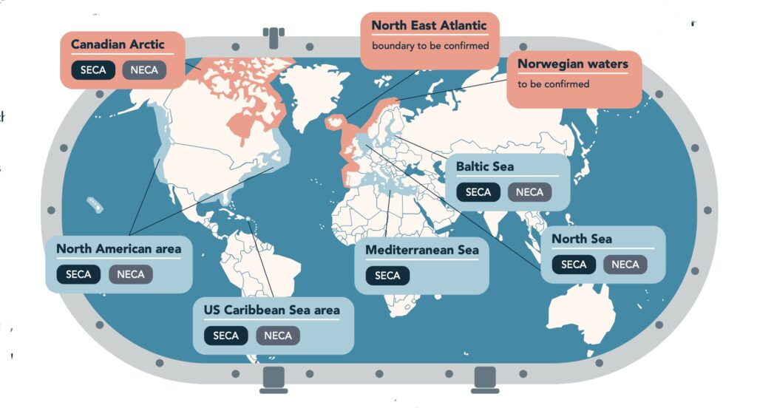
Map 0.1 Proposed and existing SOx and NOx emission control areas (ECAs: SECAs and NECAs, respectively).
Source: Image courtesy of Clean Arctic Alliance.
From 1 May 2025, the Mediterranean Sea will also become an ECA for SOx (resolution MEPC.361(79)) (IMO, 2022c) (Map 0.1). The Mediterranean Sea is estimated to be navigated by more than 30,000 vessels each year, it supports 20% of the seaborne trade and statistics estimate that in 2019, 24% of the global fleet and more than 17% of the worldwide cruises regularly passed through this basin (Leone, 2021). The implementation of the Mediterranean SECA in this region aims to reduce the impacts of these busy high traffic density routes and mitigate the health and environmental issues related to air pollution. Furthermore, the signatories of the Barcelona Convention agreed to assess and discuss the possible technical and economic feasibility of an ECA for NOx in the next two years.

Sulphur Oxides (SOx)
In 2020 the IMO established the “global sulphur cap” (resolution MEPC.305(73)) (IMO, 2018). This resolution limits the content of sulphur in the marine fuel to a maximum of 0.50% m/m for ships sailing in all sea areas (outside SECAs which have as limit 0.10% m/m) and prohibits the onboard carriage of marine fuels for combustion purposes, i.e. propulsion or operation on board a ship, that are non-compliant with the regulation.

Nitrogen Oxides (NOx)
NOx emissions in the maritime sector are regulated by IMO under Regulation 13 of MARPOL Annex VI (IMO, 2018). More specifically, the regulation targets emissions from all Diesel engines with a power output exceeding 130 kW, installed on a ship either newly built or that underwent a major conversion on or after 1 January 2000. Currently, the IMO approach foresees three different limits, namely Tier I, II and III. This three NOx Tiers dictate the specific maximum allowable NOx emissions for a marine engine, depending on ship’s keel laying date and sailing area (within an ECA or not), with Tier III being the most stringent.

Particulate Matter (PM)
For the maritime sector, at international level, there is no legislation targeting PM directly. Regulation 14 from MARPOL Annex VI, regarding the sulphur content of marine fuels and its emissions, indirectly targets PM - without limiting it or proposing a monitoring scheme – as it is one of the criteria used for the definition of SECAs.
Literature shows that low sulphur fuels have lower emissions of PM. Also, EGCS can reduce PM emissions. Studies from Lehtoranta et al. (2019) and Zetterdahl et al. (2016), showed that by switching the marine fuel from high sulphur Heavy Fuel Oil (HFO) to a low sulphur distillate fuel there is a reduction of both the PM mass (by up to 67%) and average particle size. Although particulate mass is reduced, the number of particles emitted, their dimension and their effect on human health and in the environment, still need to be addressed. This effect can already be observed in existing SECAs and is analysed in chapter 3 under Discharge waters and contaminants.

Black Carbon (BC)
Currently, black carbon emissions are not directly regulated at international level. However, both the Arctic Council and the IMO are actively considering the impacts of BC in the Arctic (AMAP, 2021). The climate change effects of BC emissions from shipping are increasingly understood (Comer et al., 2015; IMO, 2020a).
The Sub-Committee on Prevention of Air Pollution from Ships has been instructing and guiding the work at IMO, by revising existing data on measurement methods, drafting recommendatory goal-based control measures, identify ways to apply thresholds values for black carbon and research on the marine fuels to further consider direct control measures). From July 2024, the carriage and use of heavy fuel oil by ships in the Arctic was banned since HFO is considered to be the main source of black carbon emissions as well as it is a persistent oil which is extremely difficult to clean in the event of a spill, with the potential to get trapped in and under Arctic Sea ice (IMO, 2021b). Subsequently, the guidelines on recommendatory goal-based control measures to reduce the impact of Black Carbon in the Arctic are gaining shape with discussions pointing for the adoption of the guidelines in its next session (currently scheduled for February 2024).

Ozone Depleting Substances (ODS)
Global initiatives not specific to the maritime sector firstly set commitments to phase-out of consumption and production of ODS, to prevent emissions such as the 1985 Vienna Convention for the Protection of the Ozone Layer (UNEP, 1985), the 1987 Montreal Protocol (UNEP, 1987) on substances that deplete the ozone layer (noted as one of the most successful examples of international cooperation), and the 2018 Kigali Amendment on the phasing down of hydrofluorocarbons (UNEP, 2018).
In shipping, deliberate emissions of ODS are prohibited under MARPOL Annex VI, regulation 12 (IMO, 2006). These emissions are defined as the ones which occur, for example, during maintenance, servicing, repairing or disposing of cooling systems or equipment (however, they do not include minimal releases associated with the recapturing or recycling of ozone-depleting substances).

Emissions from shipboard incinerators
Incineration on board of ships is normally allowed only in a dedicated incinerator, with the specific requirements defined under MARPOL Annex VI. Examples of the main requirements are the temperature of the exhausts in the 800-1200°C range; the unburned components in ash residues at maximum 10% w/w; the CO in the exhaust maximum average 200mg/MJ. However, it is possible to incinerate sewage sludge and sludge oil generated during the normal operation of a ship, but not within ports, harbours and estuaries.

Volatile Organic Compounds (VOCs)
According to the provisions of MARPOL Annex VI, VOCs emissions from cargo are to be regulated only for tankers (oil or chemical ones) and only in ports or at terminals. This regulation also applies to gas carriers when the type of loading and containment systems allow safe retention of non-methane VOCs on board, or their safe return ashore. Following on from the regional instruments put in place to prohibit the release of gaseous cargo residues (vapours) that are harmful to the environment (i.e. degassing and venting) for inland navigation vessels (CDNI, 2017) attention will now turn to analyse how these might be applied to the maritime transport sector too.

European Union framework
At EU level there are several legislations that target air pollution, however, not all of them are specific to the maritime transport sector. Besides the ratification of international conventions such as the Air Convention (LRTAP), EU directives limit the national emission totals of pollutants by Member States, including the transport sector. One example is the National Emission Reduction Commitments directive (NEC Directive), which entered into force in 2016, replacing existing rules on the annual ceilings for national emissions (Directive 2001/81/EC) and set national emission reductions for the Member States including for NOx, NMVOCs, SO₂, NH₃ and PM_{2.5}. The objective is to achieve levels of air quality that do not give rise to significant negative impacts on and risks to human health and the environment. The Zero Pollution Action Plan further defines these targets for the target year 2030 to improve air quality to reduce the number of premature deaths caused by air pollution by 55%, and to reduce by 25% the EU ecosystems where air pollution threatens biodiversity, both targets compared to 2005. Finally the NEC Directive also requires that the Member States draw up national air pollution control programmes, which should contribute to the successful implementation of air quality plans established under the Ambient Air Quality Directive (AAQD) (EU, 2016b).
Regarding sectoral legislation applicable to shipping, the following EU regulations and directives exist:

Sulphur Oxides (SOx)
At the European level, the sulphur content of liquid fuels, including those for ships, has been regulated since 1999 with the Directive 1999/32/EC (‘’Sulphur Directive’’) and since then limits have been continuously reduced by several amendments in 2005 and 2012 respectively. The Directive (EU) 2016/802, (EU, 2016a) codified in 2016, broadly transposes in EU law the IMO limits on the sulphur content of marine fuels to 0.10% m/m inside SECAs as of 2015 and to 0.50% m/m in all other areas as of 2020, while a limit of 0.10% sulphur content also for ships at berth in EU ports was established in 2005.
Member States are responsible for the enforcement of the Directive for all vessels of all flags, including vessels whose journey began outside the EU, in their territorial seas and exclusive economic zones, including the domestic one. Furthermore, the Member States, “shall endeavour to ensure availability of marine fuels that comply with the Directive” and inform the European Commission of such availability in its ports and terminals. The specific abatement methods defined by the Directive are mixture of marine fuel and boil-off gas, biofuels and EGCS.

Nitrogen Oxides (NOx)
While there is no direct EU regulation for EU legislation broadly addresses NOx reduction from international shipping, EU Member States are required to comply with the international legislation under MARPOL Annex VI and the NECAs. Attention is wide and concerns were raised at the IMO because of current non-compliance. Indeed, applicable limits are being checked through emission remote sensing in NECAs at low engine loads. Moreover, NOx engine standards applicable in the EU for inland vessels are among the strictest in the world.

Particulate Matter (PM)
At the European level, particulate matter is broadly regulated. Emissions from engines used in Inland waterway vessels and rail are limited within the Non-road mobile machinery Directive (EU, 2016d), however in a less restrictive way when compared with road transport (DNV, 2016). The AAQD (EC, 2008) and the NEC Directive (EU, 2016c) cover PM in their reporting, which are not directly linked with the maritime transport emissions. Regarding road transport, the European legislation covers this emissions both on particle mass and particle number (see Euro 6 Regulation – Regulation (EC) No 1151/2017) (EC, 2017), and Euro VI - Regulation (EC) No 582/2011 (EU, 2011).

Black Carbon (BC)
While at the European level there is no regulation in place for the shipping sector, within the NEC Directive, Member States have a reporting obligation for BC, whenever they monitor this pollutant. Reports are also being developed to support international actions. As an example, the EU-funded Action on Black Carbon occurred from 2018-2020 to develop knowledge on sources, and emissions, and support the international processes. In addition, the recent EU policy for the Arctic also makes a reference to black carbon (EC, 2021d).

Ozone Depleting Substances (ODS)
International agreements have been transposed into EU policy frameworks since the 1980s, with a high-level of ambition for the fast phase-out of ODS. The Regulation on Substances that Deplete the Ozone Layer aims to fulfil the Montreal Protocol, and also adds new, additional requirements to prevent emissions. In general, ODS production, use and trade are prohibited in the EU with only few exemptions. Moreover, intentional release of ozone-depleting substances into the atmosphere, including when contained in products and equipment, is prohibited under this Regulation, and all feasible measures must be taken to avoid unintentional emissions.

Monitoring and reporting framework
Air pollution inventories
The joint EMEP/EEA (European Monitoring and Evaluation Programme/ European Environment Agency) air pollution inventories for navigation are annual estimates provided by Member States based on fuel consumption. These inventories are the outcome of the reporting required under the Air Convention (article 8), and include emissions of CO₂, CH₄, N₂O, carbon monoxide (CO), non-methane volatile organic compounds (NMVOCs), SOx, NOx and PM for all water-born transport ranging from recreational craft to large ocean-going cargo vessels. For the purposes of the inventories, the definition of both navigation and fishing activities are consistent with ones defined under the auspices of the IPCC reporting and presented previously in the GHG section.

Sulphur Oxides (SOx)
The Sulphur Directive requires for EU Member State to ensure frequent and accurate sampling of the marine fuels available on the market or to be used onboard ships, as well as regular verifications of the ships’ logbooks, bunker delivery notes and sampling of the fuel onboard ship. Furthermore, Member States have to deliver an annual report to the European Commission (by the 30 of June) fulfilling several requirements on the monitoring and sampling carried out in the previous year, such as total annual number of vessels inspected, samples taken, as well as non-compliant vessels, penalties applied, a list of all the name and address of marine fuels suppliers in the relevant Member States, etc.
According to the Directive, ships have to keep onboard the information regarding the fuel used and in case of inspection produce the evidence. The Sulphur Directive also stipulates that the ship’s logbook should be correctly completed including fuel-changeover operations when entering in SECA areas. In 2015, a Commission Decision (EU) 2015/253 (EC, 2015), laid down the rules for the fuel sampling and reporting aiming for the cost-efficient and coherent implementation and enforcement of the Directive. It defines the fuel sampling methods and information to be included in the annual report and, defines that Member States shall inspect 10% of the ships’ logbooks and bunker delivery notes on board from the total number of individual ships calling in EU ports per year.

Nitrogen Oxides (NOx)
The control of Diesel engine NOx emissions is achieved through the survey and certification requirements leading to the issue of an Engine International Air Pollution Prevention (EIAPP) Certificate and the subsequent demonstration of in-service compliance in accordance with the requirements of the mandatory regulations, NOx Technical Code 2008 (resolution MEPC.177(58); IMO, 2008). This is performed in an early stage in laboratory on a test bed (pre-certification) or directly on-board (combined pre-certification and initial certification). In both cases, this is done according to standard test cycles with predefined speed and load profiles, and performed in reference conditions. Ensuring compliance with the limits established in MARPOL Annex VI should translate into low NOx emissions in real applications. Nevertheless, in order for this to take place, the testing conditions must be fully representative of those encountered in real world operation in term of load profiles, ambient temperature, fuel quality, etc.

Particulate Matter (PM)
From a monitoring perspective, although there is no specific reporting and monitoring scheme exclusively dedicated to PM emissions, the existing reporting and monitoring mechanisms, along with regulatory measures targeting SOx, NOx, and fuel quality, indirectly contribute to the reduction of PM emissions from the maritime sector. There are inventories targeting PM, however, these inventories are estimations based on calculations of local emission factors linked to fuel consumption. The challenge is to accurately determine emission factors which adequately reflect the variety of ship operations, a problem which is further complicated by the fact that available PM measurement tools are not commonly used in the shipping sector (DNV, 2016).

Observations from Remote Piloted Aircraft Systems and other remote sensing technology used by Member States
EMSA’s Remotely Piloted Aircraft Systems (RPAS) services are designed to assist with maritime surveillance activities linked with the implementation of Member States’ Coast Guard functions. These unmanned aerial vehicles, or drones, are equipped with different types of sensors and cameras that can collect and transmit real-time data to users, helping them with tasks such as monitoring ship emissions, detecting oil pollution, and maritime surveillance operations.
RPAS can be utilized for air pollution monitoring by using gas sensors (‘sniffers’) to measure the SOx, NOx, and CO₂ content in a ship’s plume. The fuel sulphur content (FSC) of the ship’s fuel can be estimated by considering the ratio between SOx and CO₂, adjusted by an emission factor. In the case of nitrogen, the emission can again be estimated by considering the ratio with CO₂ and additionally factoring in the fuel efficiency of the engine, expressed in g/kWh. Both fuel sulphur content and NOx emission rate are estimated with a certain level of uncertainty, which under specific circumstances may account to up to 30% (FSC) and 50% (NOx emission rate) of the value.
EMSA’s RPAS are also equipped with optical cameras and AIS receivers, which can capture images of the monitored vessels and retrieve their information, such as geographical position and heading. Data related to fuel sulphur content is also shared with the EU platform that logs and exchanges information on the results of individual compliance verifications conducted by Member States’ competent authorities under the Sulphur Directive (THETIS-EU).
The gas measurements gathered by RPAS complement the emission monitoring activities undertaken by Member State authorities, ensuring all vessels transiting in European waters comply with legal requirements. Specifically, aerial measurements may be collected in open sea areas, where inspections are not feasible, and/or when vessels do not expect measurements (for example in high seas SECA areas).

Water Pollution
Ships can be a source of pollution in sea water which covers all types of releases that can originate from the normal operations of a ship as well as accidental releases. The pollution includes several types of substances such as oil, chemicals carried in bulk, garbage or sewage, other discharge waters and contaminants emitted into the water column, such as anti-foulants, as well as ballast waters, pollutants deposited via the atmosphere, and underwater radiated noise. A ship-related pollution problem arises from the dredging and relocation of contaminated sediments in waterways and ports.

Contaminants and oil spills
Regulatory framework
International framework
From an international perspective, the MARPOL Convention (The International Convention for the Prevention of Pollution from Ships) covers the regulations for the prevention of pollution and details the discharge requirements for ships (IMO, 1983). The introduction of MARPOL in 1983 was the response to the rising number of tanker accidents in that period. The Convention introduced several concepts and regulations that paved the way for safer procedures to prevent the occurrence of oil spills. These concepts include separated ballast tanks, double hull regulation, together with other safety-related instruments such as enhanced seafarers training.

Oil
MARPOL Annex I covers the regulations for the control of pollution by oil. For example, it is illegal if a ship discharges oil with concentration above 15 ppm (parts per million). This applies to tankers above 400 GT while en-route outside a special area, for oil, which originates from cargo pump room bilges and has not been processed through oil filtering equipment.

Noxious substances
MARPOL Annex II covers the regulations for the control of pollution by Noxious Liquid Substances in Bulk. For example, it is illegal if a ship discharges noxious liquid substances at a rate exceeding the maximum rate for which the underwater discharge outlets were designed. This applies to ships while en route at a speed less than 7 knots discharging residues of noxious liquid substances in Category X, Y or Z (as per the International Bulk Chemical Code) at a distance less than 12 nautical miles from the nearest land and in a depth of water less than 25 meters.

Goods containing harmful substances
MARPOL Annex III covers the regulations for the control of pollution by harmful substances carried by sea in packaged form. For example, it is illegal if a ship jettisons harmful substances in packaged form where it is not necessary for securing the safety of the ship or saving life at sea. This applies to the jettisoning of packaged goods as per the International Maritime Dangerous Goods Code.

Sewage
MARPOL Annex III covers the regulations for the control of pollution by sewage. For example, it is illegal if a ship discharges sewage which is not pre-treated. This applies to ships while en-route at a speed less than 4 knots and at a distance less than 12 nautical miles from the nearest land, instantaneously discharging sewage held in holding tanks, which is not comminuted or disinfected. Regarding MARPOL Annex IV on sewage, most of the ship-source sewage discharge into sea is legal, in line with MARPOL discharge norms. The Baltic Sea is an exception as the IMO designate it as a Special area under MARPOL Annex IV, meaning that discharge of sewage from passenger ships (including cruise ships) is prohibited.

Garbage
MARPOL Annex V (garbage) regulates the discharge into the marine environment of plastic, domestic wastes, cooking oil, incinerator ashes, operational waste, fishing gear and animal carcasses generated during the normal operation of the ship and liable to be disposed of continuously or periodically. For example, it is illegal if a ship discharges garbage food waste, which cannot pass through a screen with openings less than 25 mm. This applies to ships while en-route within a special area at a distance less than 12 nautical miles from the nearest land and for food waste which was not comminuted or grounded.

European Union Framework
The Ship-Source Pollution Directive (SSP Directive 2005/35/EC), tackles the issue of illicit discharges from ships and thereafter introduces rules for adequate penalties for infringements (EU, 2005, 2009b).
Geographically, the SSP Directive covers illegal discharges of polluting substances carried by any ship except for warships or other state owned or operated ships used only for government non-commercial service),. Ships are covered by this directive irrespective of their flag and the maritime zone in which the illegal discharge was committed. It encompasses all shipping maritime zones as set under the United Nations Convention on the Law of the Sea (UNCLOS, 1982), from a territorial waters to the high sea, including extends to straits used for international navigation to the extent that a Member State exercises jurisdiction over them.
The SSP Directive defines infringements caused by ships and obligations of Member States to follow up such infringements. It implies that the penalties imposed must be effective, proportionate and dissuasive. The SSP Directive works together with the Directive on Port Reception Facilities (PRF Directive) which ensures adequate facilities for ships to discharge their waste in ports.
The SSP implies penalties for the following offences:
- If a discharge of oil is illegal based on international standards set in MARPOL Annex I;
- If a discharge of Noxious Liquid Substances in Bulk is illegal based on international standards set in MARPOL Annex II;
- If a discharge of harmful substances carried by sea in packaged form is illegal based on international standards set in MARPOL Annex III;
- If a discharge of sewage is illegal based on international standards set in MARPOL Annex IV;
- If a discharge of garbage is illegal based on international standards set in MARPOL Annex V.

Monitoring and reporting framework
Prior to 2024, the Ship-Source Pollution Directive required Member States authorities to report on the application of the Directive every three years. However, there was no requirements for the type of information to be reported and as a result there was little information collected. With the 2024 amendment of the SSP Directive, the reporting framework has been improved and more monitoring data will be available to analyse of pollution incidence and penalties imposed. (EC, 2023e).

CleanSeaNet service
The SSP Directive was the impetus behind the creation of the CleanSeaNet service, the European satellite-based oil spill monitoring and vessel detection service, set-up and managed by EMSA. The service provides support to EU Member States and countries of the European Economic Area in detecting and tracing illegal discharges at sea of mineral oil and noxious liquid substances that behave like oil, which in turn enhances Member States’ capabilities in addressing illegal discharges from ships to penalise them. Alert reports are generated and sent to the affected Member States, who then validate the information by their own means for verification on site or inspecting the vessel the ’potential polluter’.at port. Verification feedback from Member States is important in confirming and providing additional information on the pollution type and its source (e.g. offender). Member State can report not only CleanSeaNet service feedback forms on the potential pollution identified but also by pollution incident reports (POLREP) exchanged as part of SafeSeaNet and inspection requests related to suspected MARPOL infringements submitted via THETIS. For example, Member States submit on average only approximately 200 SafeSeaNet pollution incident reports and 120 inspection requests via THETIS annually. Feedback to CleanSeaNet alerts is higher, with Member States submitting on average 1400 feedback forms annually.
Voluntary reporting procedures regarding ship-source pollution exist at regional level under the Regional Sea Conventions in Europe. Reporting by relevant parties to Regional Sea Conventions is more advanced in some regions e.g. Baltic and North Sea (where reports on aerial surveillance activities are published annually), and less advanced in others e.g. Black Sea. In 2018-2019, 14 Member States reported to HELCOM and the Bonn Agreement on oil spills. The regional reporting commitments are however limited to a regional sea which means a narrow geographical scope.

International IMO reporting procedures regarding observed ship source pollution and relevant MARPOL enforcement cases also exist. The MARPOL Convention (article 11) requires the parties to the Convention to communicate to the IMO certain types of information, including “an annual statistical report, in a form standardized by the Organization, of penalties actually imposed for infringement of the present Convention” (IMO, 1983). Reporting to IMO on marine incidents, including marine safety investigations, has been low and with significant gaps for European parties of IMO. There is no representative information on the number of incidents nor penalties imposed. Contracting Parties of MARPOL should submit their reports using the Global Integrated Shipping Information System.

Discharge waters
In addition to MARPOL Annex I and II, several other types of ship source pollution and water discharges from ships are regulated. These include sewage, oily discharges, ballast waters and discharge waters from Exhaust Gas Cleaning Systems (EGCS) in Annex VI. An EGCS, also known as scrubbers, which are an abatement technology that aims to reduce SOx emissions from high sulphur fuels by using a fine alkaline water spray through the gas that will produce the SOx, (and to certain extent NOx, and other contaminants such as black carbon, PAH and metals) to be dissolved and washed out during the scrubbing process. The development of this type of technology is driven by the introduction of Sulphur Emission Control Areas (SECAs) and by the “global sulphur cap” mentioned in section A1.1.2- Air Quality and depletion of the ozone layer. The scrubber process avoids pollution from SOx emissions from high sulphur fuels to the atmosphere and produces acidic wash water as a by-product. Discharges from the scrubbing process to the marine environment may therefore be harmful if the discharge water is not treated in an appropriate way (Ji et al., 2023; et al., 2023). A set of potentially toxic contaminants such as nitrates, metals, and other organic compounds may, in fact, be transferred to the marine environment (scrubber water discharges) as a result of the offset of air pollution (reduced SOx emissions to the atmosphere) (García-Gómez et al., 2023; Jönander et al., 2023; Hermansson, et al., 2023a; 2023b; Marin-Enriquez et al., 2023; OSPAR Commission, 2022; Petrović et al., 2022).

Regulatory framework
International framework
In the case of EGCS, at IMO, the discussion on the importance of not transferring such pollution from air to sea has started and attention has been brought to this issue with the adoption of different documents, such as MEPC.340(77) and MEPC.1/Circ.899 on scrubber discharge waters (IMO, 2021c, 2022a), and MEPC.1/Circ.900 on scrubbers’ residues delivery to port reception facilities (IMO, 2022b). The transfer of pollution, is covered under the United Nations Convention on the Law of the Sea (UNCLOS), among others, under Article 195, where it is stated that there is a "Duty not to transfer damage or hazards or transform one type of pollution into another" (UNCLOS, 1982). The potential conflicts between the regulations in place and UNCLOS are currently being discussed at IMO (see for example document IMO MEPC 81/9 (IMO, 2024).

European Union framework
The key EU legislation for scrubber discharge wasters in the Sulphur Directive and the Ship-Source Pollution Directive. While there is not a specific EU policy framework regulating the use of EGCS, the MARPOL regulations have been transposed into EU law as an alternative method of compliance with the international standards on SOx emissions by the Sulphur Directive. Furthermore, EGCS residues, including wash wasters that do not conform with the IMO discharge criteria into sea are covered by Directive (EU) 2019/883 on Port reception facilities for the delivery of waste from ships (EU, 2019a). Lastly, EGCS water pollution can be connected with other European level legislations regulating the marine environment and ship waste, that regulate pollutants that among others, are present in the wash water discharges of EGCS, such as (metals and contaminants) through Directive 2008/105/EC Environmental Quality Standards (EQS; EU, 2008b), Directive 2008/56/EC Marine Strategy Framework (EU, 2008a) and Directive 2000/60/EC Water Framework (WFD; EU, 2000).

Monitoring and reporting framework
From a monitoring perspective, the current international framework provides tools under two international non-binding instruments: 1) The 2021 IMO EGCS guidelines (resolution MEPC.340(77)) which provides a set of criteria and schemes to be followed on the testing, survey, certification and verification of the EGCS (IMO, 2021c), and 2) The 2022 IMO Guidelines for risk and impact assessment of the discharge water from exhaust gas cleaning systems (MEPC.1/Circ.899) which provides a harmonised and unified approach to be used by Member States when considering local or regional regulations to protect sensitive waters/environment from the discharge water from EGCS (IMO, 2022a).
The IMO 2021 EGCS Guidelines establishes a methodology with two schemes for approval of an EGCS by the Administration that aims to ensure that scrubbers are effectively meeting the sulphur emission reductions and comply with the emission ratio limits and the environmental criteria for the system’s water discharges, leaving the door open to future binding regulations. The discharge of water according to the guidelines is predicted to comply with water quality criteria, pH, PAH, turbidity, suspended particulate matter, nitrates, wash water and discharge water additives and other substance, and discharge water from temporary storage. The European Union aims that the guidelines are revised, and it is expected that the work triggered in 2019 is finalised by 2025 with a possible regulatory development, through the output on “Evaluation and harmonisation of rules and guidance on the discharge water from EGCS into at the aquatic environment, including conditions and areas”. The European Commission have been very important for the developments at IMO, with several submissions on the health and environmental impacts and toxicity of EGCS discharges, asking for the revision of MARPOL to add a clear definition of what are discharge waters (IMO, 2019a, 2019c, 2021a, 2023b).
The IMO Guidelines for risk and impact assessment of the discharge water from exhaust gas cleaning systems (MEPC.1/Circ.899) and the application of such recommendatory guidelines is for Member States to use when undertaking national, local or regional level risk and impact assessments regarding EGCS discharge water in their territorial waters. Considering various metals as cadmium, lead, nickel and vanadium and also various PAH such as acenaphthene, benzo(a)anthracene and pyrene. Also including in the analysis data concerning and available on a database in the IMO, are physico-chemical data, ecotoxicological data and toxicological data.
However, due to the lack of binding regulations to further control the use of ECGS and resulting wash, a growing number of EU Member States have restricted or banned the use of scrubbers in high-traffic areas like ports and canals due to their environmental impacts, by introducing, either under national legislation or through Port Authorities, additional conditions for the operation of scrubbers. These measures vary from not allowing discharges of wash waters from open-loop (OL) scrubbers in specific port areas to the prohibition of wash water discharges within 3 nautical miles (NM) off the coast. To date, restrictions (or bans) are in force in 16 European Union countries including Belgium, Croatia, Cyprus, Estonia, Finland, France, Germany, Ireland, Latvia, Lithuania, Norway, Portugal, Romania, Slovenia, Spain and Sweden at different levels (Map ) (EGCS Association, 2023). Information on Bulgaria, Denmark, Greece, Malta, The Netherlands and Poland is not available. In addition, work is progressing towards potentially adopting binding regulations in MARPOL Annex VI to regulate the discharge waters from EGCSs.
With the ambition of further reducing the emission of SOx and the Europe’s collective objective to expand SECA regions, we can expect the use of EGCS to increase in the future. According to a recent study by DNV, the global fleet equipped with scrubbers is bound to continue to increase in the following years, with numbers exceeding the 5,000 scrubber-equipped vessels currently registered in 2023 (DNV, 2023a).

Ballast Water and Non-indigenous species
Non-indigenous species (NIS) also referred as non-native, alien, invasive or exotic organisms, refer to species that have been introduced to environments outside of their natural range through human activities, including shipping. NIS are called invasive alien species (IAS) when they create serious negative consequences for their new environment.
Currently, around 800 NIS exist in the European seas (JRC, 2021) and approximately 87 NIS are recognised as invasive in European marine environments (EEA, 2023a). The largest proportion of NIS introductions into European seas are associated with shipping (via ballast waters and ship hauling) (46,6%). Ballast water is used to maintain ship stability during voyages, and it is often taken up in one location and discharged in another, so in addition to the introduction of non-native species, the movement of contaminants such heavy metals, poisons, or pharmaceutical ingredients can also be a worry (Lv et al., 2022).

Regulatory framework
International framework
At global level the regulatory framework is based on the International Convention for the Control and Management of Ships’ Ballast Water and Sediments, 2004 (BWM Convention), which entered into force globally in September 2017 (IMO, 2017). The BWM Convention applies to all ships carrying ballast waters during international voyages. Internationally trading ships of 400 GT and above are required to carry an International Ballast Water Management Certificate, an approved Ballast Water Management Plan and a Ballast Water Record Book.

European Union framework
One of the key commitments of the Biodiversity Strategy is to manage established invasive alien species and decrease the number of Red List species – the species that face the risk of extinction – that IAS threaten by 50%. To tackle Invasive Alien Species (IAS) Regulation (EU) No 1143/2014 sets out guidelines to prevent, minimise, and mitigate the negative impact of IAS on biodiversity. (EU, 2014b).
The Marine Strategy Framework Directive (MSFD, 2008/56/EC; EU, 2008) good environmental status includes a descriptor for preventing adverse alterations to ecosystems caused by NIS.

Monitoring and reporting framework
From a BWM Convention perspective, the number and share of the ships that meet D-2 standard might allow to assess the progress on preventing the spread of NIS and IAS. In addition, an indicator monitoring the decrease of the number of Red List species threatened by the IAS by 50% is currently under development and will be used to monitor the Biodiversity Strategy 2030 (EC, 2023f). MSFD follows an adaptive management approach, and thus it must be kept up-to-date and reviewed every 6 years.

Underwater radiated noise
Shipping is known to be one of the primary contributors to anthropogenic noise in seas and oceans. Considering the characteristics of sound propagation in water and anatomical adaptation, sound is used by fauna as the main mechanism to interact with the surrounding environment, being used for social interactions, reproduction, navigation, detection of obstacles and preys. Available evidence shows that shipping contributes to the impacts generated by underwater radiated noise (URN) (Cruz et al., 2021; Duarte et al., 2021; Erbe et al., 2019). Several policies are being implemented under the auspices of International Multilateral agreements, Regional Sea Conventions and at European level.

Regulatory framework
International framework
At international level, in 2023 the IMO successfully reviewed the Guidelines on the reduction of Underwater Radiated Noise (IMO, 2023e). These guidelines are intended to assist all relevant stakeholders in establishing mechanisms through which noise reduction efforts can be achieved and recommend shipowners and designers to undertake noise management planning at the earliest design stages. Similarly, underwater radiated noise management planning may be conducted for existing ships. The Guidelines provide for the development of a noise management plan that allows a customized approach suitable to an individual ship’s design and operation, as well as the establishment of the (predicted or actual) baseline underwater radiated noise level, setting quantitative targets where possible and selecting the URN reduction approaches and related actions.
The revised guidelines also include a dedicated section about the relationship between the Energy Efficiency Compliance Measures and underwater radiated noise. Many of the energy efficiency improvement options to meet energy efficiency regulations (EEDI, EEXI and CII) can result in an improvement in underwater radiated noise performance and could therefore provide positive synergies with climate policies. Important to note that the Guidelines also provide a role for Member States administrations and other stakeholders to take supportive actions in defining noise sensitive areas and species, possibly setting future overall URN targets, establishing incentives programs and on evaluation and monitoring.

European Union framework
In the European Union, underwater radiated noise is addressed by the Marine Strategy Framework Directive, which introduces threshold levels and requires the monitoring of underwater noise levels and its adverse effects in EU waters.
One of the flagship actions of the Zero Pollution Action Plan is reducing underwater noise through the EU threshold values to be set under the Marine Strategy Framework Directive (ZPAP, COM (2021) 400; EC, 2021f). The Commission (through the work of the Technical Group on Noise – TG NOISE) established the threshold values in 2022 (TG NOISE, 2022) for underwater noise stemming from activities such as shipping, offshore construction, and marine exploration. More specifically, Descriptor 11 of the MSFD covers the introduction of energy, including continuous (and impulsive) underwater radiated noise, and requires that it must be at levels that do not adversely affect the marine environment.

Monitoring and reporting framework
According to the 2017 Commission Decision (EU, 2017), GES for underwater radiated noise must be assessed based on two criteria, one of them being “Anthropogenic continuous low-frequency sound”, where shipping noise is included. The second criteria is that the spatial distribution, temporal extent and levels of anthropogenic continuous low-frequency sounds do not exceed levels that adversely affect populations of marine animals, which requires Member States establishing threshold values for these levels through cooperation at Union level, considering regional or sub-regional specificities.

Marine litter and waste generation

Marine litter, passively fished waste and container loss
Marine litter is defined as all human-made solid items that end up in the coastal or marine environment. The major cause is poor waste management and littering on land, and seaborne activities such as shipping and fishing also contribute to the problem (EEA, 2023b).
Up to a third of the litter generated by merchant shipping is not correctly delivered and processed in port (EC, 2018). Ship paints also have been identified as one of the largest and significant sources of microplastic pollution in the oceans (Gondikas et al., 2023). In macro and micro forms, sea-based sources account for around 20% of marine litter (UNEP, 2005; SEI, 2016).
The loss of containers is also considered as sea-based source of marine litter. Containers transport a great variety of goods, in which toxic products and hazardous substances exist. The loss of containers can lead to containers to sink without any further information about its location that may cause habitat destruction, they can open at sea and liberate the cargo or they can wash up to shore.

Regulatory Framework
International framework
Marine litter is a transboundary problem. There is an ongoing process for a binding international agreement on plastics. In February 2022, during the fifth session of the United Nations Environment Assembly (UNEA-5.2), a significant resolution (UNEP/EA.5/Res.14) was adopted to establish an international legally binding agreement on plastic pollution and marine litter (‘Plastics Accord’). The goal is to complete the negotiations by the end of 2024.
The IMO Strategy, adopted in 2021, aims to achieve zero plastic waste discharges to sea from ships by 2025” (IMO, 2023c). Within this context, several initiatives to address marine plastic litter from ships and strengthen international legislation are ongoing at IMO, including:
- Evaluation of regulatory measures to reduce the environmental risk associated with the transport of plastic pellets. The aim will be to improve packaging, stowage on board, labelling and improve disaster response and pollution preparedness (Faber, J. et al., 2023). To this extent an IMO Circular is being drafted as a short-term measure of reducing the environmental risks associated with the carriage of plastic pellets in packaged form by sea (IMO, 2023).
- An amendment to MARPOL Annex V to provide for the reporting mechanisms, the modalities and the information to be reported to Administrations and IMO to facilitate and enhance reporting of the loss or discharge of fishing gear.
Recognising the serious hazard to navigation, safety at sea and marine environment from lost containers, the IMO has agreed to amend chapter V of the SOLAS Convention and protocol I of the MARPOL Convention with a view to make mandatory the reporting of lost containers through a standardized procedure from 2026 (IMO, 2022d).

European Union framework
The EU’s ZPAP (EC, 2021f) sets ambitious quantitative targets for reducing plastic litter at sea by 50% (in terms of number of items) and the quantity of microplastics released into the environment by 30% by 2030, taking 2016 as the reference year (EC, 2021f). These targets are supported by the Circular Economy Action Plan, which identifies plastics as one of its five priority areas. The EU Plastics Strategy (COM (2018) 028) specifically addresses the leakage of plastics and microplastics and includes the Single Use Plastics Directive (2019/904/EU; EU, 2019) which focuses on targeting the ten most found single-use plastic items on Europe's beaches and seas.
The MSFD creates a legally binding framework for assessing and monitoring litter quantities, spatial distribution and impacts in the marine and coastal environment and thereby plays a significant role in reducing marine litter and addressing the issue of marine plastic pollution from all sources in Europe.
When it comes to passively fished waste, the Port Reception Facilities (PRF) Directive 2019/883/EU includes a requirement to dispose (at port) and report the waste collected by fishers in bets during their work (EU, 2019a).
The new fisheries Control Regulation (just entered into force on 9 January 2024), includes articles on regulating fishing gears lost at sea (related to logbook) and on the retrieval of lost gears (EU, 2023e).
At EU level, the issue of reporting/notification of lost containers is addressed in European Union legislation through Directive 2002/59/EC on the establishment of a Community vessel traffic monitoring and information system (EU, 2002) and Directive 2009/18/EC governing the investigation of accidents in the maritime transport sector (EU, 2009a). Directive 2002/59/EC requires that ships report to the coastal Member States containers or packages seen drifting at sea.

Monitoring and Reporting Framework
The PRF Directive imposes obligations on Member States to collect and report monitoring data on passively fished waste from fishing vessels. Some countries utilise existing schemes such as the Fishing for Litter initiative (KIMO, 2023) to collect passively fished waste data. Passively fished waste can be considered as an indicator correlated to the quantities of litter in the sea. The first data were reported in 2021 (see Chapter 3 for the results).
Marine litter is also one of the GES descriptors (D10) of the MSFD. There is an ongoing effort at the Technical Group on Marine Litter to define GES threshold, which has already been achieved for the coastline, where the threshold has been set at 20 litter items per 100 meters of coastline. To achieve GES, Member States must establish and implement a programme of measures, including for the shipping sector, if necessary. Most countries reported on GES (MSFD Art.8).
As previously mentioned, pellets could also be classified in the future as a "harmful substance" in International Maritime Law, which would bring about more stringent obligations regarding their handling, as well as mandatory reporting should containers be lost at sea. Discussions are ongoing regarding this in the International Maritime Organization, supported by the EU. Monitoring efforts should also focus on the impacts of these pellet losses on the environment, fauna and human health.
Finally, while the reporting of lost containers is mandatory at EU level and will become mandatory at international level as of 2026, there is no mandatory procedure to what to do next, even though under the Nairobi International convention on the Removal of Wrecks includes “cargoes that are lost at sea from ships are defined as wrecks”, the practical procedures to its recovery are extremely difficult (IMO, 2007; Jo, 2020). Future mechanisms for liability and compensation could also be considered to avoid, for example, that clean-up activities are paid by the coastal municipalities instead of the polluters. To report containers lost at sea within the EU, a reporting model has been developed through SafeSeaNet and has been systematically used since 2012 (EU, 2002). In addition, data reported to the European Marine Casualty Information Platform (EMCIP), as part of the Directive 2009/18/EC governing the investigation of accidents in the maritime transport sector, provides the most comprehensive overview of lost containers within the EU waters (EMSA, 2011).

Waste reception at ports
Regulatory Framework
International framework
The MARPOL Convention and its Annexes contain general discharge prohibitions for a number of pollutants as describe above and sets out the norms and conditions under which certain types of waste can be legally discharged into the marine environment. At the same time, MARPOL requires its contracting parties to provide for facilities in ports and terminals for the reception of the waste and residues from ships. These port reception facilities must be adequate, i.e. capable of receiving the types and quantities of waste from ships normally visiting the port where those facilities are located, without causing undue delay.

European Union framework
The PRF Directive was developed with the aim to protect the marine environment against the negative effects from discharges of waste from ships by improving the availability and use of adequate port reception facilities in the Union and the delivery of waste to those facilities. In 2021, four implementing regulations were adopted to include specific definitions on the method to check if a ship has sufficient storage capacity for waste; the union risk-based targeting mechanism to select which ships to inspect; the criteria for determining that a ship produces reduced quantities of waste and manages its waste in a sustainable and environmentally sound manner, and; the monitoring data methodologies and the format for reporting passively fished waste.
The PRF Directive also encourages lower waste generation and sustainable handling by ships. Ships must fulfil at least one of the mandatory criteria (either an on-board waste segregation or adopting environmentally sustainable purchasing policies) in order to have a reduced waste fee in EU ports. The Directive also stipulates a minimum annual inspection requirement for vessels, allowing PRF inspectors to record waste disposal operations, which can contribute to the analysis of waste management at sea.

Monitoring and Reporting Framework
The PRF Directive mandates the electronic reporting of waste receipts from ships through the SafeSeaNet system in the EU. The waste receipts provide valuable source of information on different waste types generated by ships and delivered at EU ports. The electronic reporting of waste receipts started in September 2022.

Ship Recycling
Regulatory Framework
International framework
The Hong Kong International Convention for the Safe and Environmentally Sound Recycling of Ships, 2009 (the Hong Kong Convention, HKC), adopted in May 2009, aims at ensuring that ships do not pose any unnecessary risks to human health, safety and to the environment, when being recycled after reaching the end of their operational lives. This also addresses issues such as the ships going for recycling may contain environmentally hazardous substances such as asbestos, heavy metals, hydrocarbons, ozone-depleting substances and others. It also addresses concerns raised about the working and environmental conditions at many of the world's ship recycling locations. The HKC applies to:
- ships entitled to fly the flag of a Party or operating under its authority;
- ships of 500 GT and above or to ships operating throughout their life only in waters subject to the sovereignty or jurisdiction of the State whose flag the ship is entitled to fly. and,
- Ship Recycling Facilities operating under the jurisdiction of a Party.
The Hong Kong Convention (ratified by 11 EU Member States by the beginning of 2024) will officially enter into force on June 26, 2025 and will cover:
- the design, construction, operation and preparation of ships so as to facilitate safe and environmentally sound recycling without compromising the safety and operational efficiency of ships;
- the operation of ship recycling facilities in a safe and environmentally sound manner, and;
- the establishment of an appropriate enforcement mechanism for ship recycling, incorporating certification and reporting requirements.
The Convention, requires that ships to be sent for recycling will be required to carry a ship specific inventory of hazardous materials (IHM), based on a list of hazardous materials included that are contained in an appendix to in the Convention.

European Union Framework
Regulation (EU) No 1257/2013 (EU, 2013) on ship recycling (SRR) aims to prevent, reduce and minimise accidents, injuries and other negative effects on human health and the environment when ships are recycled and the hazardous waste they contain is removed. It sets out the following responsibilities for ship owners and for recycling facilities both in the EU and in other third countries:
- Every new and existing ship flagged to an EU MS has to have on board an inventory of the hazardous materials
- Before a ship flagged to an EU Member State is recycled, its owner must provide the facility carrying out the work with specific information about the vessel and that facility should prepare a ship recycling plan. This, for instance, identifies the type and amount of hazardous materials and waste that will be generated from the obsolete vessel.
- A ship flagged to an EU MS may only be recycled at facilities listed on the EU List of facilities, which was established by Commission Implementing Decision (EU) 2016/2323. The facilities may be located in the EU or in non-EU countries. They must comply with a series of requirements related to workers' safety and environmental protection.
- These requirements are designed to prevent health risks to the workers involved and the neighbouring population and to minimise any adverse effects on the environment. They also provide for specific training and protective equipment for employees dismantling the vessels and require a record to be kept of any incidents or accidents.
- The legislation contains an authorisation process for ship recycling yards within the EU. Those in other countries must submit an application to the European Commission and demonstrate that they fulfil all the criteria in the regulation.
Article 12 of the SRR extends the requirement to have an Inventory of Hazardous Materials (IHM) onboard to all vessels entering an EU port, regardless of the flag and this has to be certified through a Statement of Compliance from the flag State administration. Many flag States have met this requirement through using the IHM Certificate in the HKC text and adding a reference to the EU legislation to prove compliance.
One of the main differences between the HKC and the SRR is the requirement for EU Flagged ships to be recycled in an EU approved Ship Recycling Facility. The Regulation (EC) No 1013/2006 on Waste Shipment of the European Parliament and of the Council, of 14 June 2006, applies within the European Union the requirements of the Basel Convention on the Control of Trans Boundary Movements of Hazardous Wastes and their Disposal and also applies an amendment to the Convention adopted in 1995 (EU, 2006). The so-called 'Basel ban' entered into force in 2019 and prohibits the export of hazardous waste from Member States (MS) to countries that are not members of the Organization for Economic Cooperation and Development (OECD).
Under Regulation (EC) No 1013/2006, ships flying the flag of an EU Member State sent for dismantling are classified as hazardous waste because dangerous substances are present therein. The regulation covers only vessels that do not fall within the scope of Regulation (EU) No 1257/2013. However, with the future Regulation (EC) No 1013/2006, the ban to export end-of-life vessels for recycling in shipyards located in non-OECD countries will also apply to ships under Regulation (EU) No 1257/2013 that become waste in the EU.

Monitoring and reporting framework
In accordance with Article 21 of the SSR, EU Member States must submit reports on ship recycling every 3 years, including information such as lists of ships to which a ready for recycling certificate has been issued and information on illegal ship recycling. Further to this, Article 30 of the SRR calls for a review of the Regulation 18 months before entry into force of the HKC. An evaluation is presently being undertaken to assess how well the Regulation contributes to the general policy objectives of the European Green Deal and the circular economy action plan as well as how it has been applied and its impact to date, and to identify shortcomings with its implementation and enforcement.
Issues being considered in the review include a financial measure to improve the number of ships being recycled in the EU listed facilities and improvements in implementation and enforcement. Today the regulation is largely circumvented by ship owners re-flagging their ships to non-EU flag, in particular flag of convenience, with the view to dismantle the ships in non-EU listed facilities, mainly in South Asia.

Hazards and physical disturbance of the seabed

Collisions with mammals
Fast-growing maritime traffic, coupled with increased vessel speed and engine power, has heightened the risk of collisions between vessels and marine species (Schoeman et al., 2020). Collisions occur when vessels, ranging from large cargo ships to smaller recreational boats, unintentionally strike marine mammals and fish (Minton et al., 2021). The impact of collisions can be severe, leading to injuries, fatalities, and resulting in population declines. Along the Atlantic and Mediterranean coasts, collisions are the main human-caused large cetacean deaths (Peltier et al., 2019).

Regulatory Framework
International framework
At the global scale, efforts are underway to minimise ship strikes. In 2009 the International Maritime Organization (IMO) developed guidelines to minimise the risk of ship strikes with cetaceans (IMO, 2016).

European Union framework
As part of the EU's Biodiversity Strategy for 2030, one of the targets is to legally protect at least 30% of European seas by 2030, with 10% of the sea area designated as strictly protected (EC, 2020b). The Birds and Habitats Directives, along with the Natura 2000 sites designated under these directives, make a significant contribution towards achieving the strategic targets of the Biodiversity Strategy (EEA, 2023b). Natura 2000 sites preserve rare, threatened, or vulnerable marine species and unique marine environments (EEA, 2018). The primary objectives of these protected sites are to reduce anthropogenic pressures that significantly disturb species or damage habitats and to implement positive measures, including mitigating ship collisions with marine mammals. One of the MSFD criteria of good environmental status for species requires that ‘population abundance of the species is not adversely affected due to anthropogenic pressures, such that its long-term viability is ensured.’ This implies that pressures impacting species’ abundance, including collisions with ships, must be managed and reduced where necessary. The Marine Spatial Planning Directive (MSPD, 2014/89/EU) mandates the establishment of marine spatial plans and allows Member States to implement spatial zoning, routing measures, speed restrictions, or the establishment of traffic separation schemes to minimise the risk of ship strikes and disturbance to marine animals.

Monitoring and reporting framework
Country or regional level monitoring and assessments are currently being conducted as part of MSFD program of measures. However, at the EU level, there is a lack of comprehensive monitoring schemes and indicators.

Physical disturbance of the seabed
To safeguard marine biodiversity and living resources, it is essential to ensure the integrity of the seafloor in the face of pressures that could impact its functions and services. The physical disturbance of the seabed from maritime transport and port activities is linked to several human activities such as the expansion of port facilities, wake-induced habitat disturbance, dredging, and anchoring. The main disturbance caused by anthropogenic activities is the re-suspension of sediments within the water column and the benthos, as well as abrasion from dredges and anchors. This has both short- and long-term negative repercussions on marine ecosystems, habitats, and species diversity (Nylund et al., 2021).

Regulatory framework
International framework
The United Nations Convention on the Law of the Sea (UNCLOS) sets obligations for the Coastal States to adopt laws and regulations to prevent, reduce and control pollution of the marine environment arising from, or in connection with, seabed activities subject to their jurisdiction (UNCLOS, 1982).
Furthermore, the Convention pays particular attention for the protection from harmful effects of activities such as dredging and also defines dumping as any deliberate disposal at sea of wastes or other matter from vessels (or other artificial structures at sea). The London Convention (London Convention, 1972) and Protocol (London Protocol, 2006) have very similar definitions, which translate into a list of waste or other material that can be considered for dumping including dredged material.

European Union Framework
The MSFD GES descriptor 6 is related to seafloor integrity. It requires that the “seafloor integrity is at a level that ensures that the structure and functions of the ecosystems are safeguarded and benthic ecosystems, in particular, are not adversely affected” (EU, 2017). In 2023, the MSFD Common Implementation Strategy Technical Group on Seabed Habitats and Sea-floor Integrity has set three thresholds for good environmental status of seabed integrity in 2023 (TG SEABED, 2023). These include the maximum threshold of the benthic habitat that can be adversely affected (25%), including a maximum that can be lost (2%). In the case of maritime transport, the seabed areas likely to be under adverse effects or lost include port areas, anchoring areas and dredged shipping lanes.

Monitoring and reporting framework
There is no international framework for the monitoring of seabed disturbance in a systematic way. At the EU level, the MSFD requires that systematic monitoring is carried out of the extent and condition of seabed habitats and the impacts of human activities on seafloor integrity, including where relevant maritime transport. Member States must report to the Commission progress towards the achievement of the threshold values for good environmental status every six years.

Ro-Ro and Ro-Pax ships are ships built for freight vehicle transport along with passenger accommodation.
Relevant data are available on the Scientific, Technical and Economic Committee for Fisheries (STECF) website: https://stecf.jrc.ec.europa.eu/index.html
MRV system allows for correction of already submitted emissions on a rolling basis. All MRV data and information was extracted on 16 October 2023. Data provided or updated by shipping companies after this date is not reflected in this report.
The 2020 MRV data also accounted for the UK vessels.
Note that the definitions of the categories differ across the dataset. For MRV emissions are divided in intra EEA, extra EEA and at berth. For inventories and STEAM, emissions are divided in domestic and international navigation. Notice that these categories are defined in a different way in the two datasets.
Tonnes-kilometre (tkm): unit of measure of freight transport which represents the transport of one tonne of goods over the distance of one kilometre: https://ec.europa.eu/eurostat/statistics-explained/index.php?title=Glossary:Tonne-kilometre_(tkm)
Passenger-kilometre (pkm): unit of measure of passenger transport which represents the transport of one passenger over a distance of one kilometre: https://ec.europa.eu/eurostat/statistics-explained/index.php?title=Glossary:Passenger-kilometre
https://blue-economy-observatory.ec.europa.eu/fishing-fleet-fuel-analysis_en
More specifically: i) the discharge is not allowed in areas such estuaries, specific ports, harbours (or areas with other regional measures); ii) the water to be discharged does not comply with the criteria defined under the IMO 2021 EGCS guidelines (resolution MEPC.340(77)).
The last period is shorter (3-year).
Key to categories: ‘ballast water’: with ships ballast waters; ‘hull fouling’: attached to ships’ outer hulls; ‘contaminant’: carried with another species in a ship; ‘Corridor’: via man-made shipping canals; ‘other’: any other ship-related means. The last period is shorter (3-year).
These figures refer to vessels globally, as fleet regionalisation (to EU or European Economic Area) is difficult and not meaningful since vessels from all over the world are present in European Seas. Only a small share (< 4000 vessels) with Certificate is registered in the European Economic Area countries.
SPL calculations are performed for two 1/10- decade (one tenth of a decade, or decidecade) bands, with nominal centre frequencies (63 and 125 Hz) corresponding to the European Union’s (EU’s) Marine Strategy Framework Directive (MSFD) environmental status indicators for low-frequency continuous sound (2008/56/EC).
Monitoring events of the recent most recent available five years 2018–2022 are included. The share is calculated based on the number of items, not the volume/weight.
Monitoring events of the recent most recent available five years 2018–2022 are included. The share is calculated based on the number of items, not the volume/weight.
Monitoring events of the period 2013–2022 are included.
To be noted that not all the Member States have yet reported under the PRF Directive for the first and second obligatory reporting period.
Data from Portugal and Spain has been reported, but is currently being updated by the authorities. Graph will be updated by adding these two amounts.
6089 and 7225 PRF Directive inspections where respectively carried out in 2022 and 2023.
Data should be interpreted with the disclaimer that countries started reporting waste receipts electronically gradually in 2022 and 2023, and are still not doing it for the totality of the waste disposal operations: 12 countries started in in 2022 and by 31 December 2023 a total of 20 countries were reporting. With time, all countries should issue electronic waste receipts and for all waste disposals at ports, in order to have more reliable information and better quality of data.
Disclaimer: not all countries reported waste receipts in 2022 and 2023 electronically and those that reported did it only for part of the disposal operations.
No date provided for the certification.
Not including Jumeira, which was the centre of an infringement case.
No dates provided for the Ready for Recycling Certificate and no information provided for the Statement of Completion.
The index is designed as a spatial overlay of the animal species probability of occurrence and vessel density. In areas where marine species are present and the density of marine traffic is high, the collision risk index is also high. 26 red-list species of marine animals were included in the calculation of the index: 3 species of turtles and 23 species of cetaceans. Each species was assigned a strike frequency factor, which indicates the level of susceptibility of the species to collisions with vessels. Weighted species occurrence probability layers were summed for the two species groups and multiplied by the vessel density layer for the years 2017-2022.
Natura 2000 areas is calculated first as mean value for each Natura 2000 site and then averaged per marine subregion, whereas mean values for entire marine subregions are calculated as mean values for entire areas.
Cetacean species include Killer whales (Orcinus orca), White-beaked dolphins (Lagenorhynchus albirostris), Humpback whales (Megaptera novaeangliae), Minke whales (Balaenoptera acutorostrata), Common bottlenose dolphins (Tursiops truncatus), Harbor porpoises (Phocoena phocoena), Long-finned pilot whales (Globicephala melas), Striped dolphins (Stenella coeruleoalba), Sperm whales (Physeter catodon), and Short-beaked common dolphins (Delphinus delphis). Sea turtle species include Loggerhead sea turtles (Caretta caretta), Green sea turtles (Chelonia mydas), and Leatherback sea turtles (Dermochelys coriacea). These are the species recognised in Natura 2000 sites most affected by collision risk.
Pressure intensity layers produced under sections expansion of ports, dredging, turbidity and anchor damage have been reclassified to unified intensity scale 0.1 – Vey low to 1 – Very high. In the second step the corresponding layers were combined into composite physical disturbance of seabed grid pressure layer where final intensity value of each grid cell equals the maximum intensity value of all assessed layers in the corresponding cell.
Pressure intensity layers produced under sections expansion of ports, dredging, turbidity and anchor damage have been reclassified to unified intensity scale 0.1 – Vey low (manageable pressure disturbance) to 1 – Very high (permanent habitat loss). In the second step the corresponding layers were combined into composite physical disturbance of seabed grid pressure layer where final intensity value of each grid cell equals the maximum intensity value of all assessed layers in the corresponding cell. Yellow colour shows low impact to physical disturbance of seabed, mainly caused by turbidity of vessels. High impact (red colour) mostly occurs at ports and their vicinity, where seafloor was deepened to maintain navigable waterways. Such marine habitats are considered as highly physically disturbed or even completely degraded.
The acronym NM refers to nautical miles. Near shore = 0–1 NM zone, coastal waters = 1–12 NM zone (for Greece, 1–6 NM), offshore = 12 NM – END, where END = equidistance to neighbouring state or 200 NM. The analysis covers only marine waters of EU member states.
Analysis as visualised on the left figure has been on the areal information on ports as provided in Copernicus Corine Land Cover spatial datasets. The information on the port area for the reference year 2018 has been estimated using the CORINE Land Cover 2018 dataset. Conversely, the areas for previous years (2012, 2006 and 2000) have been estimated using CORINE Land Cover Change layers which provide land cover change information between the analysed periods. As Copernicus data does not distinguish between coastal and riverine ports, only those ports were analysed which are situated up to 10 km from the coastline as defined in regional seas around Europe dataset. The dataset for the Black Sea includes only port areas located in Bulgaria, Romania and Türkiye as these are only three countries along the Black Sea coast that are covered in the Copernicus CLC datasets. Non-EEA countries situated along the Mediterranean Sea (e.g. Tunis, Egypt, Israel) are not included in this assessment as they are not part of Copernicus CLC datasets. To calculate the expansion of ports per marine region (right figure), the coastal ports have been overlayed with regional seas around Europe layer. Percentage of expansion has been calculated in accordance with the first year with data (2000). The dataset for the Black Sea includes only port areas located in Bulgaria, Romania and Türkiye as these are only three countries along the Black Sea coast that are covered in the Copernicus CLC datasets. Non-EEA countries situated along the Mediterranean Sea (e.g. Tunis, Egypt, Israel) are not included in this assessment as they are not part of Copernicus CLC datasets.
Only ports in EU part (Bulgaria and Romania) are considered in these analyses.
Sum of tonnage (left figure) graph has been calculated by summing the inward and outward weight of transferred goods in 2021 per port. As the EMODNET port layer includes also riverine ports, only those ports were selected which are lay less than 50 km from the 10 km from the coastline as defined in regional seas around Europe. To aggregate the port information to marine regions the derived dataset has been overlayed with regional seas around Europe layer. The percentage of near-shore marine area affected by ports (right figure) has been calculated by first applying 1 Nautical mile buffer belts to CLC ports. To calculate the estimation of coastline affected by ports per marine region, the marine area affected by ports layer has been overlayed with 1 NM marine buffer belt as provided in EEA marine assessment area dataset. The result of this intersection presents a proxy of percentage of coastline affected by ports. The dataset includes only port areas located in EU Member States because the 1 NM buffer belt layer includes only marine buffer belt areas calculated from the EU coastline.
The percentage of biological zones affected by port facilities (depicted in the left figure) was determined through an analysis of the distribution of benthic broad habitats within a 1 NM buffer zone surrounding the ports. In the right figure, the pressure intensity was computed, considering that the intensity of pressure exerted by ports diminishes with increasing distance from the port itself. The pressure intensity is notably high in close proximity to the port facility and gradually decreases with distance, categorized as follows: 0-0.25 NM (Very high), 0.25-0.5 NM (High), 0.5-0.75 NM (Medium), and 0.75-1 NM (Low).
The percentage of substrate type affected by port facilities (depicted in the left figure) was determined through an analysis of the distribution of benthic broad habitats within a 1 NM buffer zone surrounding the ports. In the right figure, the pressure intensity was computed, considering that the intensity of pressure exerted by ports diminishes with increasing distance from the port itself. The pressure intensity is notably high in close proximity to the port facility and gradually decreases with distance, categorized as follows: 0-0.25 NM (Very high), 0.25-0.5 NM (High), 0.5-0.75 NM (Medium), and 0.75-1 NM (Low).
However, in case a net zero carbon fuel is used as a pilot fuel, GHG emissions can be eliminated on well to wake basis.
https://www.copernicus.eu/en
https://digital-strategy.ec.europa.eu/en/policies/destination-earth
https://research-and-innovation.ec.europa.eu/funding/funding-opportunities/funding-programmes-and-open-calls/horizon-europe/eu-missions-horizon-europe/restore-our-ocean-and-waters/european-digital-twin-ocean-european-dto_en
https://www.mercator-ocean.eu/en/digital-twin-ocean/
Such as warships, naval auxiliaries, fish-catching or fish-processing ships, ships not propelled by mechanical means, and government ships used for non-commercial purposes.
In addition, if available, the NEC Directive requires member states to report also on PM₁₀, Black Carbon and Thermoplastic starch (TPS), metals such as cadmium, lead and mercury and POPs, Polycyclic aromatic hydrocarbon (PAH), dioxins, furans, Polychlorinated biphenyls (PCBs) and hexachlorobenzene (HCBs), as agreed under the Gothenburg Protocol.
Political agreement has been reached on a revised Regulation.
Compilation of data for period 2012-2021.
Compilation of data for period 2012-2020.
HELCOM is an intergovernmental organisation for the environment of the Baltic Sea. HELCOM consists of ten members – the nine Baltic Sea countries Denmark, Estonia, Finland, Germany, Latvia, Lithuania, Poland, Russia and Sweden, plus the European Union.
Bonn Agreement is an intergovernmental environmental agreement for the North Sea. Members of the Bonn Agreement are Belgium, Denmark, the European Community, France, Germany, Ireland, the Netherlands, Norway, Sweden, United Kingdom and Spain.
International Maritime Organisation GISIS database: https://gisis.imo.org/Public/Default.aspx
See IMO Workshop on the Relationship between Energy Efficiency and Underwater Radiated Noise from Ships, 18-19 September 2023: https://www.imo.org/en/About/Events/Pages/URN-Workshop-2023.aspx
The SRR does not apply to: warships, naval auxiliaries or other ships owned or operated by a State and used for the time being only for non-commercial governmental services; ships of less than 500 gross tonnage (GT), and; ships which throughout their life cycle are operated only in waters under the sovereignty or jurisdiction of the Member State whose flag they fly.
As of January 2024 there are 45 approved facilities – 35 in Europe and the UK, 9 in Turkey and 1 in the USA.

